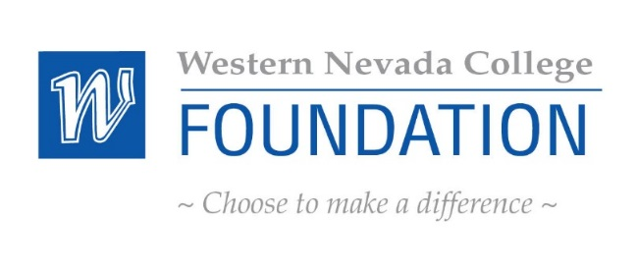
WNC Foundation Board of Directors Meeting Agenda
Thursday, October 21, 2021
Western Nevada College Dini Library, Room 201
2201 W College Parkway, Carson City, NV 89703
8:00 a.m. – 12:00 p.m.

NOTE: Below is an agenda of all items scheduled to be considered. Notification is hereby provided that items on the agenda may be taken out of the order presented, two or more agenda items may be combined for consideration, and an agenda item may be removed from the agenda or discussion relating to an item on the agenda may be delayed at any time. Reasonable efforts will be made to assist and accommodate physically handicapped persons desiring to attend the meeting. Please call Carol McIntosh at the WNC Foundation office at (775) 445-3240 in advance so that arrangements for attendance may be made.

INTRODUCTIONS AND WELCOME (Sean Davison, Board Chair) INFORMATION ONLY
PUBLIC COMMENT INFORMATION ONLY
Public comment will be taken during this agenda item. No action will be taken on a matter raised under this item until the matter is included on an agenda as an item on which action may be taken. The Chair of the Board of Trustees may place reasonable limitations as to the amount of time individuals may address the Board. The Chair may elect to allow public comment on a specific agenda item when that item is being considered.

AGENDA

- 2020-2021 FY Review Results (Mike Aurnague) FOR POSSIBLE ACTION

- July 22, 2021 Approval of Minutes FOR POSSIBLE ACTION
- Introductions (Sean Davison, Chair) INFORMATION ONLY

- WNC Foundation Board Membership (Sean Davison) INFORMATION ONLY
- Special Presentation/Honoring Past Board Members
- Annual Board Member Packets

- Approval of New Co Vice Chair Candidate (Sean Davison) FOR POSSIBLE ACTION
- Tina Holland, Board Member

- State of the College (Dr. Vincent Solis, WNC President) INFORMATION ONLY

- Finance Committee Report (Scott Fields, Secretary/Treasurer) INFORMATION ONLY

- What Have We Learned? Student Experiences through COVID-19
- (Dr. Rebecca Bevans, Professor, Psychology) INFORMATION ONLY

- Roundtable Discussion (WNC Foundation Board) INFORMATION ONLY

- COVID-19 Video Project and WNC Testing Site INFORMATION ONLY
- (Dr. Rachelle Bassen, Professor, Biology)
- (Eric York, Director of Strategic COVID Response)

- Advancement Committee Updates (Niki Gladys) INFORMATION ONLY

- Advancement/Event
  - Golf Tournament Results
  - Thanks for Giving

- Grant and Scholarship Update INFORMATION ONLY
- (Niki Gladys, Executive Director, Advancement)
- (Carol McIntosh, Assistant Director, Development)

- New Business INFORMATION ONLY
- Board Member Recognition (Carol McIntosh) INFORMATION ONLY
  - Celebrate board members with upcoming birthdays and other exciting life events.

- Public Comment INFORMATION ONLY
Note: Public comment will be taken during this agenda item. No action will be taken on a matter raised under this item until the matter is included on an agenda as an item on which action may be taken. The Chair of the Board of Trustees may place reasonable limitations as to the amount of time individuals may address the Board. The Chair may elect to allow public comment on a specific agenda item when that item is being considered.

ADJOURNMENT
NEXT REGULARLY SCHEDULED MEETING:
Board Meeting: January 20, 2022 Location:TBD

THIS NOTICE HAS BEEN POSTED AT THE FOLLOWING LOCATIONS:
Western Nevada College Website
Carson City Library Website
Nevada Public Notice Website

