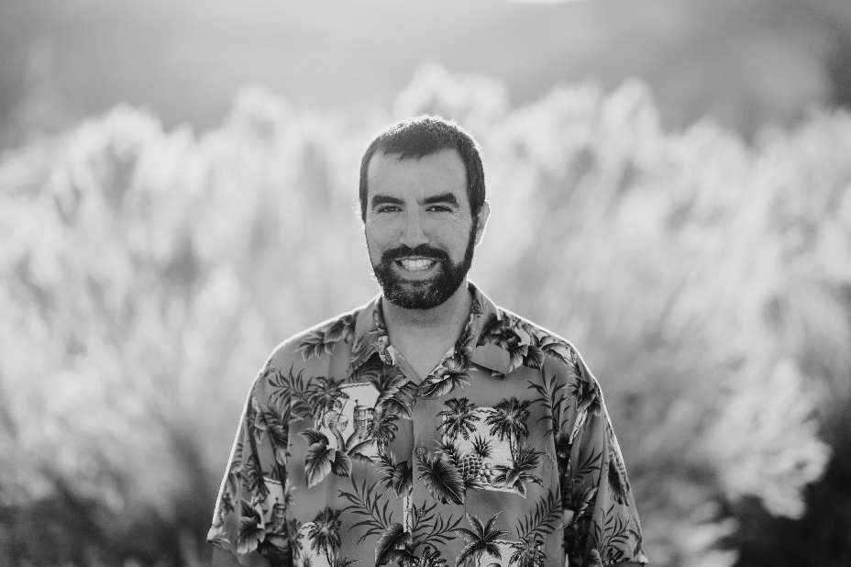

Jacob Council has vast experience in managing people and leadership. He currently works for the State of Nevada.

Jacob started his journey in a small town where he worked for a local restaurant. He started as most do, at the bottom, and worked his way up to lead manager. Jacob was responsible for day-to-day operations and was depended on heavily by the owners. Jacob worked here through high school and part of college.

After high school, Jacob continued his education at Western Nevada College and while attending WNC, was also part of the ASWN leadership. During this time, he also found a new job, closer to home, with a different restaurant and the story is the same as before; started at the bottom and worked his way up to General Manager. In this position, Jacob had to not only run the restaurant but also had franchisee requirements to follow. He was responsible for promoting other employees and ensuring they could lead a shift effectively. After some time, Jacob decided to work for the State of Nevada and the story remains the same. He learned the expectations of his job and promoted. In this position he was responsible for managing day to day operations, in a large-scale commercial kitchen. Due to the knowledge of budgeting and forecasting from the kitchen, Jacob has recently accepted a promotion within the same department in the State of Nevada. Regardless of the environment Jacob is working in, he tries to understand the leadership style needed to produce effective, productive employees. Due to his experience and education, Jacob has the skills necessary to lead and manage employees, as well as understands the importance of adjusting the style in order to ensure success in the employee and company.

Educational accomplishments include BS in Management and Leadership, MBA in Human Resource Management and is currently working on his Doctorate in Organizational Leadership and Development with an expected graduation date in early 2023.

Jacob still lives locally with his wife and two kids and hopes to travel the world when he retires.