Program Review
Welding
2024

Table of Contents:
- Program/Program Review History………………………2
- Alignment to Institutional Goals.......................................2
- Program Data……………………………………………11
- Financials………………………………………………..23
- Departmental Information………………………………23
- Faculty Profiles………………………………….………29
- Comparisons………………………………….…………30
- Recommendations and Commendations…….………….30

- Program/Program Review History
- Program Overview
- This review will functionally begin with data from 2013 as that is the year the AAS Technology degree was instituted and previous programs were deactivated. That year WNC removed emphases from degrees in order to comply with NSHE completion requirements. As a result, Welding is now part of a 6 program degree including Automotive Mechanics, Computer Information Technology, Construction, Machine Tool, and Mechatronics Technology.
- The following is a list of currently offered awards in Welding:

Award | Description | Required Courses
Skills Certificate: Welding | Students are introduced to the many welding certifications available by meeting the standards of the American Welding Society codes. This includes instruction on code certification required by the American Petroleum Institute and the American Society of Mechanical Engineers. | Shielded Metal Arc-Welding and Gas Metal Arc-Welding  WELD 211: Welding I  WELD 212: Welding I Practice  WELD 221: Welding II  WELD 222: Welding II Practice  Fluxed-Core Welding and Gas Tungsten Arc-Welding  WELD 231: Welding III  WELD 232: Welding III Practice  WELD 241: Welding IV  WELD 242: Welding IV Practice  AWS Code Exam  WELD 250: Welding Certification Preparation
Certificate of Achievement: Welding Technology | Provides students with opportunities to practice and prepare for welding certification examinations and the knowledge and skills for employment in welding and related careers. | WELD 211: Welding I  WELD 212: Welding I Practice  WELD 221: Welding II  WELD 222: Welding II Practice  WELD 250: Welding Certification Preparation  General Education Requirement: 12 credits  English/Communications Requirements (6)  Human Relations (3)  Recommended BUS 110  Mathematics (3)
Associate of Applied Science Technology: Welding | This program provides opportunities to practice and prepare for welding certification exams and allows students to explore other industrial skills that are used in a variety of occupations and businesses.  The mission of the Associate of Applied Science in Technology is to provide employment-related knowledge and skills necessary as a professional in a chosen field of study. | WELD 211: Welding I  WELD 212: Welding I Practice  WELD 221: Welding II  WELD 222: Welding II Practice  WELD 231: Welding III  WELD 232: Welding III Practice  WELD 241: Welding IV  WELD 242: Welding IV Practice  WELD 250: Welding Certification Preparation  General Education Requirement: 24 credits  English/Communications Requirements (6)  Recommended BUS 107  Human Relations (3)  Recommended BUS 110  Mathematics (3)  Recommended MATH 110  Science (3)  US/Nevada Constitution (3)  General Elective (3)

Certificate of Achievement in Welding Technology Course Sequence
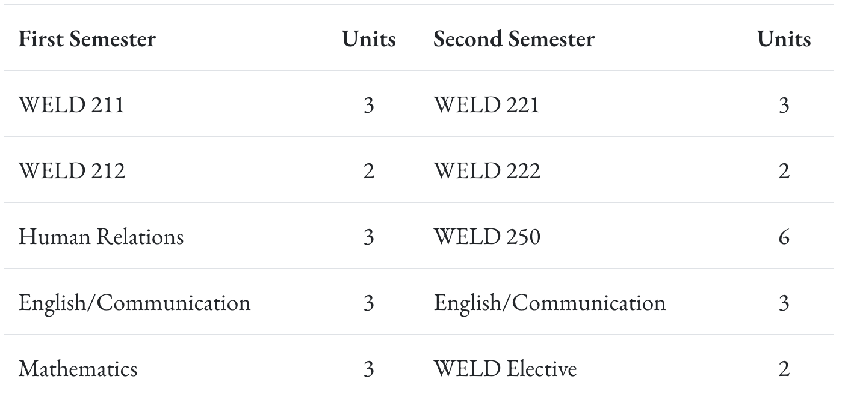

Associate of Applied Science Technology in Welding Course Sequence
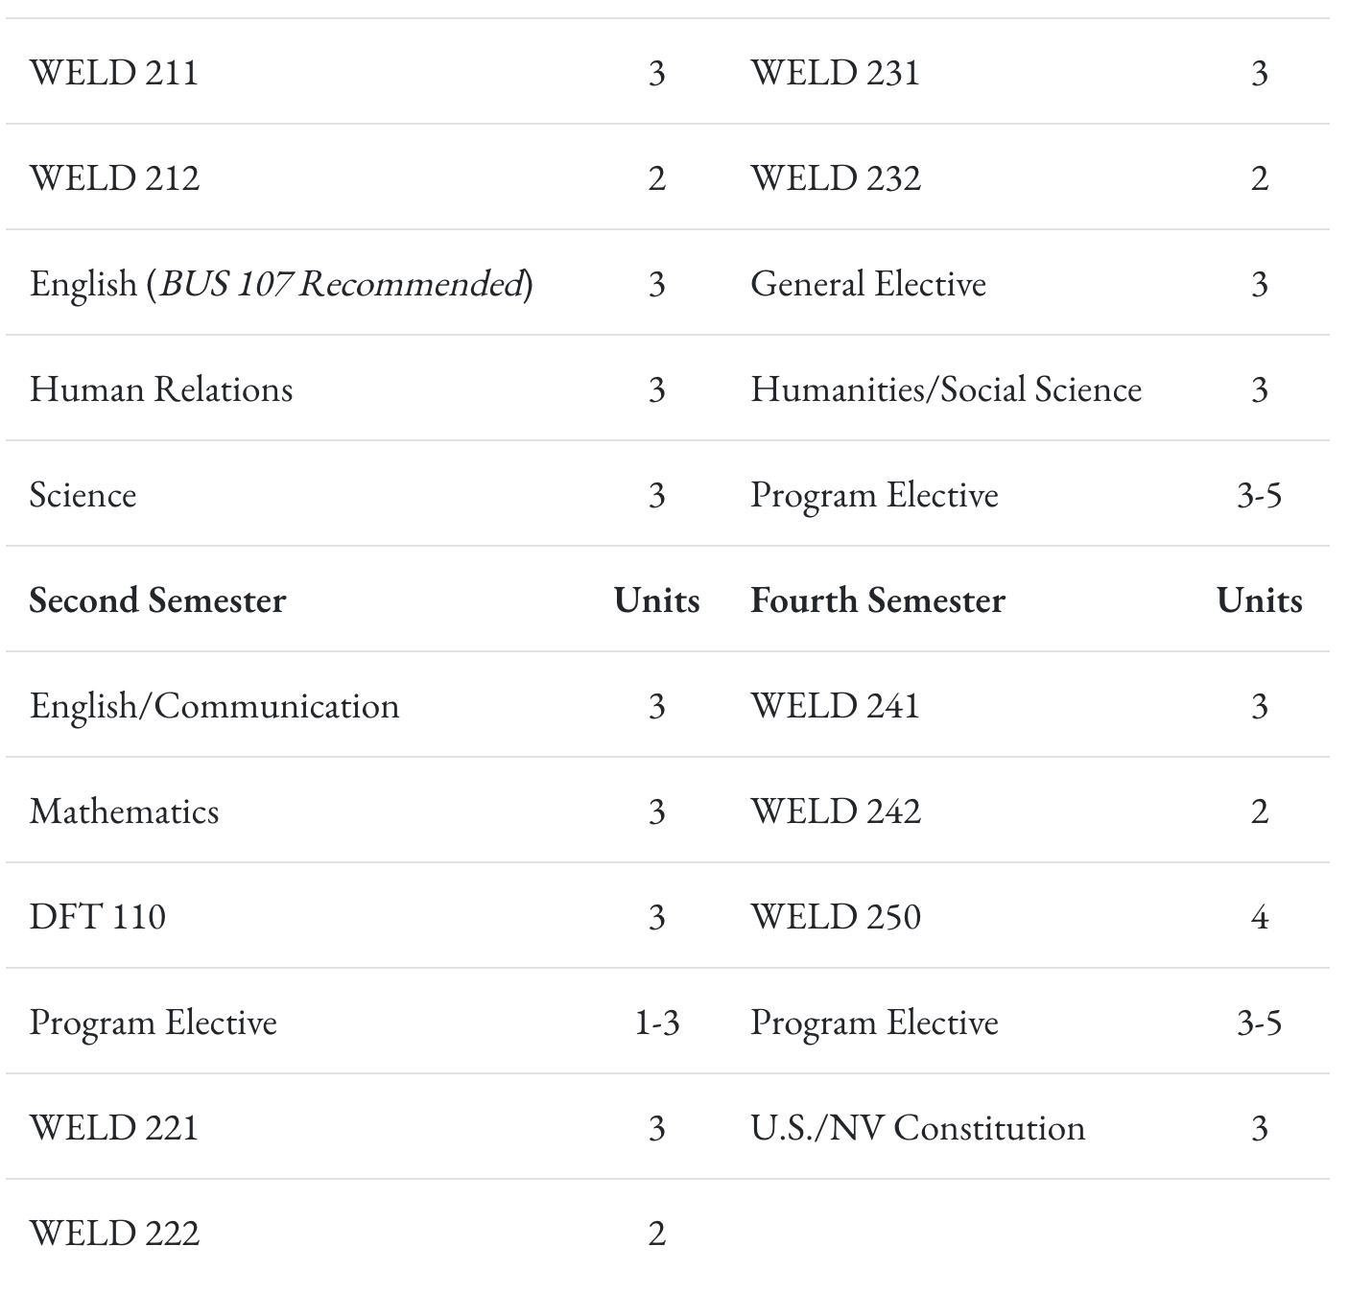

- Program Review History
  - A brief review was done in 2018 utilizing a previous program review template. At that time Welding offered an Associate of Applied Science and a Certificate of Achievement. At that time WNC was the only public American Welding Society Accredited Testing Facility in Nevada and had very high student enrollment and retention.

II. Alignment to Institutional Goals

WNC | Welding
Vision: WNC is an integral and innovative educational partner fostering equity and a life of learning in an exclusive environment for the evolving, diverse community we serve.  Values: WNC is student centered, inquiry driven and data informed as we nurture community connections and promote an environment of equity and inclusion.  Mission: WNC contributes to solutions for the 21st century by providing effective educational pathways for the students and communities of Nevada. | This program provides opportunities to practice and prepare for welding certification exams and allows students to explore other industrial skills that are used in a variety of occupations and businesses.  The mission of the Associate of Applied Science in Technology is to provide employment-related knowledge and skills necessary as a professional in a chosen field of study.
WNC Student Learning Outcomes:  - CONTENT KNOWLEDGE: Demonstrate understanding of essential information and concepts relevant to a discipline or area of study.  - COMMUNICATION: Effectively convey and/or interpret a central idea via visual, oral, or written media.  - QUANTITATIVE LITERACY: Correctly analyze, interpret, draw conclusions from, and communicate quantitative processes and information.  - INFORMATION LITERACY: Locate, evaluate, and appropriately use information from multiple resources in support of a claim or central idea.  - DIVERSITY AND SOCIETY: Identify and discuss changing human societies demonstrating an understanding of the subject and respect for various cultural, methodological, and/or theoretical perspectives.  - CRITICAL THINKING: Integrate knowledge and skills to develop logical conclusions and/or solutions that demonstrate a well-reasoned evaluation of a problem, question, perspective, or solution.  - CAREER PREPARATION: Apply specialized knowledge, approaches, and skills to successfully complete projects and/or demonstrate relevant professional and/or industry-standard competencies | AAS Student Learning Outcomes:  - Know the subject matter appropriate to the emphasis of the degree.  Have met the institutional student learning outcomes.  - Have met the institutional student learning outcomes.  - Have met the institutional student learning outcomes.  - Have met the institutional student learning outcomes.  - Have acquired skills and can perform tasks necessary for employment or career advancement.  - Have met the institutional student learning outcomes.  - Have met the institutional student learning outcomes.  AAS Technology Student Learning Outcomes:  Know the subject matter appropriate to the emphasis of the degree. (WNC SLO 1,3,6,7)  Communicate effectively and appropriately, in oral and written form. WNC SLO 2)  Locate, evaluate and properly utilize the tools and resources appropriate to a technology degree professional. (WNC SLO 1,6,7)  Acquire skills and perform tasks necessary for employment or career enhancement. (WNC SLO 1,7)  Developed an appreciation of the importance of social, ethical, legal and diversity issues. (WNC SLO 5,7)  Developed an appreciation of the need and importance of lifelong learning. (WNC SLO 1)
The Welding and Industrial Skills Program at Western Nevada College (WNC) provides students with the knowledge and practical experience required to prepare for welding certification exams and to explore a range of industrial skills applicable to various occupations. By focusing on hands-on training and industry-standard practices, the program ensures that students not only acquire technical expertise but also develop broader academic and professional competencies that align with WNC’s Institutional Student Learning Outcomes.

CONTENT KNOWLEDGE
Students gain a solid foundation in welding theory, metallurgy, fabrication techniques, and safety practices—core competencies within the welding and industrial trades. This mastery of essential knowledge reflects WNC’s institutional goal for students to demonstrate understanding of essential information and concepts relevant to their discipline.

COMMUNICATION
Effective communication is integral in industrial settings, where precise documentation and verbal clarity are crucial for safety and collaboration. The program develops these skills through lab exercises, safety presentations, and documentation of welding procedures, ensuring students can effectively convey and interpret central ideas in both oral and written formats.

QUANTITATIVE LITERACY
Welding and industrial skills require accurate measurement and interpretation of technical data, including blueprints, material thickness, and weld parameters. Students develop quantitative literacy through tasks like measuring tolerances, calculating weld requirements, and interpreting welding codes—fulfilling WNC’s outcome for students to correctly analyze, interpret, and communicate quantitative information.

INFORMATION LITERACY
Students locate and evaluate information from welding codes (such as AWS standards), equipment manuals, and trade publications to support their practice and preparation for certification exams. This ability to find and apply relevant information directly addresses WNC’s emphasis on locating, evaluating, and using information from multiple sources in support of a claim or task.

DIVERSITY AND SOCIETY
The program’s emphasis on workplace safety, respect for diverse perspectives in teams, and ethical industrial practices fosters an appreciation of social, legal, and cultural considerations in the workforce. By addressing these issues within lab activities and coursework, the program aligns with WNC’s SLO to identify and discuss the impact of changing human societies and respect for cultural diversity.

CRITICAL THINKING
Troubleshooting welding defects, evaluating materials, and applying safety standards require students to integrate technical knowledge with practical problem-solving. Students practice making adjustments based on observations, critical assessments, and data analysis—reflecting WNC’s outcome of developing well-reasoned evaluations and solutions.

CAREER PREPARATION
The program is designed to prepare students for certification exams (such as AWS) and to equip them with industrial skills relevant across multiple trades. By gaining hands-on experience with industry-standard equipment and tools, students develop competencies that meet professional expectations—fulfilling WNC’s goal to ensure graduates apply specialized knowledge and skills to complete projects and demonstrate industry-standard competencies.

WNC Institutional Objectives | Welding
WNC provides access to educational pathways and opportunities | Welding is the most desired program within the WCTE Department, with classes being offered in an accelerated format as well as a traditional format.
WNC students make an efficient transition from preparatory to college level coursework | For students seeking to start the program after graduation, Nevada’s current graduation and GDE requirements adequately prepare students.
WNC provides equitable access for students regionally and demographically | Welding is offered on both the Carson and Fallon campuses, with a very diverse ethnic makeup within the classes
WNC provides access to dual credit pathways | Dual credit is not being offered anywhere at this time, but students have the opportunity to earn articulated credits if they meet the GPA and End of Program exam minimums
WNC supports student learning, progress, and completion | Many of the accelerated welding students finish two or three skills certificates at the completion of the program
WNC advances student achievement of learning outcomes at course, program, and institutional levels | When we had 3 full time instructors (2 on the Carson campus and one on the Fallon campus) we had many students pass the AWS certification test, for a variety of welds.
WNC builds student engagement with education and the WNC community | The Welding program at WNC is well known for their excellent instruction and expertise. Many students attend due to word of mouth.
WNC identifies and closes achievement gaps across student populations by supporting achievement across demographic groups in traditional and non-traditional fields | Performance gaps are less than 10% between groups annually.
WNC sustains a learning environment that promotes equity and inclusion | Students of all ethnicities, genders and income levels, succeed at a high level in the welding program and within the classes
WNC responds to the needs of industry and provides effective pathways for students toward in-demand occupations | All full time instructors have great connections with industry, and are constantly looking at ways to improve so that the classes are industry standard.
WNC contributes to solutions to the critical issues facing 21st century Nevada | With business moving to Northern Nevada, welders are in high demand across this region.

Curriculum Map

III. Program Data

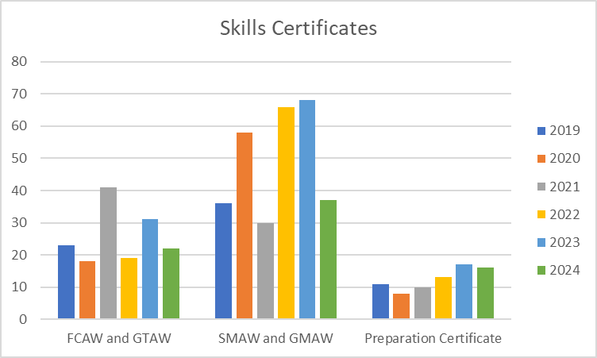

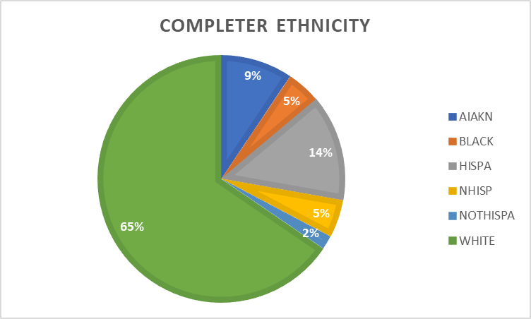

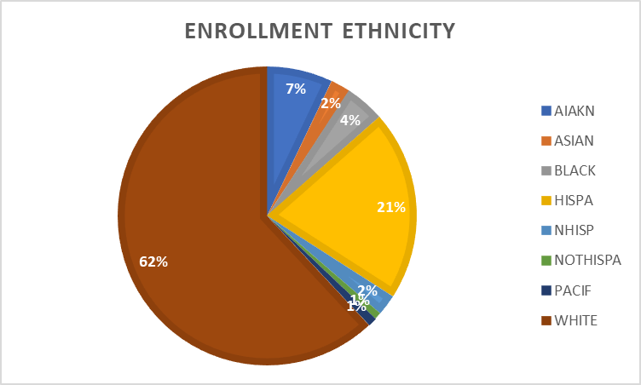

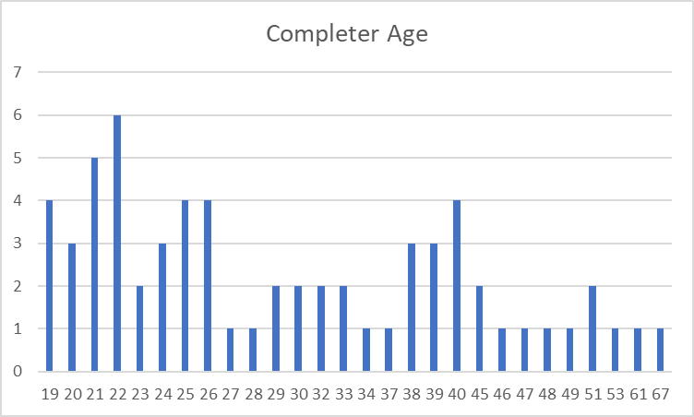

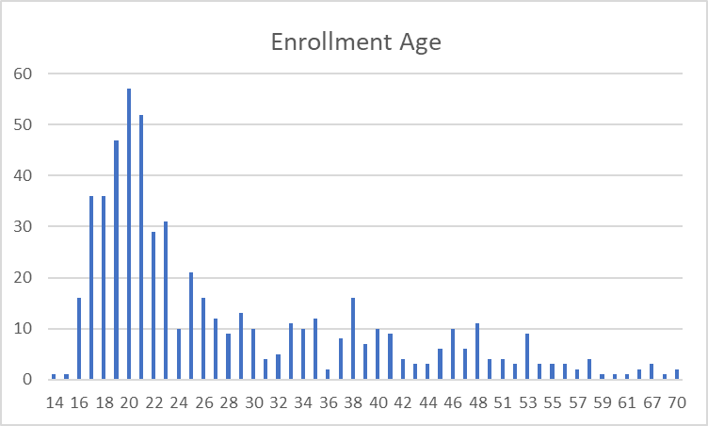

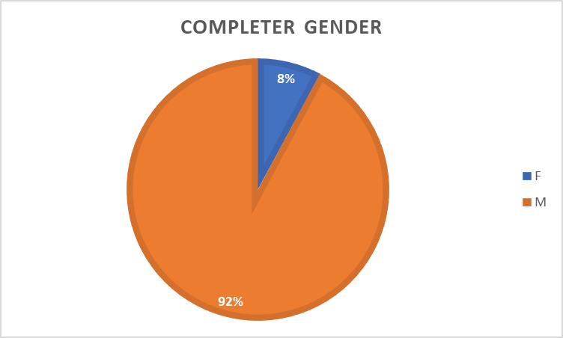
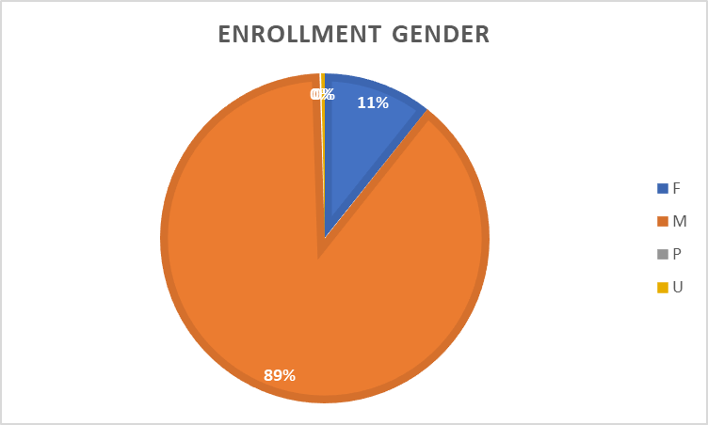

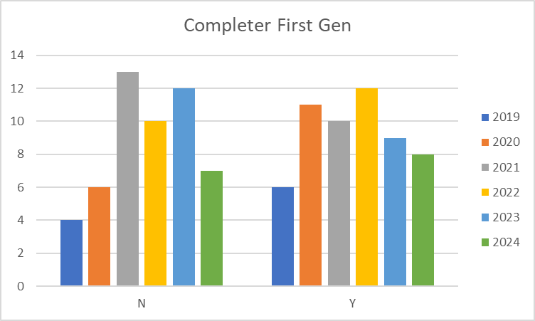

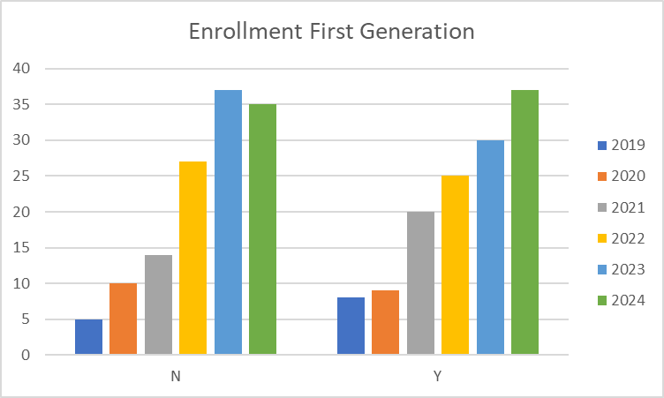

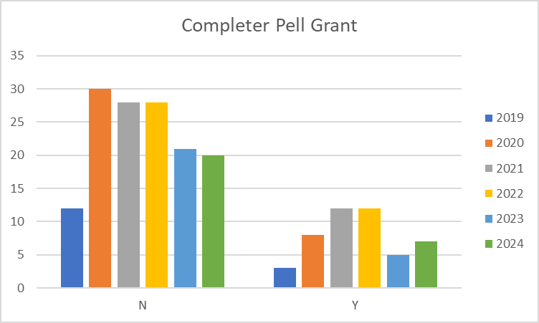

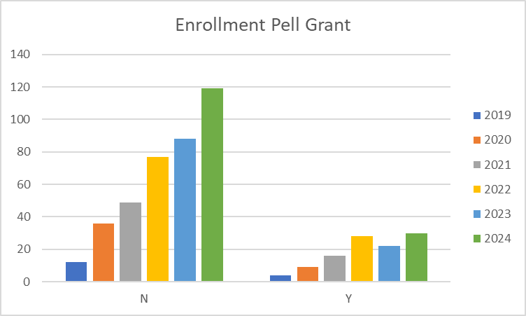

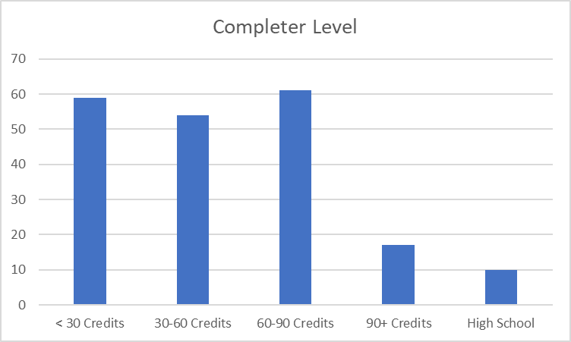

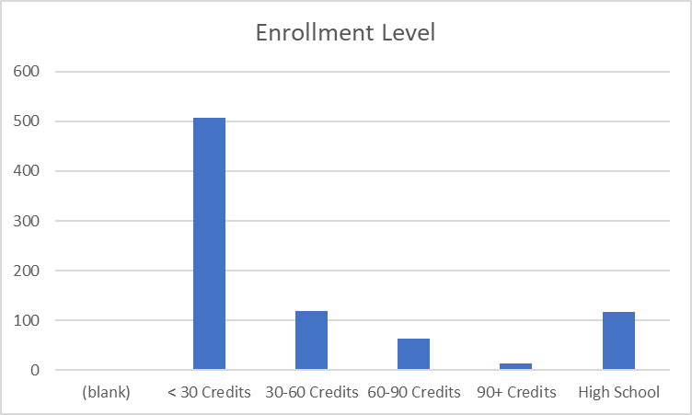

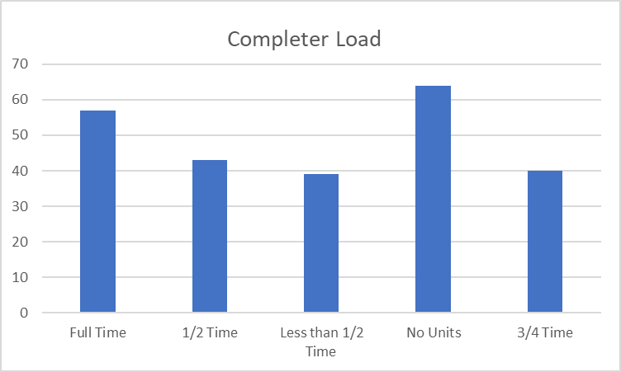
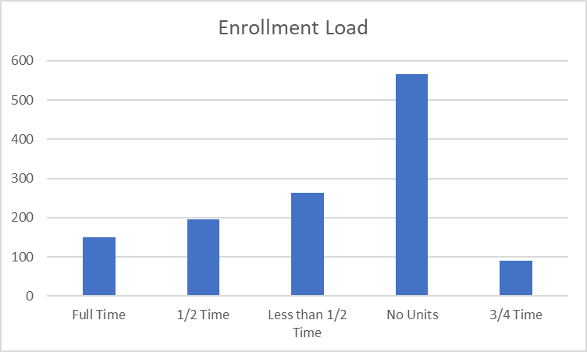

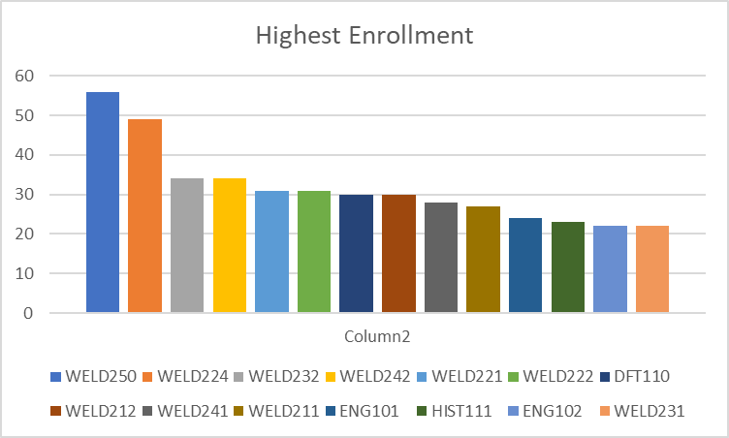

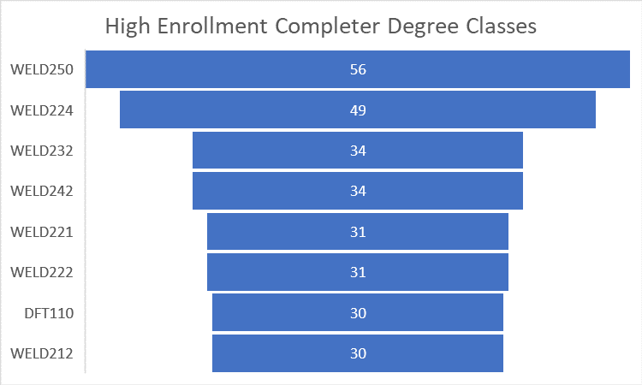

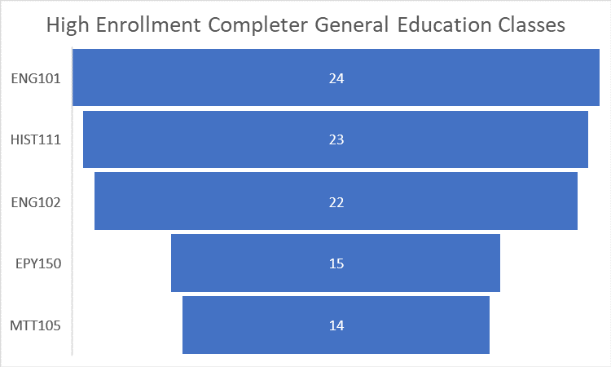

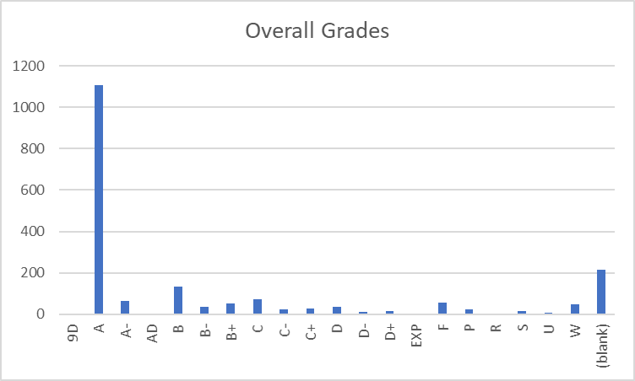

IV. Financials

- Skills Certificate:
  - SMAW and GMAW
    - Tuition and Books – $1,348
  - FCAW and GTAW
    - Tuition and Books – $1,348
  - Welding Preparation Certificate (AWS)
    - Tuition and Books - $1,215

- Certificate of Achievement:
  - Tuition and Books – $4,240
- Associates:
  - Tuition and Books – $8,210

V. Additional Department Information

- Academic Advising
The availability of program electives is inconsistent. While students often fill Weld I and II along with the practice sessions, no new sections are typically opened. This may be due to instructor availability, but there seems to be a need to expand introductory classes when demand increases. Program electives currently allow for MTT lectures, but not the accompanying practice. These classes tend to work best as a pair, and students prefer to take them together. Adding the practice session, if it doesn’t conflict with other scheduling, could help address this need.

- Advancement

Scholarships for the program are provided through the William N. Pennington Foundation, along with several other supporting donors. Recently, Southwest Gas made a donation of metal tubing for student practice.

- Grants (Roads Workforce Liaison - Administrative Faculty Advancement, Grant Writer Advancement, Grant Administrator, Vice President of Academic & Student Affairs, Career Services Specialist)

15 students were approved for SANDI funding in Welding between 2019 and 2024. The SANDI grant expired on September 30, 2024.

- CFO

Course | Total Approved Fee | Expendable Supplies
WELD 211 | 100 | 100
WELD 212 | 100 | 100
WELD 221 | 100 | 100
WELD 222 | 100 | 100
WELD 224 | 100 | 100
WELD 231 | 100 | 100
WELD 232 | 100 | 100
WELD 241 | 100 | 100
WELD 242 | 100 | 100
WELD 250 | 100 | 100

How course fee requests are approved:
Each year, the CFO sends out a request for any new course fees or changes to existing fees. Any new fees are then compiled and presented to the College Council for review. If a proposed fee exceeds $50, it must be approved by the Board of Regents (BOR). However, fees of $50 or less can be approved directly by the WNC College President.
Once a fee is approved or updated, the Student Finance Coordinator ensures that the new or revised fees are updated in PeopleSoft for the term when they become effective. This process ensures that students registering for these classes are charged the appropriate fee upon enrollment.
- Academic Director
In June 2023, a new director was hired after a transitional year when the division was led by an interim director. This leadership change required several adjustments within the division. Since the new director’s arrival, improvements in the department's overall effectiveness have been evident. The introduction of best practices in scheduling and communication has enhanced operational efficiency, and there has been a noticeable increase in awareness of the Western College of Technology and Education (WCTE) both on campus and in the surrounding communities. This increased visibility has contributed to a more cohesive and effective program.
The department is organized with a Director overseeing the entire division, which includes faculty in several areas such as Graphic Design, Business, Education, Criminal Justice, Aviation, EMS, Fire Science, Agriculture, Computer Information Technology, and Health/PE. The Director is supported by an Administrative Assistant IV, who handles a variety of administrative functions. To further improve operational efficiency, the division has recently expanded its team. An Outreach and Training Coordinator has been hired to manage all Skilled Trade Programs, including Welding, Automotive, Machine Tools, Construction, and Advanced Manufacturing. An additional Administrative Assistant III has been added to support various programs, including Skilled Trades, Fire Science, and EMS. Additionally, an Early Childhood Education (ECE) Program Coordinator was brought on board recently to manage the numerous ECE grants at the college. This organizational structure provides dedicated oversight and support across all programs, improving overall operational efficiency.
The department is committed to maintaining instructional effectiveness through several key initiatives. The recent hiring of a new Director and an Outreach and Training Coordinator provides focused leadership and specialized management for Skilled Trade Programs. This ensures that instructional practices align with industry standards and best educational practices. The addition of an Administrative Assistant III and an Early Childhood Education Program Coordinator enhances the support structure for various programs, enabling better coordination, resource allocation, and responsiveness to instructional needs. Furthermore, the department has implemented best practices for scheduling and communication, which optimize instructional time and improve interactions between faculty, students, and stakeholders. Each program, including Skilled Trades, Fire Science, EMS, and Early Childhood Education, benefits from dedicated coordinators who ensure that instructional materials, resources, and methodologies remain up-to-date and effective. The division also actively seeks feedback from students, faculty, and industry partners to identify areas for improvement, fostering continuous enhancement of instructional strategies.
The process for assigning teaching responsibilities within the department is highly collaborative. Full-time instructors provide the Director with an overview of course assignments for the upcoming semester. The Director reviews the plan, and if any issues arise—such as negative feedback from course evaluations or student complaints—the Director works with the instructors to ensure the best-qualified faculty member is assigned to each course. Faculty workloads are typically heavy, with most full-time WCTE faculty carrying an overload due to the large number of courses required to ensure students can graduate on time. To support new faculty, the department has developed a training course in collaboration with the Learning and Innovation department. This course provides new instructors with tools to enhance their teaching effectiveness and outlines the framework for course structure and delivery at the college. All instructors are fully credentialed, either through their educational background or relevant professional experience.
The program is actively focused on recruiting and retaining underrepresented faculty and staff through targeted outreach and recruitment initiatives. This includes engaging with professional networks and organizations that support diversity in education and industry, as well as participating in job fairs and events that attract a diverse pool of candidates. Creating an inclusive and supportive work environment is also a priority, as it helps retain underrepresented faculty and staff. While several significant hires have been made recently, the department faced a loss with the departure of Juan Ramirez, a full-time Welding Instructor, which impacted the College's standing within the community. However, the hiring of new adjunct instructors is expected to help rebuild trust and restore the program’s reputation.
There is a recognized need for a second full-time instructor in CIT to help manage the growing demand for courses and support students effectively.
Until recently, additional support staff was a significant concern. However, since May, the department has been able to hire an additional Administrative Assistant, an Outreach Coordinator, and an Early Childhood Education Program Coordinator. With these new hires, the department now has adequate support staff to meet its operational needs.
Many of the department's more costly programs, such as Perkins and WINN, are funded through grants. Lab fees are used to cover consumables, but rising material costs have created challenges. The department has had to dip into its general operating budget to secure the necessary supplies for maintaining industry-standard programs.
The department regularly assesses its use of funding and human resources through reviews and strategic planning. Financial resources are monitored to ensure alignment with the program’s goals and effective utilization. Expenditures are evaluated based on their impact on student outcomes, program growth, and operational efficiency. For human resources, the department reviews faculty and staff workloads and the effectiveness of course delivery and student support services. Feedback from students, faculty, and staff is used to identify areas for improvement, ensuring that resources are optimized to meet the program's needs.
Facilities remain one of the department's biggest concerns. Some buildings have mold issues, leading to classrooms being closed just before the semester begins. Other buildings experience uncontrollable leaks that pose a risk to expensive equipment and vehicles, further complicating operations.
- Learning and Innovation

In the Fall of 2023, Learning and Innovation piloted a 16-week Canvas-based “Faculty Development” course. This course provided information on expectations for WNC instructors as well as strategies and tools for teaching effectively.
Additionally, Learning and Innovation hosts the Zoom-based “Coffee and Classroom Conversations” series that focuses on a wide range of teaching topics. This series is driven by faculty interests and WCTE faculty have regularly attended these sessions.
The Learning and Innovation team has met with WCTE faculty for support in assignment development and teaching strategies, as well offering professional development opportunities for faculty in support of student learning initiatives including the introduction of best practices for working with students in CTE fields.
Learning and Innovation also provides technical support for Canvas including help desk support and instructional design.

- ACMC

In October 2024, the Welding Certificate of Achievement was updated to reduce WELD 250 to 3 credits and to add DFT 110; this change was made specifically to address the needs of prison students and to create better scaffolding between the CoA and the AAS Tech Welding degree.

- Financial Aid
Feedback from students tends to focus primarily on course delivery, conflicts with instructors, access to resources, and various learning challenges they may face. These concerns are important to address, as they directly impact the overall student experience and their ability to succeed in the program. By understanding and addressing these issues, we can improve both the quality of education and the support systems available to students.
For students pursuing the AAS-Tech degree, we observe that they are generally well supported throughout their studies. This is largely due to their close connection with their subject matter faculty, who provide guidance, mentorship, and specialized expertise. This connection seems to create a supportive environment that helps students stay engaged and succeed in their coursework.
There is discussion about whether there’s a way to track and demonstrate if students in WCTE degree programs are successfully stacking their credentials, such as earning Skills Certificates, Certificates of Achievement (COA), and ultimately completing the AAS degree. It may not have been formally reported, but it would be valuable to measure how students are progressing through these stacked credentials, as it could provide insights into the effectiveness of the program and highlight areas for improvement.
Students often declare a degree primarily to open up options for Financial Aid, even if they have no intention of completing the degree. While this practice is not entirely new, it’s something that should be noted. One area where the process falls short is in documenting whether the student has achieved their initial goal. There is a tendency to assume that if a student does not graduate with the degree, the assistance provided was a failure, even though they may have completed other objectives. This gap in tracking student outcomes could be addressed to better reflect the support students are receiving, regardless of whether they ultimately earn the degree.
Another ongoing challenge is the attraction of fraudsters to online programs, particularly those who are looking to take advantage of Financial Aid dollars. These individuals often target online programs to exploit the system, which remains a concern across many institutions.
Additionally, there are occasional issues with the approval process for certain programs, particularly when it comes to the AAS-Technology degrees, which are approved by agencies like the State Approving Agency for VA Benefits. When a new reviewer examines the catalog, there is often confusion about how to categorize the Technology emphasis or how to handle the different pathways, such as Automated Systems or CIT. While these issues can usually be resolved through conversation and clarification with the reviewer, it remains a recurring challenge that requires attention each time a new person evaluates the catalog.

- Faculty
The welding program offers students a clear pathway from foundational welding knowledge to professional-level skills, preparing them to meet national certification standards. Through the program, students are not only trained in essential techniques but are also supported in earning industry-recognized welding certifications.
Enrollment is diverse, attracting students across different age groups and genders. The program benefits from consistent demand in the job market—local employers regularly reach out to request skilled welders. With ongoing regional growth, employment opportunities in welding remain strong, and the program continually adapts to evolving industry standards to ensure students are prepared for current and future needs.
Currently, the program is in good shape, but it is facing some staffing challenges. With the departure of a full-time instructor, the program is in the process of hiring; however, finding qualified candidates has been difficult. Despite this, the program continues to serve a wide audience—from career-minded students to hobbyists, and even artists working with metals and plastics. Welding is integral to nearly every trade, highlighting the broad applicability of the skills taught.
While there is some interest in expanding course offerings, the program already operates classes Monday through Saturday, both mornings and evenings. Logistical challenges, including staffing and facility constraints, make further expansion difficult at this time.
A current strength is the availability of scholarships, which have been critical to maintaining strong enrollment. However, there is concern that if these scholarship opportunities were to decrease, enrollment could suffer. Additionally, rising costs for consumables like gases and welding rods are putting financial pressure on the program. To sustain operations, an increase in lab fees will likely be necessary to offset these rising costs.

VI. Faculty Profiles - provide a narrative response to each of the following:

- Randy Naylor
  - B.S. in Civil Engineering - UNR
- Jorgen Jeppesen
  - Associate of Occupational Techology
- Dave Stegg
  - Associate of Science – WNC
  - Associate of Applied Science – Welding from WNC
  - Certificate of Achievement – Welding Technology from WNC
- Luis Alainz
  - Associate of Applied Science – Welding from WNC
  - 1G, 2G, 3G and 6G AWS certifications
  - 20 years of experience
  - Welder in the Military
- Calvin Jones
  - Associate of Science from WNC
  - 10 years of experience
- Michael Thiede
  - U.S. Marine Corps Machinist and Welding School
  - Iron Workers Union Apprenticeship Program

VII. Comparisons - provide a narrative response to each of the following:

- TMCC
  - AAS - Welding, Manufacturing Technologies
  - Certificate of Achievement, Welding Technology
  - Certificate of Achievement, Manufacturing Technologies Welding CNC
  - Skills Certificates
    - Welding, FCAW and GTAW
    - Welding, SMAW and GMAW
    - Manufacturing Technologies Welding CNC
- Career College of Northern Nevada closed in 2024 and many of their students went to TMCC, but many were unable to afford the tuition. Possible grant funded opportunities should we need additional students.

VIII. Recommendations and Commendations - provide a narrative response to each of the
following:
Commendations
- This was the first time implementing the new program review process, which required assistance and participation from many individuals. Administrative departments and IT were essential in gathering necessary information and fielding questions.
- Welding full-time faculty for their contributions to program history and insight into industry trends. Adjunct faculty for the program development participation.
- Welding has included an assessment of Welding 250 (Welding Preparation Certificate) in the annual plan. This is an exemplary example of faculty engaging in program-level assessment.
Recommendations
- The program is currently searching for a second full-time instructor, but has been unable to attract a qualified candidate due to low salary placement. Consider adjusting the salary to make the position more attractive to competitive candidates.
- The cost of consumables has increased, but course fees have remained the same. Fees should be reviewed to keep up with the market cost.
- Consider adding MTT 106 as a program elective to align with MTT 105.
- Add prerequisites to the following courses (all need to be hard flagged in PeopleSoft due to safety concerns):

Corequisite Enrollment Required
WELD 211/212
WELD 221/222
WELD 231/232
WELD 241/242

Prerequisites required
WELD 221/222 - 211 and 212 or instructor approval
WELD 231/232 - 221 and 222 or instructor approval
WELD 241/242 - 231 and 232 or instructor approval

WELD 250 – instructor approval

