Program Review
Mechatronics and Electronics Technology
2024

Table of Contents:
- Program/Program Review History………………………2
- Alignment to Institutional Goals.......................................8
- Program Data……………………………………………16
- Financials………………………………………………..29
- Departmental Information………………………………29
- Faculty Profiles………………………………….………38
- Comparisons………………………………….…………38
- Recommendations and Commendations…….………….39

- Program/Program Review History
- Program Overview
  - This review will functionally begin with data from 2013 as that is the year the AAS Technology degree was instituted and previous programs were deactivated. That year WNC removed emphases from degrees in order to comply with NSHE completion requirements. As a result, Mechatronics and Electronics Technology is now part of a 6 program degree including Automotive Mechanics, Computer Information Technology, Construction, Machine Tool, and Welding.
  - The following is a list of currently offered awards in Mechatronics and Electronics Technology:

Award | Description | Required Courses
Skills Certificate: Industrial Electronics Technology | This course of study prepares students for the Certified Electronics Technician Associate Exam, which is administered by the International Society of Certified Electronics Technicians (ISCET). | MPT 111: Fundamentals of Manufacturing and Automation I  ELM 110: Basic Electricity  ELM 112: Electrical Theory, DC  ELM 121: Circuit Design  OSH 222: General Industry Safety
Skills Certificate: Manufacturing Technician | The Manufacturing Technician program is the entry point for those seeking career opportunities in Advanced Manufacturing, Robotics and Mechatronics. This program will prepare individuals to succeed in modern production environments that use industry 4.0 controls, automation and processes. Upon completion, students will be prepared to earn the C-101 Certified Industry 4.0 Associate I - Basic Operation certificate through the Smart Automation Certification Alliance (SACA). | MPT 111: Fundamentals of Manufacturing and Automation I  MPT 112: Fundamentals of Manufacturing and Automation II  ELM 110: Basic Electricity  ELM 127: Introduction to AS Controls  OSH 222: General Industry Safety
Skills Certificate: Mechatronics Foundation | Mechatronics is the study of electrical, mechanical, fluid power and control components that make up automated systems in high-tech industrial environments. This program is for individuals currently working or seeking opportunities in occupations such as maintenance, IT and engineering. Students will become well-versed in basic factory floor controls, automation and programming, learning to analyze and modify modern production control systems that use industry 4.0 automation technologies and processes. Upon completion, students will be prepared for the SACA C-102 Certified Industry 4.0 Associate II. | MPT 160: Mechanical Drive Systems I  ELM 129: Electric Motors & Drives  ELM 134: Programmable Logic Controllers I  ELM 140: Industrial Robotics
Certificate of Achievement: Mechatronics | The Mechatronics Certificate of Achievement expands on the electrical and mechanical skills in the foundational courses and/or field experience to develop further proficiency in Industry 4.0 processes. | MPT 111: Fundamentals of Manufacturing and Automation I  MPT 112: Fundamentals of Manufacturing and Automation II  MPT 160: Mechanical Drive Systems I  ELM 127: Introduction to AC Controls  ELM 134: Programmable Logic Controllers I  OSH 222: General Industry Safety  Choose 2 units from the following program electives:  ELM 136: Programmable Logic Controllers II (3)  MPT 114: Fundamentals of Manufacturing and Automation III (3)  General Education Requirement: 12 credits  English/Communications (6)  Human Relations (3)  Mathematics (3)
Certificate of Achievement: Industrial Electronics Technology |  | ELM 110: Basic Electricity  ELM 112: Electrical Theory, DC  ELM 121: Circuit Design  MPT 111: Fundamentals of Manufacturing & Automation I  MPT 112: Fundamentals of Manufacturing & Automation II  OSH 222: General Industry Safety  Choose any 4 from the following program electives:  MPT, ELM, DFT, ENGR, WELD, or MTT  General Education Requirement: 9 credits  English/Communications (3)  Human Relations (3)  Mathematics (3)  Must be MATH 110 or higher
Associate of Applied Science Technology: Mechatronics & Electronics | The Mechatronics and Electronics degree develops knowledge and skills needed for career progression in an automated Advanced Manufacturing environment where the integration of computers and electronic technologies control industrial systems and machines.  The purpose of the Associate of Applied Science degree in Mechatronics and Electronics Technology is to provide employment-related knowledge and skills necessary to succeed as a professional in a chosen field of study. | ELM 110: Basic Electricity  ELM 112: Electrical Theory DC  ELM 127: Introduction to AC Controls  ELM 129: Electric Motors & Drives  ELM 134: Programmable Logic Controllers I  ELM 140: Industrial Robotics  MPT 111: Fundamentals of Manufacturing and Automation I  MPT 112: Fundamentals of Manufacturing and Automation II  MPT 160: Mechanical Drive Systems I  OSH 222: General Industry Safety  Choose 8 credits from the following program electives: AIT, CADD, DFT, ELM, ENGR, ET, MPT, MT, OR MTT  General Education Requirements: 24 credits  English/Communications (6)  Mathematics (3)  Recommend MATH 126  Science (3)  Human Relations (3)  Humanities/Social Science (3)  US/Nevada Constitution (3)  General Elective (3)

Certificate of Achievement in Mechatronics Course Sequence

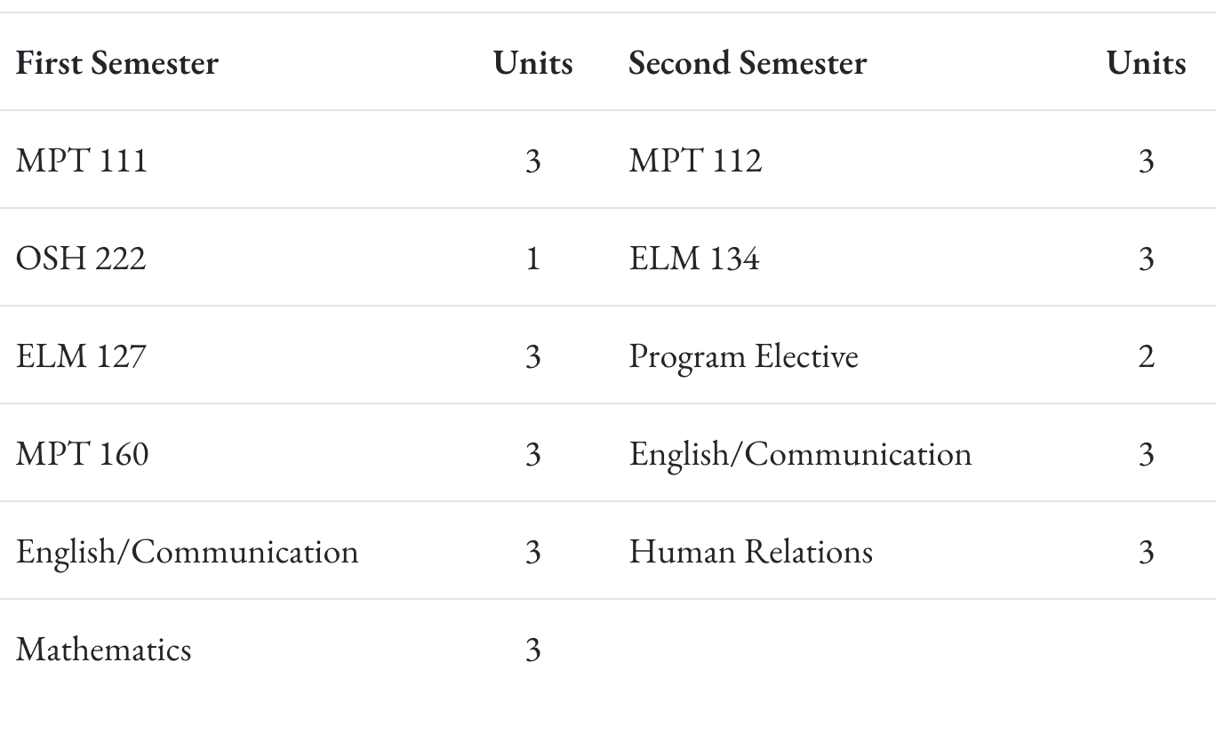
Certificate of Achievement in Industrial Electronics Technology Course Sequence

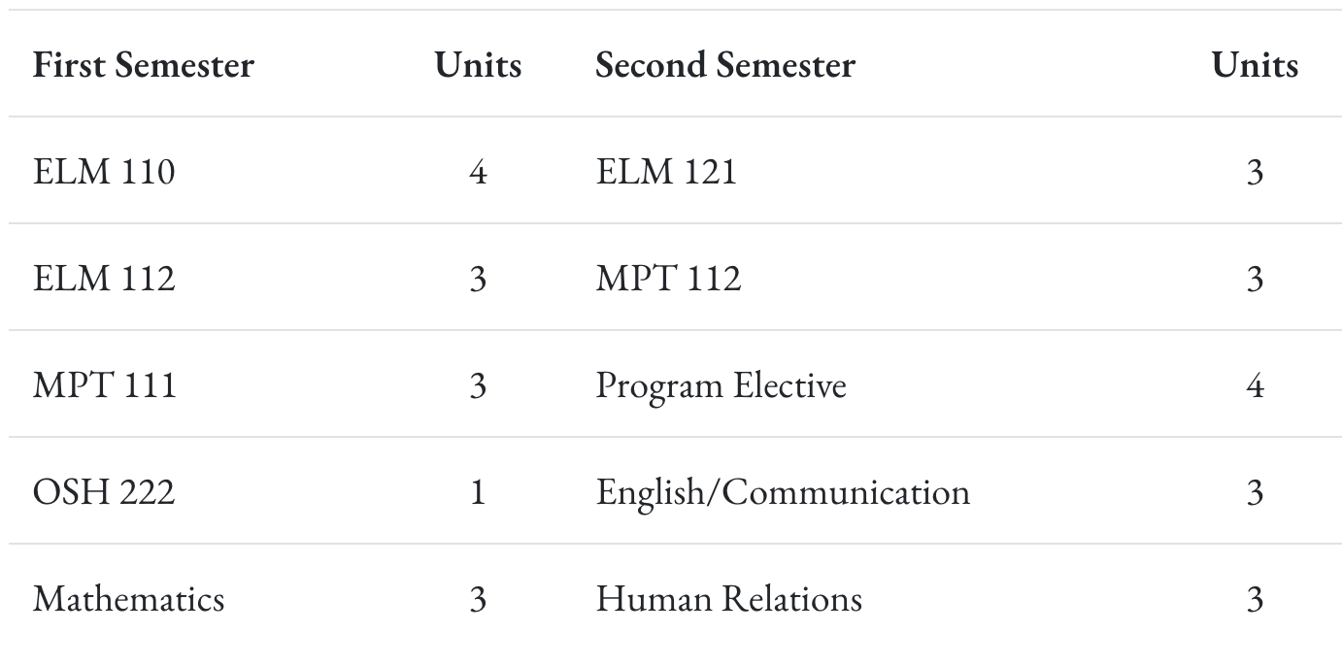
Associate of Applied Science Technology in Mechatronics and Electronics Course Sequence

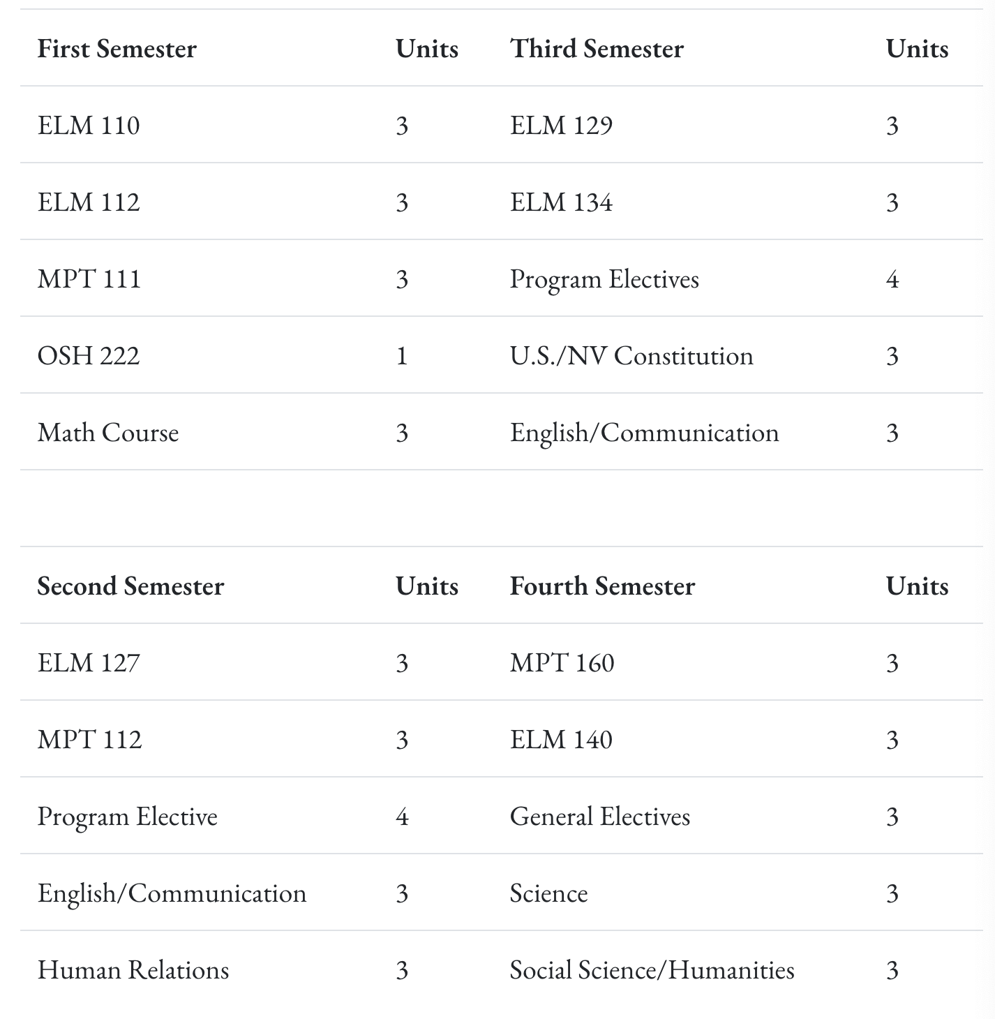

- Program Review History
  - A brief review was done in 2018 utilizing a previous program review template. At that time Mechatronics and Electronics Technology offered an Associate of Applied Science in Mechatronics and was structured to align with the Siemens Mechatronic Systems Certification Program exam objectives. At that time, students who enrolled in the program were required to have completed an introductory series of courses and earn their Manufacturing Technician credential. The program was limited to students who had background or experience in industrial technology. There have been significant curricular changes since the last program review.

II. Alignment to Institutional Goals

WNC | Mechatronics
Vision: WNC is an integral and innovative educational partner fostering equity and a life of learning in an exclusive environment for the evolving, diverse community we serve.  Values: WNC is student centered, inquiry driven and data informed as we nurture community connections and promote an environment of equity and inclusion.  Mission: WNC contributes to solutions for the 21st century by providing effective educational pathways for the students and communities of Nevada. | Mechatronics is the high-tech field combining electrical, mechanical, fluid power and control systems in industrial environments. These programs ensure an understanding of Industry 4.0 concepts and theories applied through hands-on experiences to ensure operation knowledge. Students will develop a troubleshooting mindset through an interactive approach to automated systems that includes real-world problem solving, research, safety practices, documentation and effective teamwork.  The Industrial Technology programs of study focus on building a solid base of fundamental knowledge and skills to prepare for careers in modern manufacturing, mining, aerospace and high tech health care environments.  Class and lab work explores the industrial environment, culture, processes and values. Knowledge and skill courses include technology-rich computer-based studies and hands-on lab experiences with industrial components and allow students to move forward through advanced studies including automation, mechatronics and robotics.  Endorsed By:  NATIONAL ASSOCIATION OF MANUFACTURERS  for entry-level workers and experienced technicians alike.  Industrial Electronics:  Designed to provide fundamental knowledge of and experience with industrial electronic components and systems to learn job skills applicable in a variety of technical environments. Students will learn about and use equipment, tools and processes to prepare for International Society of Certified Electronics Technicians (ISCET) certification as a Certified Electronics Technician associate and be prepared to work as a technician in assembly or troubleshooting positions.  Manufacturing:  The Manufacturing Technician program is the entry point for Advanced Manufacturing, Robotics and Mechatronics studies as it prepares students to earn the Manufacturing Technology Level 1 (MT1) credential. The MT1 documents that an individual is prepared for above entry-level industrial technology positions with fundamental knowledge and skills in general manufacturing concepts and technologies. The nationally recognized MT1 certification is embedded into this 3-course series and is issued by the Manufacturing Skills Institute as well as endorsed by the National Association of Manufacturers.  Mechatronics Technology:  Mechatronics is the high-tech field combining electrical, mechanical, fluid power and control systems in industrial environments. These programs ensure hands-on experience and operational knowledge as aligned with the rigorous Siemens Mechatronics industry certification exam objectives in addition to expanded technical studies. Class and lab experiences include developing a troubleshooting mindset through an interactive approach to automated systems, including problem-solving, research, safety, documentation and effective teamwork.  The purpose of the Associate of Applied Science degree in Mechatronics and Electronics Technology is to provide employment-related knowledge and skills necessary to succeed as a professional in a chosen field of study.
WNC Student Learning Outcomes:  - CONTENT KNOWLEDGE: Demonstrate understanding of essential information and concepts relevant to a discipline or area of study.  - COMMUNICATION: Effectively convey and/or interpret a central idea via visual, oral, or written media.  - QUANTITATIVE LITERACY: Correctly analyze, interpret, draw conclusions from, and communicate quantitative processes and information.  - INFORMATION LITERACY: Locate, evaluate, and appropriately use information from multiple resources in support of a claim or central idea.  - DIVERSITY AND SOCIETY: Identify and discuss changing human societies demonstrating an understanding of the subject and respect for various cultural, methodological, and/or theoretical perspectives.  - CRITICAL THINKING: Integrate knowledge and skills to develop logical conclusions and/or solutions that demonstrate a well-reasoned evaluation of a problem, question, perspective, or solution.  - CAREER PREPARATION: Apply specialized knowledge, approaches, and skills to successfully complete projects and/or demonstrate relevant professional and/or industry-standard competencies | AAS Student Learning Outcomes:  - Know the subject matter appropriate to the emphasis of the degree.  Have met the institutional student learning outcomes.  - Have met the institutional student learning outcomes.  - Have met the institutional student learning outcomes.  - Have met the institutional student learning outcomes.  - Have acquired skills and can perform tasks necessary for employment or career advancement.  - Have met the institutional student learning outcomes.  - Have met the institutional student learning outcomes.  AAS Technology Student Learning Outcomes:  Know the subject matter appropriate to the emphasis of the degree. (WNC SLO 1,3,6,7)  Communicate effectively and appropriately, in oral and written form. WNC SLO 2)  Locate, evaluate and properly utilize the tools and resources appropriate to a technology degree professional. (WNC SLO 1,6,7)  Acquire skills and perform tasks necessary for employment or career enhancement. (WNC SLO 1,7)  Developed an appreciation of the importance of social, ethical, legal and diversity issues. (WNC SLO 5,7)  Developed an appreciation of the need and importance of lifelong learning. (WNC SLO 1)

CONTENT KNOWLEDGE
All three programs provide robust discipline-specific instruction, enabling students to master foundational and advanced technical concepts.
- Industrial Electronics focuses on electronic systems, preparing students for ISCET certification, emphasizing real-world circuit diagnostics and component functions.
- Manufacturing Technician students gain general manufacturing knowledge through coursework aligned with Manufacturing Technology Level 1 (MT1) standards.
- Mechatronics Technology integrates mechanical, electrical, and control systems with fluid power, meeting the industry-aligned Siemens Mechatronics Certification standards.
These experiences collectively fulfill WNC’s outcome for students to demonstrate essential knowledge relevant to their field of study.

COMMUNICATION
Effective communication is embedded within each program through the interpretation of technical documentation, collaboration on lab exercises, and written assessments.
- Students are required to communicate clearly in both oral and written formats, including technical reports, diagrams, and system analyses.
- Teamwork in lab environments and project-based learning strengthens verbal and interpersonal communication skills.
These activities address WNC’s SLO for students to effectively convey or interpret ideas using visual, oral, or written media in professional contexts.

QUANTITATIVE LITERACY
Each program emphasizes mathematical reasoning and technical problem-solving:
- Students interpret circuit schematics, analyze tolerances, measure variables, and calibrate systems using math-based tools.
- Quantitative thinking is central to troubleshooting in mechatronics and electronics, where diagnostic tools and sensors generate data that must be analyzed to solve problems.
This integration satisfies WNC’s expectation that students analyze and communicate quantitative processes relevant to real-world technical challenges.

INFORMATION LITERACY
Students in these programs regularly research component specifications, interpret technical manuals, and apply information from a variety of digital and printed resources.
- The ability to locate, evaluate, and integrate information into practical applications—whether preparing for certification exams or assembling system components—is core to all three programs.
These tasks align with WNC’s goal of developing students’ ability to use information from multiple sources to support a claim or solution.

DIVERSITY AND SOCIETY
While focused on technical disciplines, the programs acknowledge diverse workplace environments and the social responsibility of technical professionals:
- Safety standards, ethical practices, and respect for workplace roles and regulations are emphasized across the curriculum.
- Group-based labs and diverse classroom settings foster collaboration and respect for cultural and methodological differences, supporting WNC’s institutional emphasis on diversity and inclusion.

CRITICAL THINKING
Problem-solving is central to all three programs:
- Students learn to troubleshoot system malfunctions, interpret data, and use logic-based diagnostics to arrive at effective solutions.
- The Mechatronics program, in particular, emphasizes a "troubleshooting mindset," combining hands-on learning with simulation and decision-making exercises.
These elements align strongly with WNC’s outcome requiring students to integrate knowledge and skills to develop well-reasoned solutions.

CAREER PREPARATION
Career readiness is a hallmark of these programs, which are all aligned with nationally recognized certifications:
- ISCET (Industrial Electronics), MT1 (Manufacturing), and Siemens Mechatronics certifications serve as industry benchmarks for employment.
- Students develop specialized technical competencies and are prepared for entry-level through advanced positions in high-demand Nevada industries.
This supports WNC’s institutional goal to prepare students with the specialized knowledge and skills needed to succeed professionally.

WNC Institutional Objectives | Mechatronics
WNC provides access to educational pathways and opportunities | - Annual headcount has gone up significantly in the last 2-3 years.  - Courses are offered in a variety of modes, including open entry/open exit, hybrid models, and online classes.  - Students can obtain stackable skills certificates, COA’s, Associates and Bachelors of Applied Science Degrees/Certificates.
WNC students make an efficient transition from preparatory to college level coursework | WNC’s program aligns with the Nevada Department of Education (NDE) high school CTE program so that students are able to earn college credit for skills and competencies they master in high school and seamlessly continue toward a certificate or degree after graduation.  For students seeking to start the program after graduation, Nevada’s current graduation and GDE requirements adequately prepare students
WNC provides equitable access for students regionally and demographically | - Good range of age groups represented in Manufacturing and Electronic classes, including many 25 and older.
WNC provides access to dual credit pathways | At this time there are no dual credit pathways for MPT or ELM courses
WNC supports student learning, progress, and completion | With the TESLA cohort we have 12-13 students completing two skills certificates in one semester
WNC advances student achievement of learning outcomes at course, program, and institutional levels | 85% of students demonstrate proficiency in core competencies such as basic electricity, AC controls, mechanical drive systems, and PLCs
WNC builds student engagement with education and the WNC community | Partnership with Redwood and Tesla allows student engagement within these companies.
WNC identifies and closes achievement gaps across student populations by supporting achievement across demographic groups in traditional and non-traditional fields | Performance gaps are less than 25% between groups annually, with the goal of getting this to 10% between groups.
WNC sustains a learning environment that promotes equity and inclusion | Very ethnically diverse group of students in the MPT and ELM classes
WNC responds to the needs of industry and provides effective pathways for students toward in-demand occupations | Twice a year advisory board meetings with industry representatives that help guide curriculum, and point students in the right direction for in-demand occupations.
WNC contributes to solutions to the critical issues facing 21st century Nevada | Advanced Manufacturing is the future for Northern Nevada’s growth in industry and WNC is working with all the major players in this sector to ensure our training is at an industry standard.

Curriculum Map

III. Program Data - contact the Program Review Support Specialist to request data.
Data should be presented via chart or graph appropriate to the information and compared with overall division data and institutional data. Include a brief narrative for each section analyzing trends in that area.

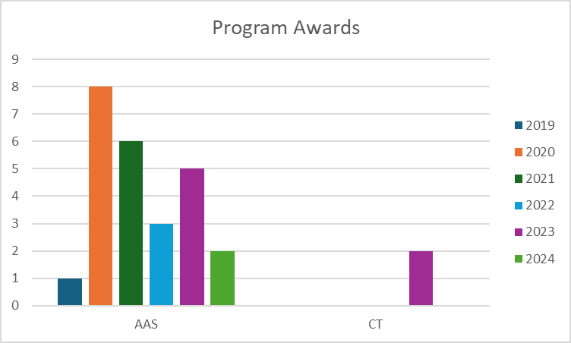

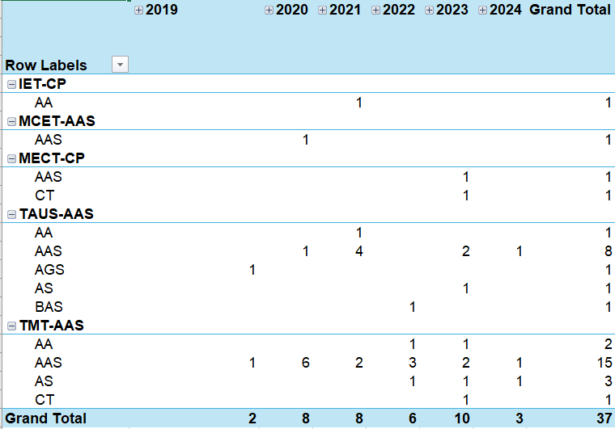
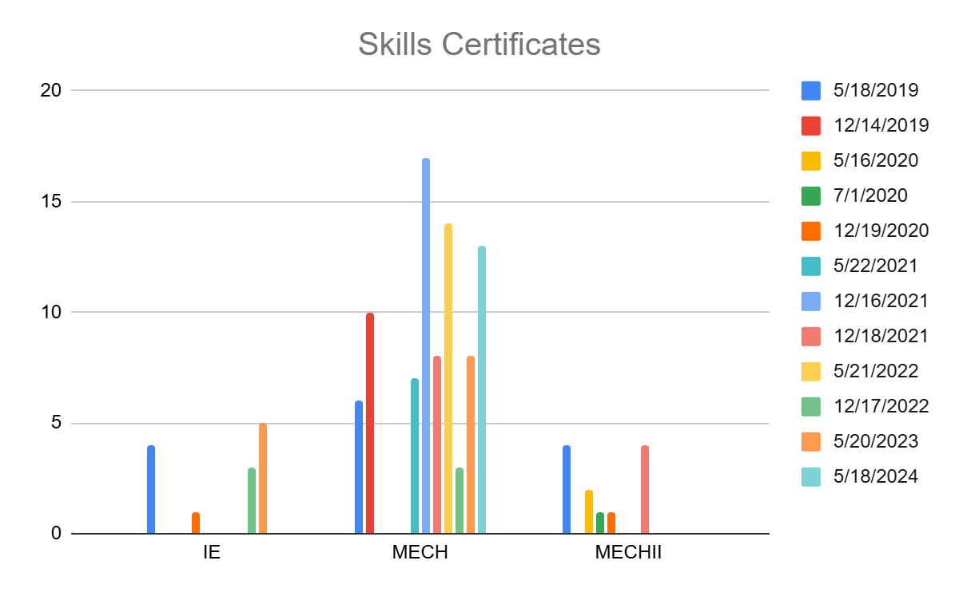

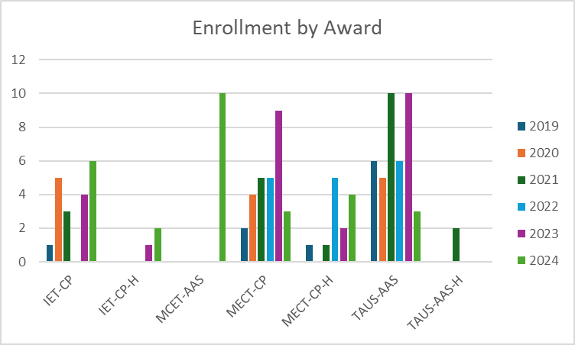

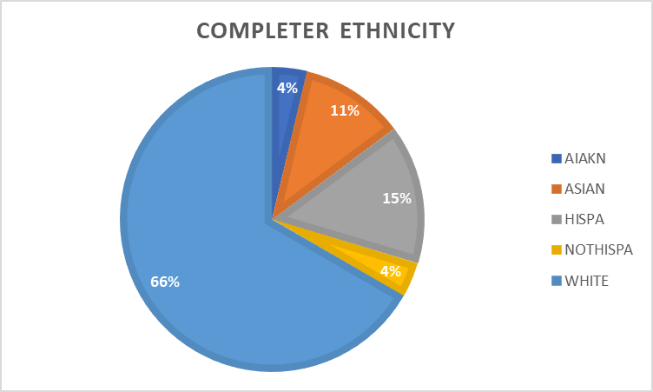

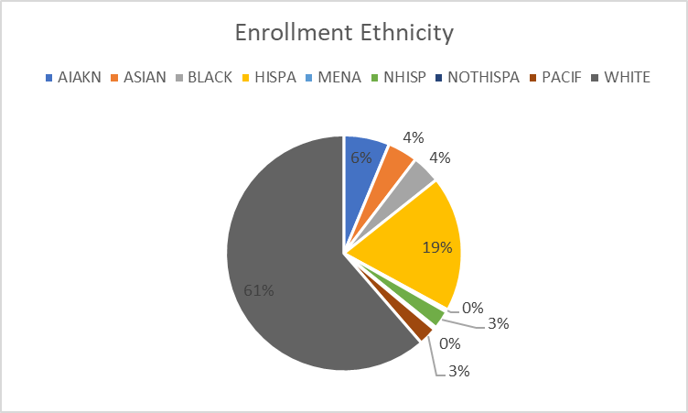

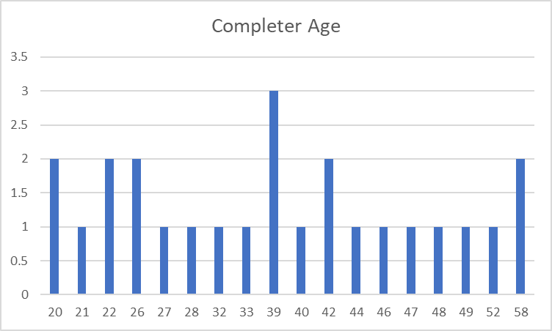

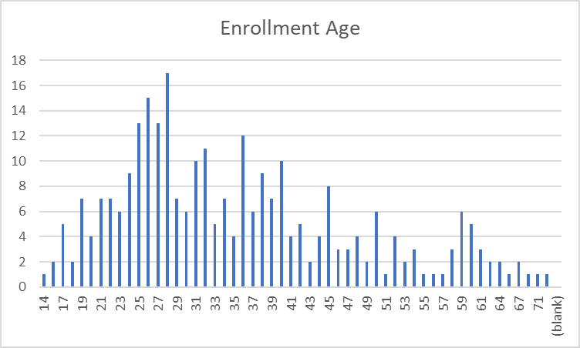

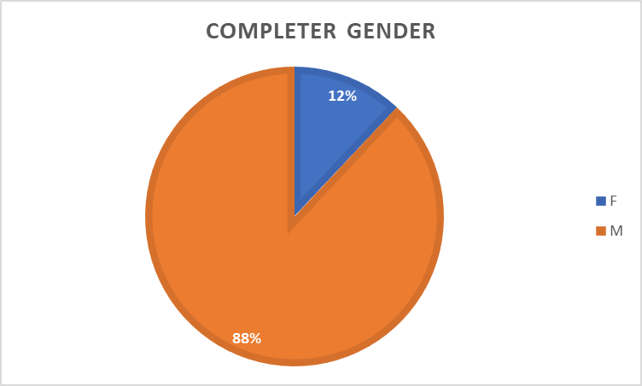

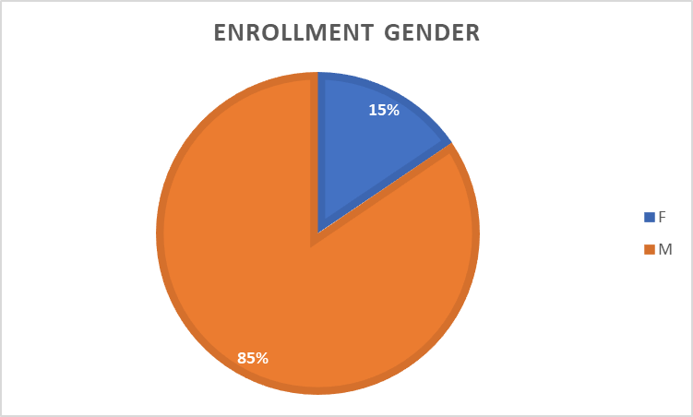

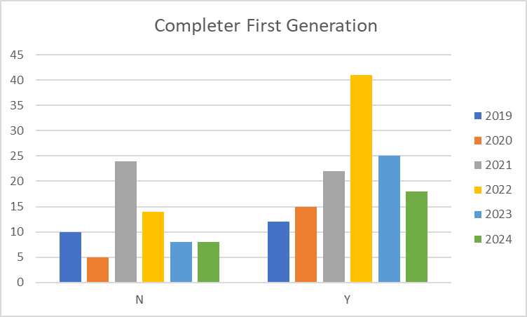

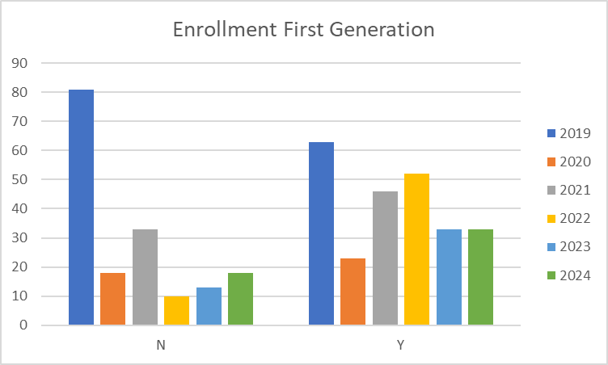

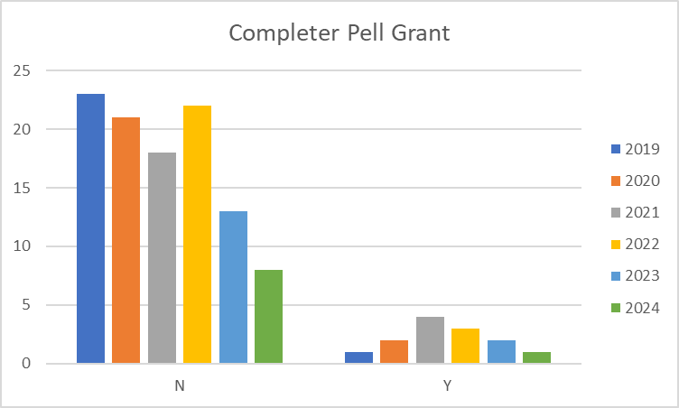

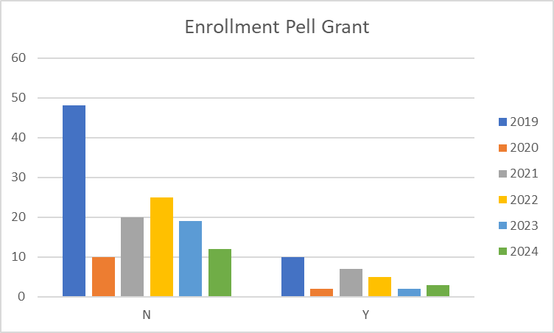

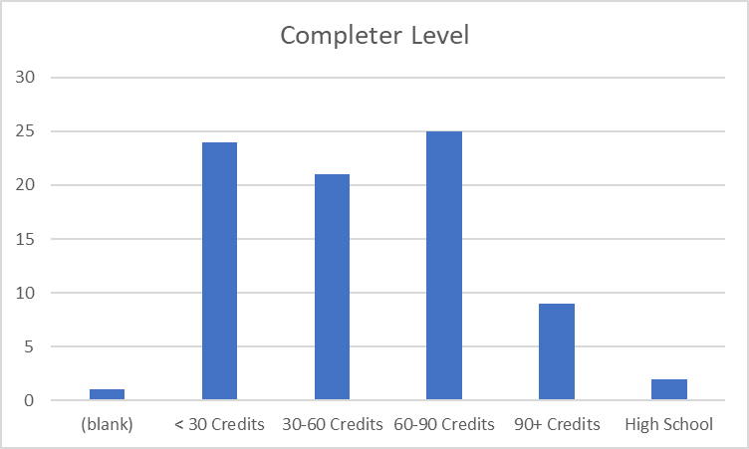

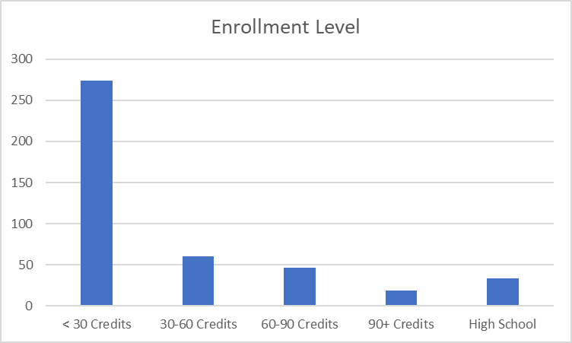

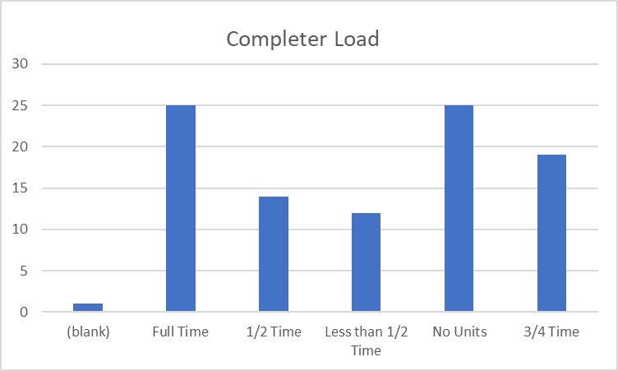

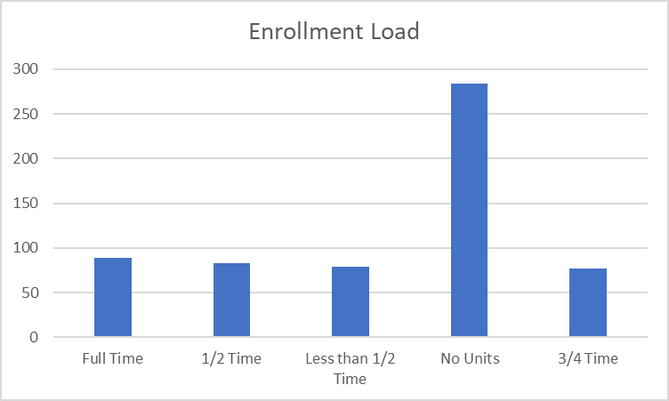

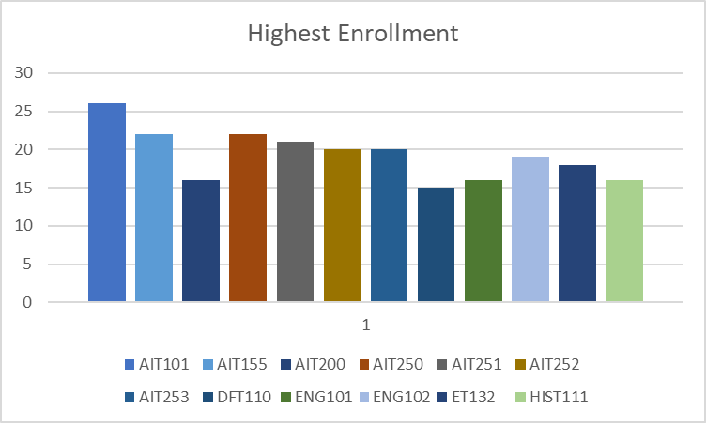

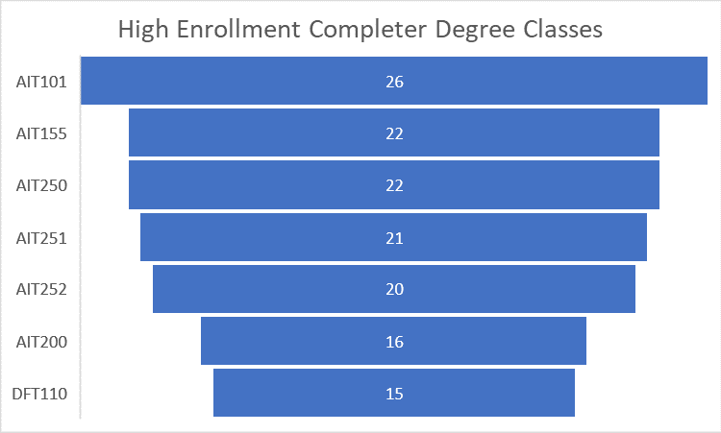

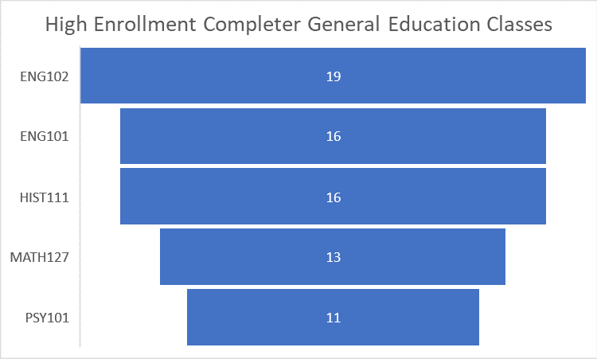

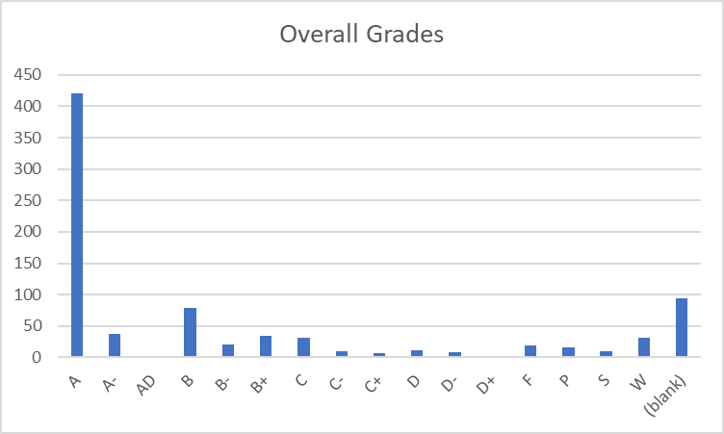

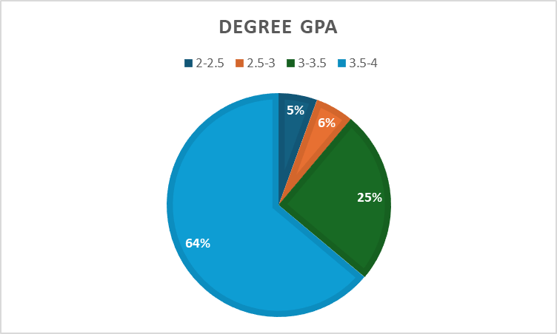
IV. Financials

- Skills Certificate:
  - Manufacturing Technician
    - Tuition and Books – $1,745
  - Mechatronics Foundation
    - Tuition and Books – $1,612
  - Industrial Electronics Technology
    - Tuition and Books – $1,877

- Certificate of Achievement:
  - Industrial Electronics Technology
    - Tuition and Books – $3,993
  - Mechatronics
    - Tuition and Books - $3,993

- Associates:
  - Tuition and Books - $8,310

V. Additional Department Information

- Academic Advising
The advanced manufacturing programs are being combined for feedback, as they fall under the same category, which has proven to be confusing for both students and advisors. There is curiosity about enrollment numbers in these programs. While students show interest in positions at companies like Panasonic and Tesla, it can be difficult to explain how these degrees and classes will help them pursue those careers. This might indicate a need for additional education for the team, including faculty. Mechatronics, in particular, seems to be a niche focus driven by Emily Howarth, and it often requires a faculty member to guide students in that direction, likely resulting in a smaller cohort. Matt Anderson may be addressing this need, but communication has been limited, so it's unclear how this is progressing in the academic setting. Availability issues, especially with program electives, also remain a challenge.

- Advancement
Scholarships for the program are provided through Click Bond, the William N. Pennington Foundation, and several other supporting donors. Grant funding has also covered much of the equipment used for student training, including the $800,000+ mobile manufacturing training lab.

- Grants (Roads Workforce Liaison - Administrative Faculty Advancement, Grant Writer Advancement, Grant Administrator, Vice President of Academic & Student Affairs, Career Services Specialist)

71 students were approved for SANDI funding for Mechatronics between 2019 and 2024. The SANDI grant expired on September 30, 2024.

- CFO

Course | Total Approved Fee | Expendable Supplies
ELM 143 | $20 | $20

How course fee requests are approved:
Each year, the CFO sends out a request for any new course fees or changes to existing fees. Any new fees are then compiled and presented to the College Council for review. If a proposed fee exceeds $50, it must be approved by the Board of Regents (BOR). However, fees of $50 or less can be approved directly by the WNC College President.
Once a fee is approved or updated, the Student Finance Coordinator ensures that the new or revised fees are updated in PeopleSoft for the term when they become effective. This process ensures that students registering for these classes are charged the appropriate fee upon enrollment.
- Academic Director
In June 2023, a new director was hired after a transitional year when the division was led by an interim director. This leadership change required several adjustments within the division. Since the new director’s arrival, improvements in the department's overall effectiveness have been evident. The introduction of best practices in scheduling and communication has enhanced operational efficiency, and there has been a noticeable increase in awareness of the Western College of Technology and Education (WCTE) both on campus and in the surrounding communities. This increased visibility has contributed to a more cohesive and effective program.
The department is organized with a Director overseeing the entire division, which includes faculty in several areas such as Graphic Design, Business, Education, Criminal Justice, Aviation, EMS, Fire Science, Agriculture, Computer Information Technology, and Health/PE. The Director is supported by an Administrative Assistant IV, who handles a variety of administrative functions. To further improve operational efficiency, the division has recently expanded its team. An Outreach and Training Coordinator has been hired to manage all Skilled Trade Programs, including Welding, Automotive, Machine Tools, Construction, and Advanced Manufacturing. An additional Administrative Assistant III has been added to support various programs, including Skilled Trades, Fire Science, and EMS. Additionally, an Early Childhood Education (ECE) Program Coordinator was brought on board recently to manage the numerous ECE grants at the college. This organizational structure provides dedicated oversight and support across all programs, improving overall operational efficiency.
The department is committed to maintaining instructional effectiveness through several key initiatives. The recent hiring of a new Director and an Outreach and Training Coordinator provides focused leadership and specialized management for Skilled Trade Programs. This ensures that instructional practices align with industry standards and best educational practices. The addition of an Administrative Assistant III and an Early Childhood Education Program Coordinator enhances the support structure for various programs, enabling better coordination, resource allocation, and responsiveness to instructional needs. Furthermore, the department has implemented best practices for scheduling and communication, which optimize instructional time and improve interactions between faculty, students, and stakeholders. Each program, including Skilled Trades, Fire Science, EMS, and Early Childhood Education, benefits from dedicated coordinators who ensure that instructional materials, resources, and methodologies remain up-to-date and effective. The division also actively seeks feedback from students, faculty, and industry partners to identify areas for improvement, fostering continuous enhancement of instructional strategies.
The process for assigning teaching responsibilities within the department is highly collaborative. Full-time instructors provide the Director with an overview of course assignments for the upcoming semester. The Director reviews the plan, and if any issues arise—such as negative feedback from course evaluations or student complaints—the Director works with the instructors to ensure the best-qualified faculty member is assigned to each course. Faculty workloads are typically heavy, with most full-time WCTE faculty carrying an overload due to the large number of courses required to ensure students can graduate on time. To support new faculty, the department has developed a training course in collaboration with the Learning and Innovation department. This course provides new instructors with tools to enhance their teaching effectiveness and outlines the framework for course structure and delivery at the college. All instructors are fully credentialed, either through their educational background or relevant professional experience.
The program is actively focused on recruiting and retaining underrepresented faculty and staff through targeted outreach and recruitment initiatives. This includes engaging with professional networks and organizations that support diversity in education and industry, as well as participating in job fairs and events that attract a diverse pool of candidates. Creating an inclusive and supportive work environment is also a priority, as it helps retain underrepresented faculty and staff. While several significant hires have been made recently, the department faced a loss with the departure of Juan Ramirez, a full-time Welding Instructor, which impacted the College's standing within the community. However, the hiring of new adjunct instructors is expected to help rebuild trust and restore the program’s reputation.
There is a recognized need for a second full-time instructor in CIT to help manage the growing demand for courses and support students effectively.
Until recently, additional support staff was a significant concern. However, since May, the department has been able to hire an additional Administrative Assistant, an Outreach Coordinator, and an Early Childhood Education Program Coordinator. With these new hires, the department now has adequate support staff to meet its operational needs.
Many of the department's more costly programs, such as Perkins and WINN, are funded through grants. Lab fees are used to cover consumables, but rising material costs have created challenges. The department has had to dip into its general operating budget to secure the necessary supplies for maintaining industry-standard programs.
The department regularly assesses its use of funding and human resources through reviews and strategic planning. Financial resources are monitored to ensure alignment with the program’s goals and effective utilization. Expenditures are evaluated based on their impact on student outcomes, program growth, and operational efficiency. For human resources, the department reviews faculty and staff workloads and the effectiveness of course delivery and student support services. Feedback from students, faculty, and staff is used to identify areas for improvement, ensuring that resources are optimized to meet the program's needs.
Facilities remain one of the department's biggest concerns. Some buildings have mold issues, leading to classrooms being closed just before the semester begins. Other buildings experience uncontrollable leaks that pose a risk to expensive equipment and vehicles, further complicating operations.

- Learning and Innovation

In the Fall of 2023, Learning and Innovation piloted a 16-week Canvas-based “Faculty Development” course. This course provided information on expectations for WNC instructors as well as strategies and tools for teaching effectively.
Additionally, Learning and Innovation hosts the Zoom-based “Coffee and Classroom Conversations” series that focuses on a wide range of teaching topics. This series is driven by faculty interests and WCTE faculty have regularly attended these sessions.
The Learning and Innovation team has met with WCTE faculty for support in assignment development and teaching strategies, as well offering professional development opportunities for faculty in support of student learning initiatives including the introduction of best practices for working with students in CTE fields.
Learning and Innovation also provides technical support for Canvas including help desk support and instructional design.

- ACMC
Industrial Electronics Technology CoA (IET-CP) was first adopted in Fall 2015. It was then eliminated with a last admit term of Spring 2021 in March 2021 (I could look back at curriculum notes if needed to give more detail). It was then put back in the catalog & reactivated in Fall 2023.
DATE | CHANGE/ACTION | Details
December 2020 | Award Eliminations | The following awards were eliminated due to low enrollment and low completion rates: AAS in General Industrial Technology, Certificate of Achievement in General Industrial Technology, and Certificate of Achievement in Industrial Electronics Technology
December 2020 | Award Name Change | The “Mechatronics Foundation Level I” skills certificate was renamed to “Mechatronics Level I” to better align with industry standards and expectations.
December 2020 | Award Updates | The following awards were updated to provide students with greater options in program requirements areas:  Certificate of Achievement in Mechatronics, Associate of Applied Science Technology Mechatronics, and Associate of Applied Science Technology Automated Systems
May 2022 | Course Addition | AIT 131 was added to the catalog as an elective option for AAS Technology degrees, designed to prepare students for the Basic Industry 4.0 Certification.
January 2023 | Major Program Revision | The program underwent a major revision to align more closely with industry standards and the TMCC program. Several courses were adopted to replace existing AIT courses, with new courses carrying a weight of 4 instead of 2.
January 2023 | New Courses Adopted | ELM Courses: ELM 110, ELM 112, ELM 121, ELM 127, ELM 134, ELM 136. MPT Courses: MPT 110, MPT 120, MPT 160.
February 2023 | Additional Courses Added | MPT 111 and MPT 112 were added to the catalog.
February 2023 | Award & Course Updates | Skills certificates in Industrial Electronics Technology, Manufacturing Technician, and Mechatronics Foundation; Certificate of Achievement in Mechatronics; and AAS degrees in Mechatronics and Automated Systems were updated to replace AIT courses with ELM and MPT courses, and to add the OSHA 222 course where appropriate.
February 2023 | New Award Proposals | A new Certificate of Achievement in Industrial Electronics Technology and a new AAS in Mechatronics and Electronics were proposed and adopted to ease the transition to the new program structure.
February 2023 | Award Deactivation | The Skills Certificate for AIT Mechatronics Level 2 was deactivated due to an inability to offer the required courses because of a lack of qualified teaching staff.
August 2023 | Additional Course Adoption | ELM 129 and ELM 140 were adopted.
August 2023 | Award Updates | Skills Certificates in Manufacturing Technician and Mechatronics Foundation were updated to include courses better aligned with industry standards. The Certificate of Achievement in Mechatronics was updated to provide greater options for elective requirements. The AAS Mechatronics and Electronics degree was updated to include courses that better align with industry needs and the TMCC program.
May 2024 | Credit Adjustment | The Industrial Electronics Technology Certificate of Achievement and the Industrial Electronics Skills Certificate were updated to reflect the change of ELM 110 from 4 credits to 3 credits.

- Financial Aid
Feedback from students tends to focus primarily on course delivery, conflicts with instructors, access to resources, and various learning challenges they may face. These concerns are important to address, as they directly impact the overall student experience and their ability to succeed in the program. By understanding and addressing these issues, we can improve both the quality of education and the support systems available to students.
For students pursuing the AAS-Tech degree, we observe that they are generally well supported throughout their studies. This is largely due to their close connection with their subject matter faculty, who provide guidance, mentorship, and specialized expertise. This connection seems to create a supportive environment that helps students stay engaged and succeed in their coursework.
There is discussion about whether there’s a way to track and demonstrate if students in WCTE degree programs are successfully stacking their credentials, such as earning Skills Certificates, Certificates of Achievement (COA), and ultimately completing the AAS degree. It may not have been formally reported, but it would be valuable to measure how students are progressing through these stacked credentials, as it could provide insights into the effectiveness of the program and highlight areas for improvement.
Students often declare a degree primarily to open up options for Financial Aid, even if they have no intention of completing the degree. While this practice is not entirely new, it’s something that should be noted. One area where the process falls short is in documenting whether the student has achieved their initial goal. There is a tendency to assume that if a student does not graduate with the degree, the assistance provided was a failure, even though they may have completed other objectives. This gap in tracking student outcomes could be addressed to better reflect the support students are receiving, regardless of whether they ultimately earn the degree.
Another ongoing challenge is the attraction of fraudsters to online programs, particularly those who are looking to take advantage of Financial Aid dollars. These individuals often target online programs to exploit the system, which remains a concern across many institutions.
Additionally, there are occasional issues with the approval process for certain programs, particularly when it comes to the AAS-Technology degrees, which are approved by agencies like the State Approving Agency for VA Benefits. When a new reviewer examines the catalog, there is often confusion about how to categorize the Technology emphasis or how to handle the different pathways, such as Automated Systems or CIT. While these issues can usually be resolved through conversation and clarification with the reviewer, it remains a recurring challenge that requires attention each time a new person evaluates the catalog.

- Faculty

Program Evolution and Expansion: From AIT to ELM & MPT
Two years ago, the program underwent a major transition, shifting from the AIT (Advanced Industrial Technology) curriculum to a new structure based on ELM (Electromechanical) and MPT (Manufacturing Process Technology) courses. This change came with the adoption of many courses and a renewed focus on real-world skill development.
One of the program’s biggest successes has been the Tesla Start partnership. Originally piloted as an 8-week internship, it quickly became evident that the timeframe wasn't long enough to adequately prepare students for Tesla’s expectations. The program evolved into a 16- or 17-week apprenticeship, running the full catalog (25 credits) and incorporating ELM, MPT, and OSH 222 courses. Backed by a governor’s grant (used to purchase a training trailer), the program has seen tremendous success, particularly with Tesla, and is scaling up next semester from a single 13-student cohort to two full cohorts (26 students).
In addition to its success at Tesla, the program is also making an impact as part of the Higher Education in Prison Program, currently offering two classes inside the prison system. Entry-level classes are offered throughout the year, and the team is actively developing support mechanisms for ESL students.

Student Demographics & Growth
While the program has shown strong growth among adult learners, high school enrollment is low and remains an area where there is room for growth. To promote the program at the high school level, three adjunct instructors also teach at local high schools, helping to build interest and exposure. The program already has an articulation agreement with Sparks High School and is currently working on one with Fallon High School.

Industry Trends & Training Focus
Tesla, and the industry more broadly, is shifting away from PLC-driven lines toward robotics, increasing the demand for hands-on, robotics-capable training. As a result, access to training equipment is improving, though trainers remain expensive. There’s growing consensus that more practical, hands-on instruction is needed, with less emphasis on book-based learning.

Facilities & Curriculum Recommendations
Despite the program’s success, facility limitations are holding it back. One example: the instructor’s office is now used as a classroom, and mold issues and crowding have become significant concerns.
To help students better navigate the 100-level curriculum, there’s a recommendation to add prerequisite courses. These would provide a clearer path through the program and support better academic planning and course sequencing.

VI. Faculty Profiles - provide a narrative response to each of the following:

- Eric Smith
  - AAS Technology – Automated Systems from Western Nevada College
  - AAS Technology – Mechatronics Technologies from Western Nevada College
  - LP-Gas Operations Certificate
- Sam Couto
  - Associates of Science in Manufacturing Technology from TMCC
  - Level One SACA Gold Certification for Instructors
- Josh Ogg
  - Business and Industry License for Washoe County School District
  - 10 years of classroom experience with 5 years of manufacturing experience
- Jack Sato
  - Bachelor of Applied Science – Cyber-Physical Manufacturing from TMCC
  - Associate of Applied Science – Automotive Technology from TMCC
  - Certifications include:
    - SACA C-101
    - SACA C-102
    - OSHA 10
    - NC3 Fundamentals of DC
    - NC3 Fundamentals of AC
    - NC3 Fundamentals of PLC-Allen Bradley
    - NC3 Precision Measurement Instruments 1-6

VII. Comparisons - provide a narrative response to each of the following:
- TMCC
  - Skills Certificates
    - Industrial Mechatronics
    - Industrial Communications and Data Analytics
    - Industrial Maintenance for Automation
    - Industrial Process and Maintenance Theory
    - Industrial Programming and Controls
  - Certificate of Achievement, Advanced Manufacturing and Automation
  - Associate of Applied Science, Manufacturing Technologies: Automation and Robotics
- Ed2Go - 180 hour course for $1,995 run through TMCC.

TMCC offers a more robust program with larger availability of specialization. TMCC and WNC are the only regional programs for Automation and Mechatronics training.

VIII. Recommendations and Commendations
Commendations
- This was the first time implementing the new program review process, which required assistance and participation from many individuals. Administrative departments and IT were essential in gathering necessary information and fielding questions.
- Mechatronics full-time faculty for their contributions to program history and insight into industry trends. Adjunct faculty for the program development participation.
Recommendations
- Many curricular changes have been made to this program in the last several years. We recommend not making program changes until we can assess the program as it exists now.
- This program was accidentally removed from the AAS Technology degree. We should submit the paperwork to add it again, as it is a low-yield program.

This requirement is actually 3 credits as none of the courses offered is under 3 credits.

