Program Review
Construction
2024

Table of Contents:
- Program/Program Review History
- Alignment to Institutional Goals
- Program Data
- Financials
- Departmental Information
- Faculty Profiles
- Comparisons
- Recommendations and Commendations

- Program/Program Review History
- Program Overview
  - Construction has had a varied history at WNC. This review will functionally begin with data from 2013 as that is the year the AAS Technology degree was instituted and previous programs were deactivated. That year WNC removed emphases from degrees in order to comply with NSHE completion requirements. As a result, Construction is now part of a 6-program degree including Automotive Mechanics, Computer Information Technology, Machine Tool, Mechatronics Technology, and Welding.
  - The following is a list of currently offered awards in Construction:

Award | Description | Required Courses
Bachelor of Applied Science | This degree allows those who have completed an associate degree in construction technology to progress academically and earn a bachelors degree.  The Bachelor of Applied Science degree in Construction Management offers associate degree students, new students and skilled workers an educational route toward a career as a construction manager or supervisor. The 120-credit program combines knowledge in construction methods, planning and project management with business and supervisory skills. It also allows those already working in the construction field to enroll in an applicable baccalaureate degree program and expand career advancement possibilities. Students must meet with a counselor and be admitted into the program. | Business and Management Core Requirements 18 Units  BUS 101: Introduction to Business  ACC 201: Financial Accounting  Choose 3 units from the following Economics courses:  ECON 100: Introduction to Economics  ECON 102: Principles of Microeconomics  ECON 103: Principles of Macroeconomics  Choose 3 units from the following Management courses:  MGT 323: Organizational Behavior & Interpersonal Behavior  MGT 367: Human Resource Management  Choose 6 units from the following Management courses:  COM 412: Intercultural Communication  MGT 462: Changing Environments  MGT 469: Managing Cultural Diversity  Program Requirements 66 Units  CADD 100: Introduction to Computer Aided Drafting  CEM 100: Fundamentals of Construction Management  CEM 330: Soils and Foundations for Construction  CEM 350: Facility Systems Design and Construction I  CEM 432: Temporary Construction Structures  CEM 451: Construction Estimating  CEM 452: Construction Cost Control  CEM 453: Construction Scheduling  CEM 454: Heavy Construction Methods and Equipment  CEM 455: Construction Management Practice  CEM 456: Construction Management Capstone  CEM 485: Construction Law and Contracts  CONS 108: Construction Materials and Methods I  CONS 109: Construction Materials and Methods II  CONS 111: Commercial Building Codes  CONS 118: Construction Contract Documents  CONS 120: Blueprint Reading and Specification  CONS 121: Principles of Construction Estimating  CONS 205: Construction Site Safety  CONS 281: Construction Planning Scheduling and Control  CONS 451: Advanced Internship in Construction  SUR 119: Construction Surveying  General Education Requirements 36 Units  English/Communications Requirements 9  Fine Arts/Humanities Requirement 3  Mathematics Requirement: MATH 126 or higher 3  Science Requirement 6  Social Sciences Requirement 3  U.S. and Nevada Constitution Requirement 3  General Electives 9
Associate of Applied Science - Technology: Construction | WNCs Construction program provides industry-specific training that addresses topics of critical importance to subcontractors, general contractors, superintendents and project managers. Students will study contract administration, coordination, negotiation, quality control and the management of labor resources, equipment and materials.  This degree allows those who have completed an associate degree in construction technology to progress academically and earn a bachelors degree. | CADD 100: Introduction to Computer Aided Drafting  CEM 100: Fundamentals of Construction Management  CONS 108: Construction Materials and Methods I  CONS 109: Construction Materials and Methods II  CONS 111: Commercial Building Codes  CONS 118: Construction Contract Documents  CONS 120: Blueprint Reading and Specification  CONS 121: Principles of Construction Estimating  CONS 205: Construction Site Safety  CONS 281: Construction Planning Scheduling and Control  CONS 290: Internship in Construction  SUR 119: Construction Surveying  General Education Requirements (24 credits)  English/Communications (6)  Human Relations (3)  Recommended BUS 110  Humanities/Social Science (3)  Mathematics: Math 126 or higher (3)  Science (3)  US/Nevada Constitution (3)  General Elective (3)
Certificate of Achievement - Construction | This certificate program prepares students for careers in the construction industry, from entry-level to management/supervision opportunities. Students completing this certificate will be ready to advance to management careers that include foreman, site supervisor, planner, scheduler, estimator and more. | CEM 100: Fundamentals of Construction Management  CONS 108: Construction Materials and Methods I  CONS 205: Construction Site Safety  CONS 109: Construction Materials and Methods II  CONS 111: Commercial Building Codes  CONS 118: Construction Contract Documents  CONS 120: Blueprint Reading and Specification  General Education Requirements: 10-12 credits  English/Communications (6)  Mathematics: MATH 110 or higher (3)  Human Relations (1-3)
Certificate of Achievement - Heating, Ventilation, Air Conditioning (HVAC) | The HVAC program prepares students for a heating and air conditioning industry career. Students completing the certificate are ready to begin careers in HVAC installation, troubleshooting and repairing HVAC systems. | AC 102: Refrigeration Theory  AC 106: Residential Gas Heating  AC 107: Electrical and Controls for HVAC  AC 113: Schematic Reading for HVAC/R  AC 150: Base Refrigeration Servicing  General Education Requirements: 7-9 credits  English/Communications (3)  Mathematics (3)  Human Relations (1-3)
Skills Certificate: Heating, Ventilation, Air-Conditioning/Refrigeration | The skills certificate in HVAC prepares students for a heating and air conditioning industry career. Gain skills, knowledge and experience preparing for the in-demand jobs installing, troubleshooting and repairing HVAC systems. | AC 102: Refrigeration Theory  AC 107: Electrical and Controls for HVAC  AC 113: Schematic Reading for HVAC/R
Skills Certificate: Construction Gateway | These courses prepare students for the National Center for Construction Education and Research (NCCER) Construction Craft Laborer credential, which certifies that individuals possess basic knowledge needed on any jobsite. | CEM 100: Fundamentals of Construction Management  CONS 108: Construction Materials and Methods I  CONS 120: Blueprint Reading and Specification  CONS 205: Construction Site Safety  MATH 110: Mathematics for Industry
Skills Certificate: Construction Skills | This certificate builds on the Construction Gateway, teaching more advanced construction methods, understanding building codes and reaching contract documents. The required internship allows students to apply new concepts in a work environment (for those already working, this can be aligned with current job responsibilities). | BUS 107: Business Speech Communications  or ENG 101: Composition I  CONS 109: Construction Materials and Methods II  CONS 111: Commercial Building Codes  CONS 118: Construction Contract Documents  CONS 290: Internship in Construction

BAS Course Sequence

Associate of Applied Science in Construction Course Sequence
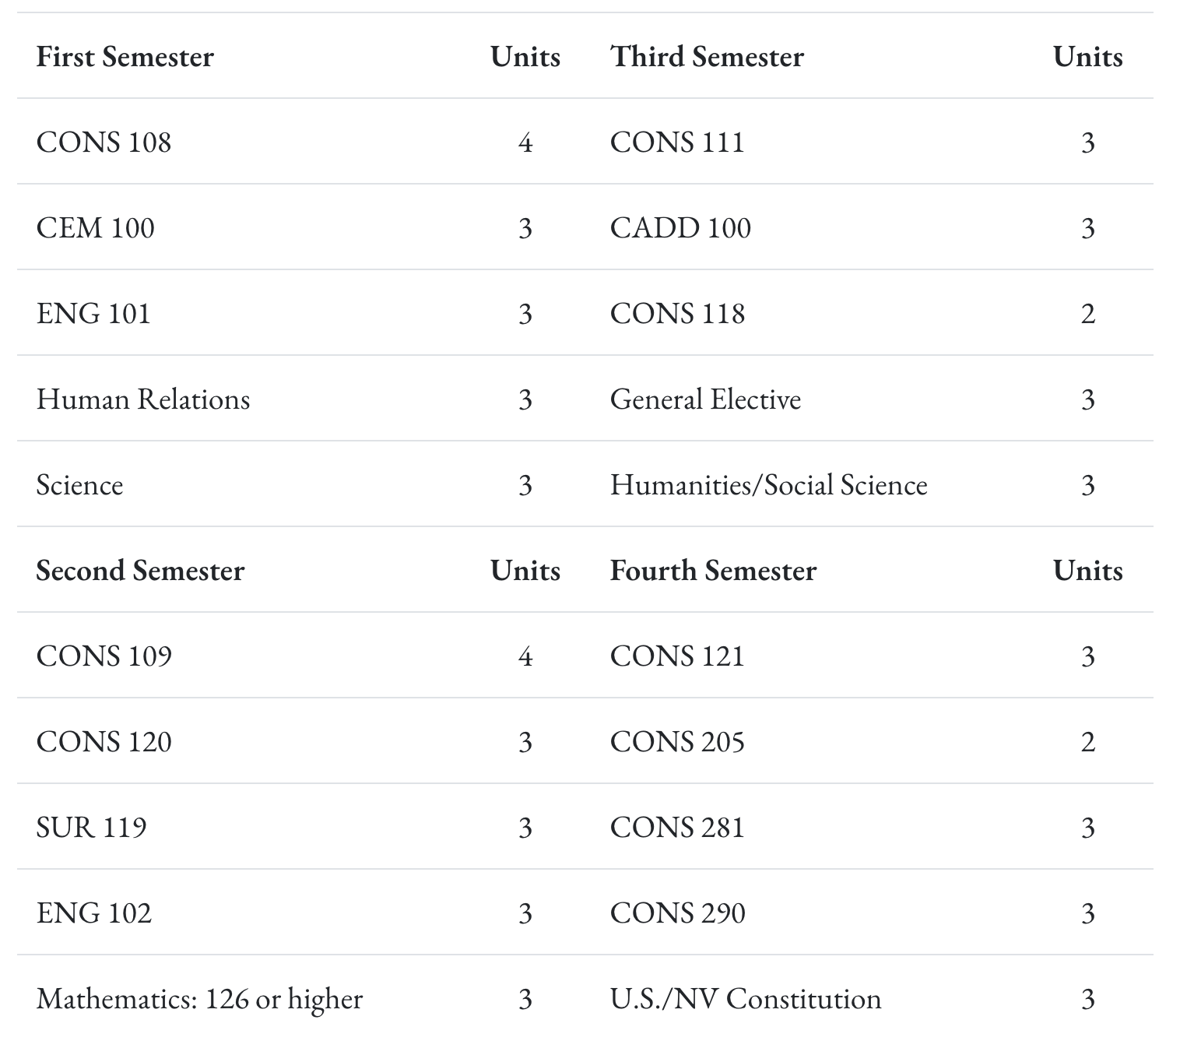

Certificate of Achievement in Construction Course Sequence

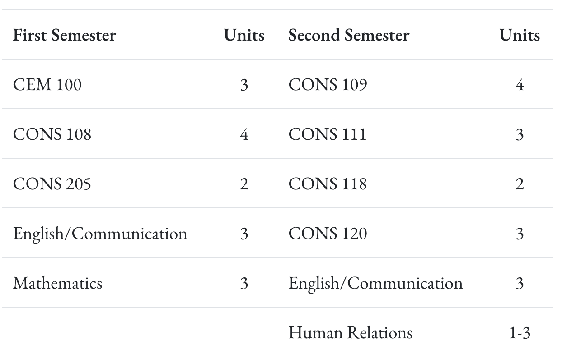

- Program Review History
  - A brief review was done in 2018 utilizing a previous program review template (previous program reviews have not included the BAS degree). At that time, Construction offered an Associate of Applied Science and a 30-hour OSHA Safety Card. There have been significant curricular changes since the last program review. Concerns noted in the 2018 review include the following:
    - Increases to the number of relevant business and management courses required for the degree.
    - The lack of relevant Marketing support in high-profile locations.
    - Eliminating the barriers that are hindering the success of the Construction Jump Start program.
    - Providing competent adjunct instructors in courses that previously were filled by individuals filling voids in the schedule without the necessary knowledge or skill sets to cover the subject matter in the correct way.
    - Student learning outcomes need to be expanded to include leadership and team building, and management requirements associated with construction management.

II. Alignment to Institutional Goals

WNC | Construction
Vision: WNC is an integral and innovative educational partner fostering equity and a life of learning in an exclusive environment for the evolving, diverse community we serve.  Values: WNC is student centered, inquiry driven and data informed as we nurture community connections and promote an environment of equity and inclusion.  Mission: WNC contributes to solutions for the 21st century by providing effective educational pathways for the students and communities of Nevada. | WNC’s Construction program provides training for a wide range of skills and certifications needed for entry and advancement in the building trades industry. Students will study contract administration, job coordination, negotiation and communication, quality control, and management of resources to include labor, equipment, materials and budget.  The Construction Certificate of Achievement and Associate of Applied Science degree provide students with a broad-working knowledge of the construction industry. This positions students for entry into the field or, for those already working, opens opportunities for career advancement or further study in Construction Management (see WNC Bachelor of Applied Science). Students will develop trade-related skills, apply safety practices, understand construction documents and practice effective communication and management.  Mission: The mission of the Associate of Applied Science in Technology is to provide employment-related knowledge and skills necessary to succeed as a professional in a chosen field of study.
WNC Student Learning Outcomes:  - CONTENT KNOWLEDGE: Demonstrate understanding of essential information and concepts relevant to a discipline or area of study.  - COMMUNICATION: Effectively convey and/or interpret a central idea via visual, oral, or written media.  - QUANTITATIVE LITERACY: Correctly analyze, interpret, draw conclusions from, and communicate quantitative processes and information.  - INFORMATION LITERACY: Locate, evaluate, and appropriately use information from multiple resources in support of a claim or central idea.  - DIVERSITY AND SOCIETY: Identify and discuss changing human societies demonstrating an understanding of the subject and respect for various cultural, methodological, and/or theoretical perspectives.  - CRITICAL THINKING: Integrate knowledge and skills to develop logical conclusions and/or solutions that demonstrate a well-reasoned evaluation of a problem, question, perspective, or solution.  - CAREER PREPARATION: Apply specialized knowledge, approaches, and skills to successfully complete projects and/or demonstrate relevant professional and/or industry-standard competencies | BAS Student Learning Outcomes:  - Knowledge in basic economic principles, business principles and construction accounting, finances and law.  - Exposure to the design theory and analysis of construction practices and systems.  - Understanding of the utilization of available resources for construction planning, methods and materials.  - Understanding, skill and knowledge of construction documents, communications, graphics and surveying.  - Skill and knowledge in construction accounting, estimating and bidding practices.  - Ability to plan and schedule construction projects.  - Application of relevant administrative skills, ethics, safety practices and problem-solving techniques to construction management.  AAS Student Learning Outcomes:  - Know the subject matter appropriate to the emphasis of the degree.  Have met the institutional student learning outcomes.  - Have met the institutional student learning outcomes.  - Have met the institutional student learning outcomes.  - Have met the institutional student learning outcomes.  - Have acquired skills and can perform tasks necessary for employment or career advancement.  - Have met the institutional student learning outcomes.  - Have met the institutional student learning outcomes.  AAS Technology Student Learning Outcomes:  Know the subject matter appropriate to the emphasis of the degree. (WNC SLO 1,3,6,7)  Communicate effectively and appropriately, in oral and written form. WNC SLO 2)  Locate, evaluate and properly utilize the tools and resources appropriate to a technology degree professional. (WNC SLO 1,6,7)  Acquire skills and perform tasks necessary for employment or career enhancement. (WNC SLO 1,7)  Developed an appreciation of the importance of social, ethical, legal and diversity issues. (WNC SLO 5,7)  Developed an appreciation of the need and importance of lifelong learning. (WNC SLO 1)
Content Knowledge
The Construction Program prioritizes mastery of essential subject matter within the field of construction technology (Program SLO 1). Students gain an understanding of construction materials, processes, codes, and safety regulations, reflecting WNC’s institutional expectation for students to demonstrate comprehension of discipline-specific concepts. This strong foundation supports both academic and professional development.
Communication
Effective communication is critical in the construction field for managing teams, interpreting plans, and maintaining safety and compliance. The program emphasizes oral and written communication skills (Program SLO 2), which directly align with WNC’s institutional SLO that students be able to clearly convey and interpret ideas across multiple formats, including written documentation, verbal instructions, and technical drawings.
Quantitative Literacy
Though not explicitly listed in the program outcomes, quantitative reasoning is deeply embedded in construction practices such as estimating materials, calculating loads, reading blueprints, and applying geometry to site layout. Through their training (particularly in Program SLOs 1 and 3), students apply mathematical principles in real-world scenarios, fulfilling WNC’s institutional expectation of analyzing and drawing conclusions from quantitative data.
Information Literacy
Program SLO 3 calls on students to locate, evaluate, and utilize tools and resources appropriate to construction technology. This requirement reflects WNC’s institutional goal of developing information literacy, as students must learn to research building codes, construction innovations, safety regulations, and sustainable practices. Proper use of technical manuals, software tools, and industry databases supports evidence-based decisions and practices.
Diversity and Society
The construction industry operates within diverse cultural and regulatory environments. Program SLO 5 helps students develop an appreciation for the ethical, legal, and societal implications of construction, such as workplace safety, equal employment opportunities, and community impact. This outcome supports WNC’s institutional objective of fostering respect for social and cultural perspectives, as well as understanding the broader societal role of construction professionals.
Critical Thinking
Construction students are continually required to assess situations, troubleshoot issues, and develop project solutions—skills emphasized in Program SLOs 1 and 3. These tasks require integrating knowledge and applying it logically in hands-on and often high-stakes environments. This aligns with WNC’s institutional SLO for critical thinking, as students develop sound evaluations and solutions in response to complex technical challenges.
Career Preparation
Career readiness is central to the Construction Program, with outcomes that focus on the development of specialized skills, hands-on experiences, and professional competencies aligned with industry standards. Students complete projects and certifications that prepare them for immediate entry into the workforce, supporting WNC’s goal to provide applied learning that leads to viable career paths.

WNC Institutional Objectives | Construction
WNC provides access to educational pathways and opportunities | - Annual headcount has gone up significantly in the last 2-3 years.  - Courses are offered in a variety of modes, including open entry/open exit, hybrid models, and online classes.  - Students can obtain stackable skills certificates, COA’s, Associates and Bachelors of Applied Science Degrees/Certificates.
WNC students make an efficient transition from preparatory to college level coursework | WNC’s program aligns with the Nevada Department of Education (NDE) high school CTE program so that students are able to earn college credit for skills and competencies they master in high school and seamlessly continue toward a certificate or degree after graduation.  For students seeking to start the program after graduation, Nevada’s current graduation and GDE requirements adequately prepare students
WNC provides equitable access for students regionally and demographically | - Many foundational construction classes are offered in an open entry, online model for students to access wherever they are located.  - Good range of age groups represented in Construction classes, including many 25 and older.
WNC provides access to dual credit pathways | - Partnered with Silver Springs High School to provide CONS 108 and CONS 109 in a dual enrollment format
WNC supports student learning, progress, and completion | - Full time instructor advises many of his students so there is a good retention rate between the Associates and Bachelor programs  - Stackable skills certificates which lead to COA and Associates degrees/certificates
WNC advances student achievement of learning outcomes at course, program, and institutional levels | 85% of students demonstrate proficiency in core competencies such as blueprint reading, construction safety, material estimation, and structural framing.
WNC builds student engagement with education and the WNC community | - Full time instructor has multiple projects outside of the classroom setting for students to participate in. For example they just helped out at a nursing home by hanging and fixing items, and also built a wall for a community center in Genoa.
WNC identifies and closes achievement gaps across student populations by supporting achievement across demographic groups in traditional and non-traditional fields
WNC sustains a learning environment that promotes equity and inclusion
WNC responds to the needs of industry and provides effective pathways for students toward in-demand occupations | Twice a year advisory board meetings with a dozen industry representatives that help guide curriculum, and point students in the right direction for in-demand occupations.
WNC contributes to solutions to the critical issues facing 21st century Nevada | Partnerships with multiple construction companies that allow students the opportunity to learn while on the job.

Analysis of Alignment:

Many of the General Education and program-specific classes are aligned to Institutional SLOs. Several have no alignment listed and should be reviewed.

Curriculum Map

III. Program Data

Bachelor’s Degree:

Associate’s Degree, Certificates of Achievement, and Skills Certificates:
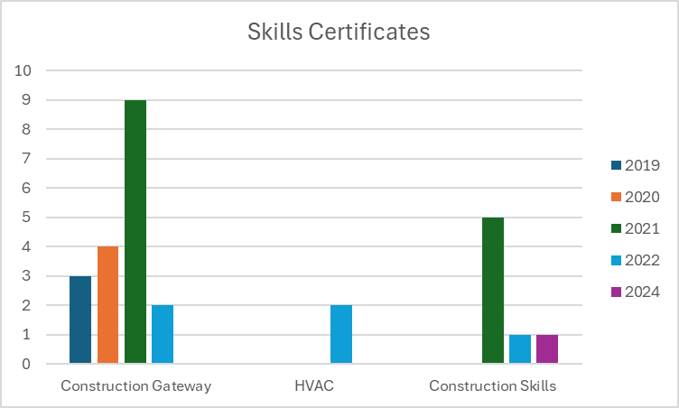

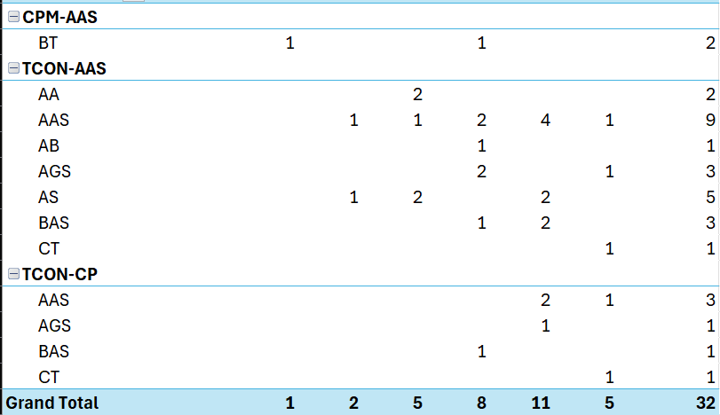

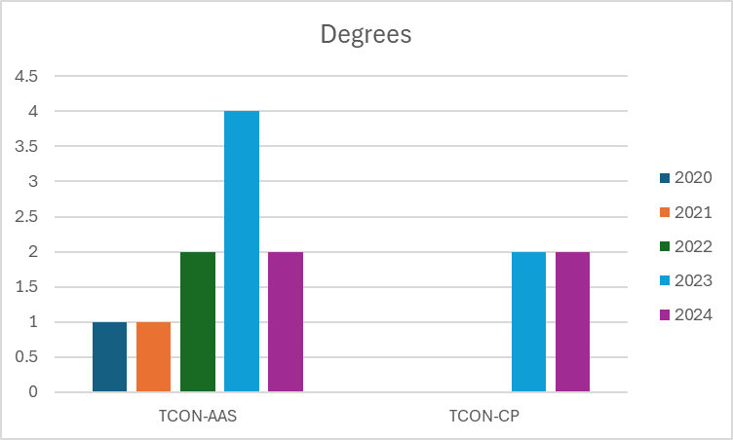

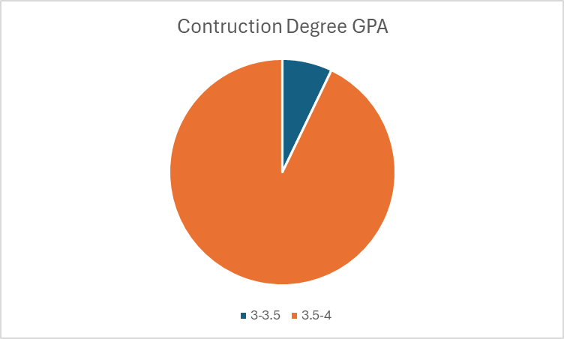

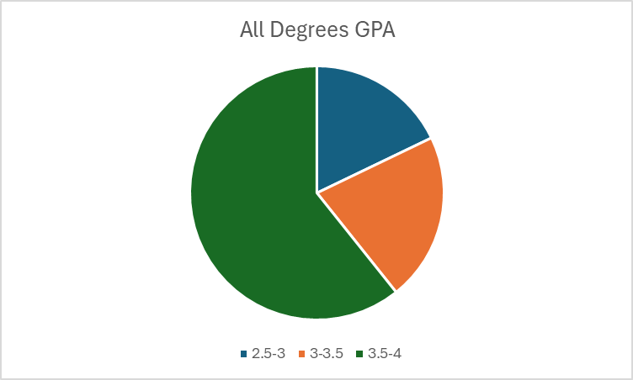

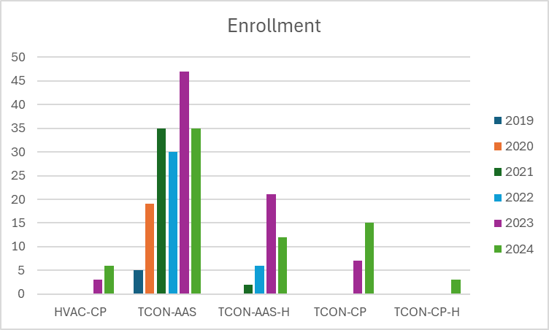

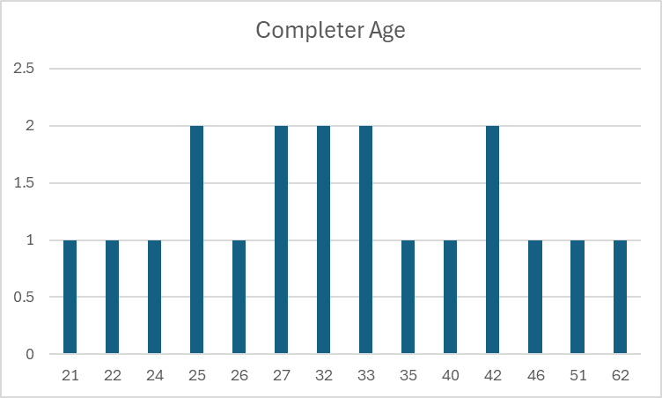

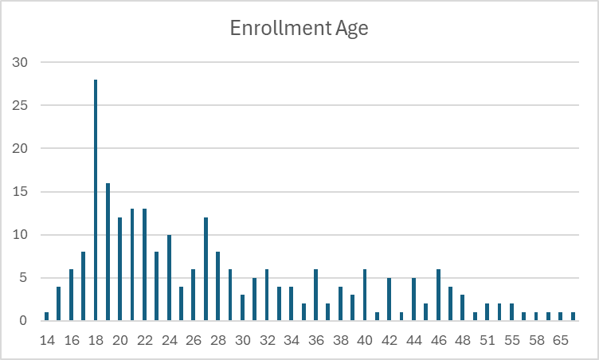

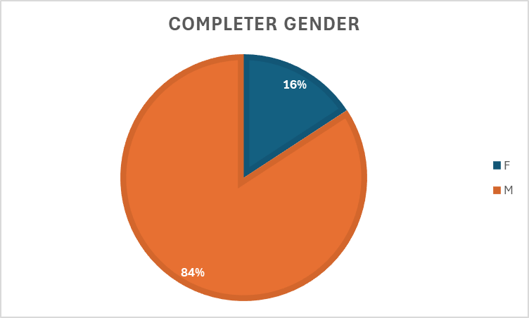

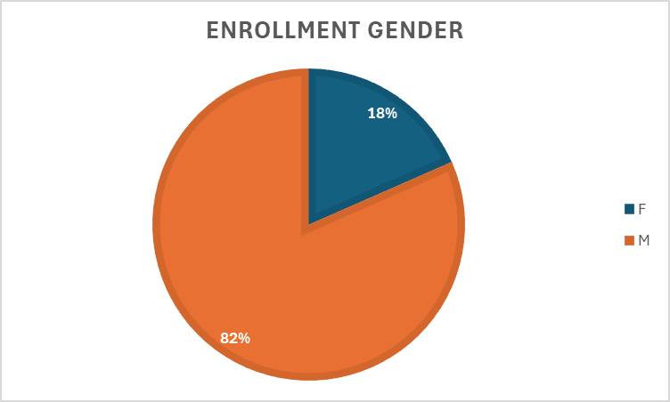

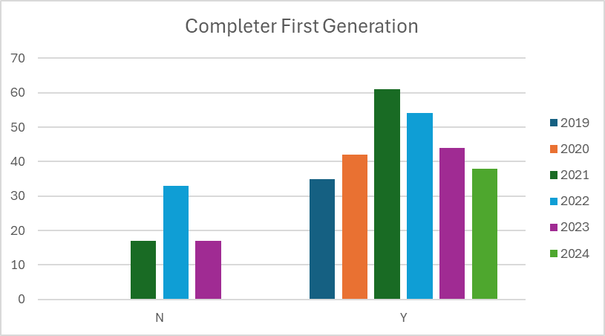

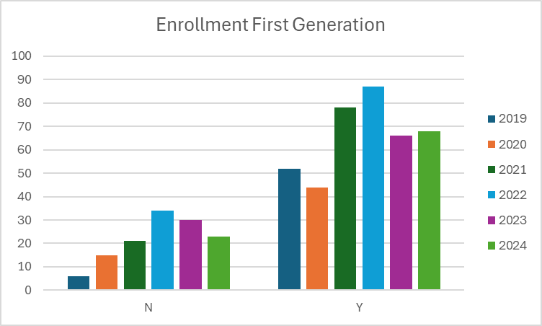

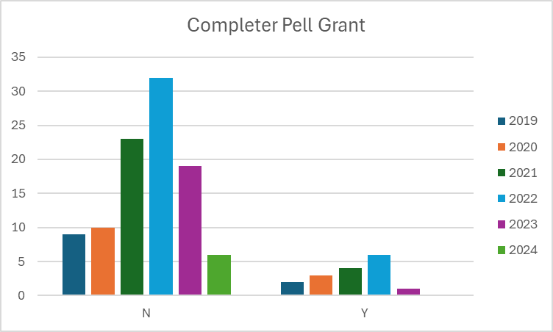

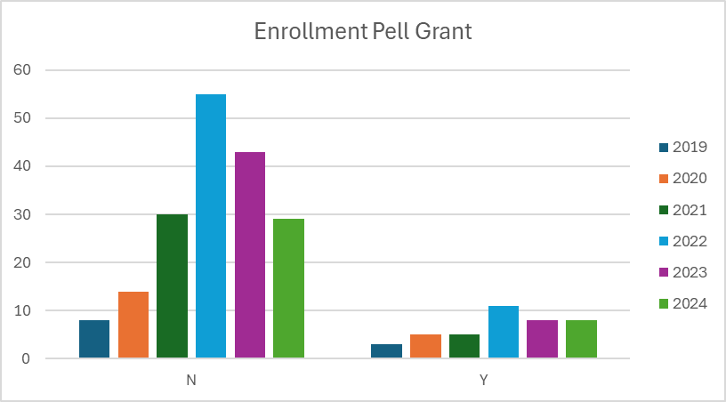

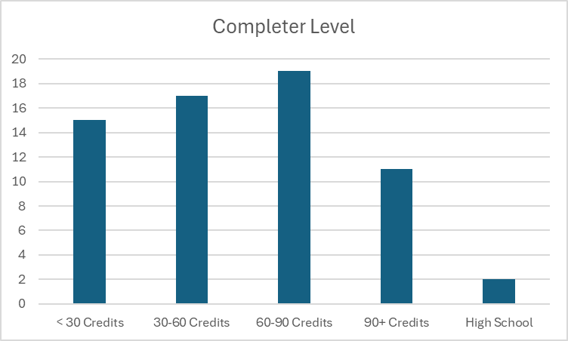

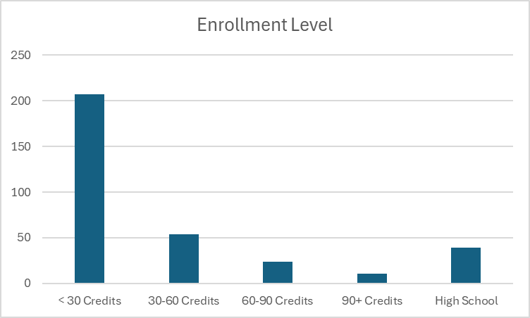

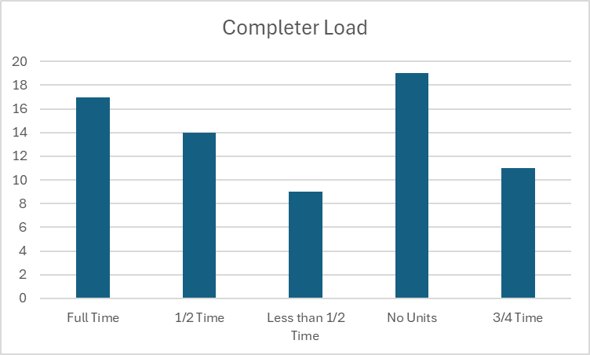

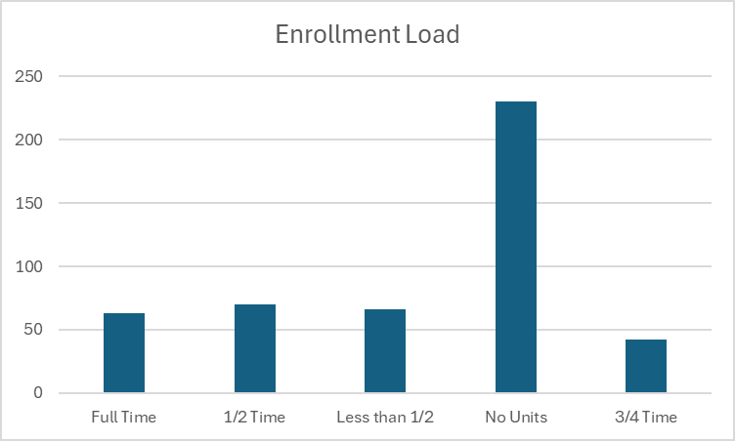

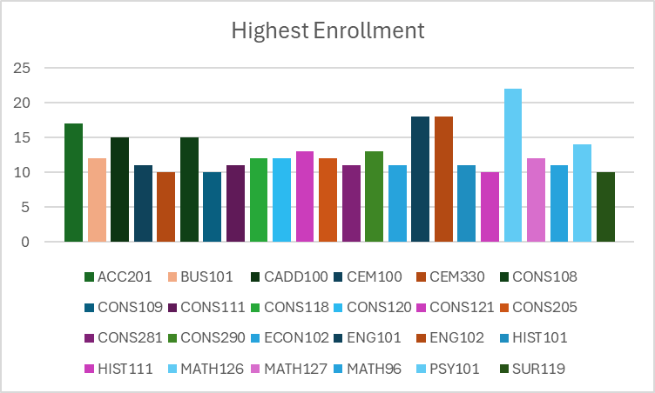

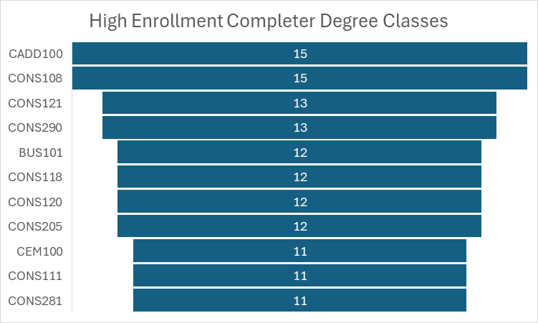

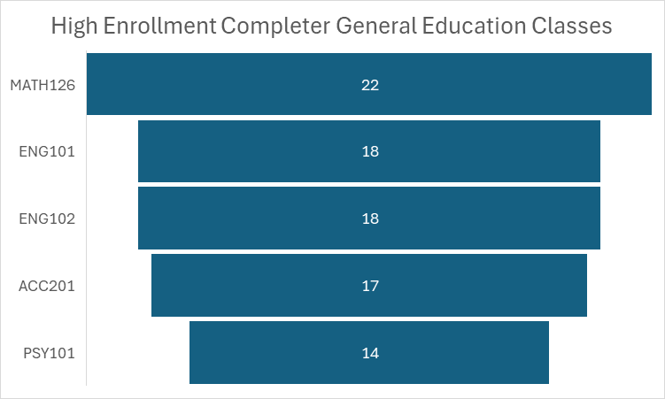

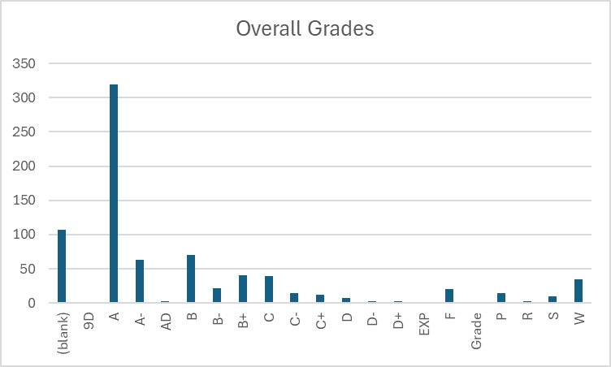

IV. Financials

The following financials provide insight into the costs to students when completing awards in this program:

- Skills Certificate:
  - Construction Gateway
    - Tuition and Books – $2,220
  - Construction Skills
    - Tuition and Books - $2,220

- Certificate of Achievement:
  - Tuition and Books - $4,690
- Associates:
  - Tuition and Books - $8,460
- Bachelor of Applied Science – Construction Management
  - Tuition and Books - $20,625

V. Additional Department Information

- Scheduling
HVAC Program Status & Instructor Prospect
- Program Hiatus
No HVAC courses have been offered since Spring 2022, following the passing of our adjunct instructor, Clifton Uren.
- Potential New Instructor
Jeff Gomes, owner of Oasis Heating & Cooling in Fallon, is planning to retire and is interested in teaching. He’s considering joining WNC as an HVAC instructor beginning in Fall 2026.

- Advancement
A $50,000 grant from NV Energy will enable the program to purchase new, state-of-the-art construction equipment for student training, along with smaller models designed to mimic the structure of large buildings.

- CFO

Course | Total Approved Fee | Expendable Supplies | Computer Lab Fee
AC 106 | $50 | $50
AC 107 | $50 | $50
AC 150 | $50 | $50
CADD 100 | $30 |  | $30
CADD 105 | $30 |  | $30
CADD 120 | $30 |  | $30
CADD 200 | $30 |  | $30
CADD 220 | $30 |  | $30
CADD 225 | $30 |  | $30
CADD 230 | $20 |  | $20
CADD 231 | $20 |  | $20
CADD 245 | $30 |  | $30
CONS 108B | $15 | $15
CONS 114B | $15 | $15
CONS 116B | $10 | $10
CONS 118B | $15 | $15
CONS 120B | $15 | $15
CONS 121B | $15 | $15
CONS 216B | $35 | $35
CONS 230B | $10 | $10
CONS 281B | $15 | $15

How course fee requests are approved:
Each year, the CFO sends out a request for any new course fees or changes to existing fees. Any new fees are then compiled and presented to the College Council for review. If a proposed fee exceeds $50, it must be approved by the Board of Regents (BOR). However, fees of $50 or less can be approved directly by the WNC College President.
Once a fee is approved or updated, the Student Finance Coordinator ensures that the new or revised fees are updated in PeopleSoft for the term when they become effective. This process ensures that students registering for these classes are charged the appropriate fee upon enrollment.
- Academic Director
In June 2023, a new director was hired after a transitional year when the division was led by an interim director. This leadership change required several adjustments within the division. Since the new director’s arrival, improvements in the department's overall effectiveness have been evident. The introduction of best practices in scheduling and communication has enhanced operational efficiency, and there has been a noticeable increase in awareness of the Western College of Technology and Education (WCTE) both on campus and in the surrounding communities. This increased visibility has contributed to a more cohesive and effective program.
The department is organized with a Director overseeing the entire division, which includes faculty in several areas such as Graphic Design, Business, Education, Criminal Justice, Aviation, EMS, Fire Science, Agriculture, Computer Information Technology, and Health/PE. The Director is supported by an Administrative Assistant IV, who handles a variety of administrative functions. To further improve operational efficiency, the division has recently expanded its team. An Outreach and Training Coordinator has been hired to manage all Skilled Trade Programs, including Welding, Automotive, Machine Tools, Construction, and Advanced Manufacturing. An additional Administrative Assistant III has been added to support various programs, including Skilled Trades, Fire Science, and EMS. Additionally, an Early Childhood Education (ECE) Program Coordinator was brought on board recently to manage the numerous ECE grants at the college. This organizational structure provides dedicated oversight and support across all programs, improving overall operational efficiency.
The department is committed to maintaining instructional effectiveness through several key initiatives. The recent hiring of a new Director and an Outreach and Training Coordinator provides focused leadership and specialized management for Skilled Trade Programs. This ensures that instructional practices align with industry standards and best educational practices. The addition of an Administrative Assistant III and an Early Childhood Education Program Coordinator enhances the support structure for various programs, enabling better coordination, resource allocation, and responsiveness to instructional needs. Furthermore, the department has implemented best practices for scheduling and communication, which optimize instructional time and improve interactions between faculty, students, and stakeholders. Each program, including Skilled Trades, Fire Science, EMS, and Early Childhood Education, benefits from dedicated coordinators who ensure that instructional materials, resources, and methodologies remain up-to-date and effective. The division also actively seeks feedback from students, faculty, and industry partners to identify areas for improvement, fostering continuous enhancement of instructional strategies.
The process for assigning teaching responsibilities within the department is highly collaborative. Full-time instructors provide the Director with an overview of course assignments for the upcoming semester. The Director reviews the plan, and if any issues arise—such as negative feedback from course evaluations or student complaints—the Director works with the instructors to ensure the best-qualified faculty member is assigned to each course. Faculty workloads are typically heavy, with most full-time WCTE faculty carrying an overload due to the large number of courses required to ensure students can graduate on time. To support new faculty, the department has developed a training course in collaboration with the Learning and Innovation department. This course provides new instructors with tools to enhance their teaching effectiveness and outlines the framework for course structure and delivery at the college. All instructors are fully credentialed, either through their educational background or relevant professional experience.
The program is actively focused on recruiting and retaining underrepresented faculty and staff through targeted outreach and recruitment initiatives. This includes engaging with professional networks and organizations that support diversity in education and industry, as well as participating in job fairs and events that attract a diverse pool of candidates. Creating an inclusive and supportive work environment is also a priority, as it helps retain underrepresented faculty and staff. While several significant hires have been made recently, the department faced a loss with the departure of Juan Ramirez, a full-time Welding Instructor, which impacted the College's standing within the community. However, the hiring of new adjunct instructors is expected to help rebuild trust and restore the program’s reputation.
There is a recognized need for a second full-time instructor in CIT to help manage the growing demand for courses and support students effectively.
Until recently, additional support staff was a significant concern. However, since May, the department has been able to hire an additional Administrative Assistant, an Outreach Coordinator, and an Early Childhood Education Program Coordinator. With these new hires, the department now has adequate support staff to meet its operational needs.
Many of the department's more costly programs, such as Perkins and WINN, are funded through grants. Lab fees are used to cover consumables, but rising material costs have created challenges. The department has had to dip into its general operating budget to secure the necessary supplies for maintaining industry-standard programs.
The department regularly assesses its use of funding and human resources through reviews and strategic planning. Financial resources are monitored to ensure alignment with the program’s goals and effective utilization. Expenditures are evaluated based on their impact on student outcomes, program growth, and operational efficiency. For human resources, the department reviews faculty and staff workloads and the effectiveness of course delivery and student support services. Feedback from students, faculty, and staff is used to identify areas for improvement, ensuring that resources are optimized to meet the program's needs.
Facilities remain one of the department's biggest concerns. Some buildings have mold issues, leading to classrooms being closed just before the semester begins. Other buildings experience uncontrollable leaks that pose a risk to expensive equipment and vehicles, further complicating operations.

- Learning and Innovation

In the Fall of 2023, Learning and Innovation piloted a 16-week Canvas-based “Faculty Development” course. This course provided information on expectations for WNC instructors as well as strategies and tools for teaching effectively.
Additionally, Learning and Innovation hosts the Zoom-based “Coffee and Classroom Conversations” series that focuses on a wide range of teaching topics. This series is driven by faculty interests and WCTE faculty have regularly attended these sessions.
The Learning and Innovation team has met with WCTE faculty for support in assignment development and teaching strategies, as well offering professional development opportunities for faculty in support of student learning initiatives including the introduction of best practices for working with students in CTE fields.
Learning and Innovation also provides technical support for Canvas including help desk support and instructional design.
The greatest adjustment has been the increased reliance on Zoom for the provision of training and support as well as the focus on Canvas support. Learning and Innovation has found that WCTE instructors can be reluctant to engage in professional development opportunities and may not be using Canvas to the full extent.

- ACMC

DATE | CHANGE/ACTION | DETAILS
May 2020 | Adopted AC courses for HVAC program | – Selected a series of AC courses to build an HVAC skills certificate  – Leveraged a grant awarded for HVAC program development
September 2020 | Integrated OSHA training & launched HVAC Skills Certificate | – Adopted OSH 222 for integration into Construction and other programs to meet industry requirements  – Officially created the HVAC Skills Certificate, slated to launch Spring 2021 on the Fallon campus
December  2020 | Changes to the BAS General Education Requirements. | - Remove Capstone, Combine Fine Arts/Humanities for 3 credits, Change math to be basic general requirements and if each degree needs to be more specific then it can.
December  2020 | Change to the BAS Construction Management program requirements | - Capstone courses removed from general education and embedded in program requirements; Fine Arts/Humanities combined; Math requirement to MATH 126 or Higher; Science requirement separate from the Math line and changed to 6 credits; general electives changed to 9 credits.
Spring 2021 | HVAC Skills Certificate implementation | – First cohort of HVAC Skills Certificate courses offered at Fallon campus
May 2022 | Added Certificate of Achievement in HVAC | – Introduced a stackable Certificate of Achievement in HVAC (built on top of the existing Skills Certificate)
November 2022 | Overhauled Construction-related certificates & prerequisites | – HVAC Skills Certificate credit requirement reduced from 24 → 12 to improve participation/completion  – Ramsdell Skills Certificate renamed Construction Skills Certificate and credits reduced 24 → 15 to lower cost and speed completion  – Moved courses from Construction Skills Certificate into Construction Gateway Skills Certificate to eliminate hidden prerequisites and enable single-semester completion (financial aid–eligible)  – Removed CONS 216 prerequisite for CONS 290  – Approved new Construction Certificate of Achievement to scaffold students from skills certificates up to the AAS in Construction
February 2023 | Deactivated Construction Energy Technology Skills Certificate | – Discontinued the Skills Certificate in Construction Energy Technology because required courses were no longer offered, and the underlying NV Energy initiative had ended

- Financial Aid
Feedback from students tends to focus primarily on course delivery, conflicts with instructors, access to resources, and various learning challenges they may face. These concerns are important to address, as they directly impact the overall student experience and their ability to succeed in the program. By understanding and addressing these issues, we can improve both the quality of education and the support systems available to students.
For students pursuing the AAS-Tech degree, we observe that they are generally well supported throughout their studies. This is largely due to their close connection with their subject matter faculty, who provide guidance, mentorship, and specialized expertise. This connection seems to create a supportive environment that helps students stay engaged and succeed in their coursework.
There is discussion about whether there’s a way to track and demonstrate if students in WCTE degree programs are successfully stacking their credentials, such as earning Skills Certificates, Certificates of Achievement (COA), and ultimately completing the AAS degree. It may not have been formally reported, but it would be valuable to measure how students are progressing through these stacked credentials, as it could provide insights into the effectiveness of the program and highlight areas for improvement.
Students often declare a degree primarily to open up options for Financial Aid, even if they have no intention of completing the degree. While this practice is not entirely new, it’s something that should be noted. One area where the process falls short is in documenting whether the student has achieved their initial goal. There is a tendency to assume that if a student does not graduate with the degree, the assistance provided was a failure, even though they may have completed other objectives. This gap in tracking student outcomes could be addressed to better reflect the support students are receiving, regardless of whether they ultimately earn the degree.
Another ongoing challenge is the attraction of fraudsters to online programs, particularly those who are looking to take advantage of Financial Aid dollars. These individuals often target online programs to exploit the system, which remains a concern across many institutions.
Additionally, there are occasional issues with the approval process for certain programs, particularly when it comes to the AAS-Technology degrees, which are approved by agencies like the State Approving Agency for VA Benefits. When a new reviewer examines the catalog, there is often confusion about how to categorize the Technology emphasis or how to handle the different pathways, such as Automated Systems or CIT. While these issues can usually be resolved through conversation and clarification with the reviewer, it remains a recurring challenge that requires attention each time a new person evaluates the catalog.

- Continuing Education

One student enrolled in the HVAC/R Technician program through Continuing Education using grant funding as the for-credit program was not offered at that time.

- Faculty
Regional Industry Trends
In Northern Nevada, warehouse and manufacturing facilities along the USA Parkway corridor are booming, while multifamily housing and retail development are slowing down. The region has also become a hub for data centers and power plants, driving strong demand for both skilled trades and management roles. WNC’s location and student-centered approach mean that the Construction program is well-positioned to meet the needs of the community’s growing need for qualified workers.
Program Staffing & Quality
- Nigel Harrison, our lead instructor for this program (originally hired as #2), has been covering the full load for the past 4–5 years without a replacement. While Nigel is managing the program to the best of his ability, this heavy workload means that updating program curriculum poses a significant challenge.
- We rely heavily on four adjunct instructors, meaning that our single full-time instructor is both managing the program and providing faculty support. As most adjuncts in this area have backgrounds in the field rather than in teaching, they need support with Canvas, grading, and attendance tracking.
- Despite healthy program enrollment and backing from our grant-funded advisory board, finding a full-time instructor has been a major challenge. This vacancy should be a top hiring priority as the future of this program will depend on the institution's ability to support it with adequate human resources.
Curricular & Credentialing Notes
- We used to offer a certificate for Certified Inspector of Structures that was separate from the Construction program, but it’s often assumed to be part of Nigel’s program, leading to ineffective advising to students interested in that area.
- There is currently no way to connect apprenticeship students to other construction courses. Admissions and Records caps transferred or on-the-job training credits at 15, which negatively impacts students who have workplace experience that could reasonably be considered experiential learning.
- Nigel runs OSHA trainings (for the Automation, Electronics, and Industrial Technology cohort and the prison program) and administers challenge exams, but those don’t feed new enrollments into our credit-bearing sequence.
Program Growth & Delivery
- Rapid Expansion: Over the past five years, enrollment has grown significantly. During COVID, all courses except two were transitioned online, and they remain fully remote-capable, which provides more flexibility for students and supports program completion.
- Evening Schedule: Classes begin at 4:00 PM or 4:30 PM to accommodate students working in construction during the day.
- Independent Study: For students who fall behind in the semester schedule (spring/fall), an independent study option keeps them on track.
Internships & Community Engagement
- Internship Courses: Introduced last year, there are now two internship courses for the AAS and two for the BAS. These opportunities are offered in summer, and they’ve become very popular.
- Service Projects: The program is seeing a resurgence of hands-on community work. This semester’s extra-credit projects included:
  - Completing the “honey-do” list at the senior center
Building a 12-ft wall for the City of Genoa
Industry Partnership & Advisory Board
- Guest Speakers & Board Meetings: The advisory board, composed of union and non-union industry leaders, meets once per semester (the next meeting occurs in May) and regularly brings in guest speakers.
- NV Energy Grant: Awarded a $50K grant to purchase 18 Bluebeam licenses (PDF manipulation software) at a total licensing cost of $27K for four years. These tools are now integrated into classroom instruction.

VI. Faculty Profiles - provide a narrative response to each of the following:
- Nigel Harrison
  - Bachelors degree in construction project management - western Nevada College
  - Masters degree, equity and diversity in education- UNR
  - OSHA- Authorized instructor, General industry and construction industry
  - Commercial pilots license
- Theresa Mauwee Harrowa
  - Bachelors of Applied Science – Construction Management from WNC
  - 15 year business owner of QCTS (Construction Consulting)
- Desmond Muir
  - Bachelors of Applied Science – Construction Management from WNC
  - Associate of Arts – Psychology from WNC
  - Certifications
    - Safety Health Practitioner
    - Lean Six Sigma Yellow Belt
    - OSHA 30
- Michelle Ryburn
  - Masters of Business Administration with a Concentration in Management and Leadership from University of La Verne
  - Bachelors Degree from California State University
  - 14 years of experience as a coordinator, assistant project manager and project manager for a variety of construction/electrical companies

- 64% full time, 46% adjunct

VII. Comparisons - provide a narrative response to each of the following:
- Apprenticeship Program & Partnerships
- Laborers’ Union (Local 169) Training Program (Reno, NV):
  - Serves as our primary apprenticeship pipeline.
  - Several courses within this program count toward our skills certificates.
  - Completion rates have historically been low.
- ABC (Associated Builders & Contractors) Program:
Provides a stronger completion record and higher student success.
  - Acts as a key industry partner for both credit- and non-credit pathways.
- TMCC. TMCC offers an AAS in Construction Management. The curriculum is wildly different from WNC’s AAS in Construction.
- WNC Apprenticeship Program - there is opportunity here to bridge the Apprenticeship program with the Construction program, particularly the BAS.

4-Year Degree & Recruitment Partnerships
- Unique Offering: We’re the only institution in the region offering a 4-year degree in our field, which gives us a competitive advantage.
- Outreach Lead: Crystal Lynn (AGC outreach) has connected us with key partners:
WCSD (Washoe County School District)
TMCC (Truckee Meadows Community College), which is eager to refer its graduates—since TMCC doesn’t offer a 4-year program—to our bachelor’s pathway.
- High School Pipeline: Carson High School is launching a Construction Technology program that could serve as a strong feeder; we’re exploring dual-enrollment options so their students can get a head start on college credits.
This network of industry (AGC), K-12 (WCSD, Carson HS), and higher-ed (TMCC) partners positions us to grow our bachelor’s program by capturing students at multiple entry points.

VIII. Recommendations and Commendations - provide a narrative response to each of the
following:
Commendations
- This was the first time implementing the new program review process, which required assistance and participation from many individuals. Administrative departments and IT were essential in gathering necessary information and fielding questions.
- Construction full-time faculty for their contributions to program history and insight into industry trends. Adjunct faculty for the program development participation.

Recommendations:
- The website does not link the AAS with the BAS and Certificate of Achievement for Construction. Building trades are unattached to the Construction program.
- Curricular changes:
  - Prerequisites should be reviewed.
  - Create a pathway from the Apprenticeship AAS and TMCC’s AA in Architecture to our BAS in Construction.
- Consider creating an opportunity for Apprenticeship students in Southern Nevada to participate in our BAS program. Two of the classes we offer are only currently available online (CADD 100 and CEM 453).
  - We should consider offering CADD 100 online as the software, which was once prohibitively expensive, is now available for free to students.
  - CEM 453 is available at UNLV, which students could take as non-degree seeking students, then reverse transfer the course to WNC. Possible problems: there are prerequisites for that course that are not required as part of our BAS curriculum. If those are hard flagged prerequisites, this wouldn’t work.
  - For comparison, an upper division credit at UNLV is $288.50. At WNC it is $208.50.
- Deactivate the following awards:
  - CTC-AAS - AAS Construction Tech, Craft Training: Carpentry Emphasis
  - CTE-AAS - AAS Construction Tech, Craft Training: Electrical Emphasis
  - CTP-AAS - AAS Construction Tech, Craft Training: Plumbing Emphasis
- Develop award specific objectives and an accompanying assessment plan.

BAS Construction Management and BAS Organization and Project Management were reviewed with the previous program review template in 2021 and are scheduled for their next review in 2029. At that time both of these degrees will be reviewed with the other awards in Construction and the program will be addressed holistically.
BUS 110 is listed as variable 1-3 credits.

