Program Review
Automotive Technology
2024

Table of Contents:
- Program/Program Review History…………………………………………….……..2
- Alignment to Institutional Goals…………………………………………….……….7
- Program Data………………………………………………………………………..11
- Financials……………………………………………………………………………24
- Departmental Information…………………………………………………...……....25
- Faculty Profiles……………………………………………………………………...33
- Comparisons…………………………………………………………………….......34
- Recommendations and Commendations……………………………………...…….35

- Program/Program Review History
- Program Overview
  - This review will functionally begin with data from 2013 as that is the year the AAS Technology degree was instituted and previous programs were deactivated. That year WNC removed emphases from degrees in order to comply with NSHE completion requirements. As a result, Automotive Technology is now part of a 6 program degree including Computer Information Technology, Construction, Machine Tool, Mechatronics Technology, and Welding.
  - The following is a list of currently offered awards in Automotive:

Award | Description | Required Courses
Skills Certificate: Automotive Collision Repair | These lab-based courses provide hands-on practice for inspecting damaged vehicles and mastering repair techniques to include grinding, painting and buffing. Student will learn the value of being detail-oriented, as well as communication skills for good customer service. Courses align with Automotive Service Excellence (ASE) and I-Car certifications. | AUTB 120: Automotive Collision I  AUTB 125: Automotive Collision II  AUTB 200: Automotive Refinishing I  AUTB 205: Auto Refinishing II
Skills Certificate: Automotive Mechanics - Automotive Transmission/Transaxle | These skills certificates can provide the foundation for first-time, entry-level technician jobs or for advancement. Each course has a lab and classroom component to help students master skills, as well as prepare for Automotive Service Excellence certifications in each area. Third-party industry-recognized credentials can be earned throughout the program.  A fee is associated with most exams. | AUTO 101: Introduction to General Mechanics  AUTO 115: Auto Electricity & Electronics I  AUTO 205: Manual Drivetrain and Axles  AUTO 210: Automatic Transmissions & Transaxles I  OSH 222: General Industry Safety
Skills Certificate: Automotive Mechanics - Automotive Heating & Air Conditioning |  | AUTO 101: Introduction to General Mechanics  AUTO 115: Auto Electricity & Electronics I  AUTO 160: Auto Air Conditioning and Heating  OSH 222: General Industry Safety
Skills Certificate: Automotive Mechanics - Automotive Brakes |  | AUTO 101: Introduction to General Mechanics  AUTO 115: Auto Electricity & Electronics I  Auto 145: Automotive Brakes  OSH 222: General Industry Safety
Skills Certificate: Automotive Mechanics - Automotive Electrical/Electronics Systems |  | AUTO 101: Introduction to General Mechanics  AUTO 115: Auto Electricity & Electronics I  AUTO 117: Advanced Auto Electronics  OSH 222: General Industry Safety
Skills Certificate: Automotive Mechanics - Automotive Steering and Suspension |  | AUTO 101: Introduction to General Mechanics  AUTO 115: Auto Electricity & Electronics I  AUTO 155: Steering & Suspension  OSH 222: General Industry Safety
Skills Certificate: Automotive Mechanics - Automotive Steering and Suspension |  | AUTO 101: Introduction to General Mechanics  AUTO 115: Auto Electricity & Electronics I  AUTO 225: Engine Performance I/Fuel & Ignition  OSH 222: General Industry Safety
Certificate of Achievement: Automotive Mechanics | Offers students an opportunity to acquire the necessary skills and technical theory for a successful career as an automotive mechanic. Individuals already employed in the automotive mechanics field will be able to upgrade their knowledge. | AUTO 101: Introduction to General Mechanics  AUTO 115: Auto Electricity & Electronics I  Auto 145: Automotive Brakes  AUTO 155: Steering & Suspension  AUTO 225: Engine Performance I/Fuel & Ignition  General Education Requirements: 12 credits  English/Communications (6)  Human Relations: Recommended BUS 110 (1)  Mathematics (3)  General Electives (2)
Associate of Applied Science Technology: Automotive Mechanics | This program offers students an opportunity to acquire the necessary skills and technical theory for a successful career as an automotive mechanic. Individuals who are now employed in the automotive mechanics field will be able to upgrade their knowledge. Students obtaining this associate degree will have completed courses of a very technical nature, chosen to complement each other and provide breadth and depth of diagnostic and repair skill abilities necessary to work in a service facility.  Following an extensive examination of its courses, instructors and facilities, Western has earned a certification from the National Automotive Technicians Education Foundation (NATEF). | AUTO 101: Introduction to General Mechanics  AUTO 115: Auto Electricity & Electronics I  AUTO 117: Advanced Auto Electronics  AUTO 130: Engine Reconditioning  AUTO 145: Automotive Brakes  AUTO 155: Steering & Suspension  AUTO 160: Auto Air Conditioning and Heating  AUTO 210: Automatic Transmissions & Transaxles I  AUTO 225: Engine Performance I/Fuel & Ignition  AUTO 227: Engine Performance II/Emission Control  General Education Requirements - 24 credits  English/Communications (6)  Human Relations: Recommended BUS 110 (3)  Mathematics (3)  Humanities/Social Science (3)  Science (6)  US/Nevada Constitution (3)

Associate of Applied Science in Automotive Technology Course Sequence
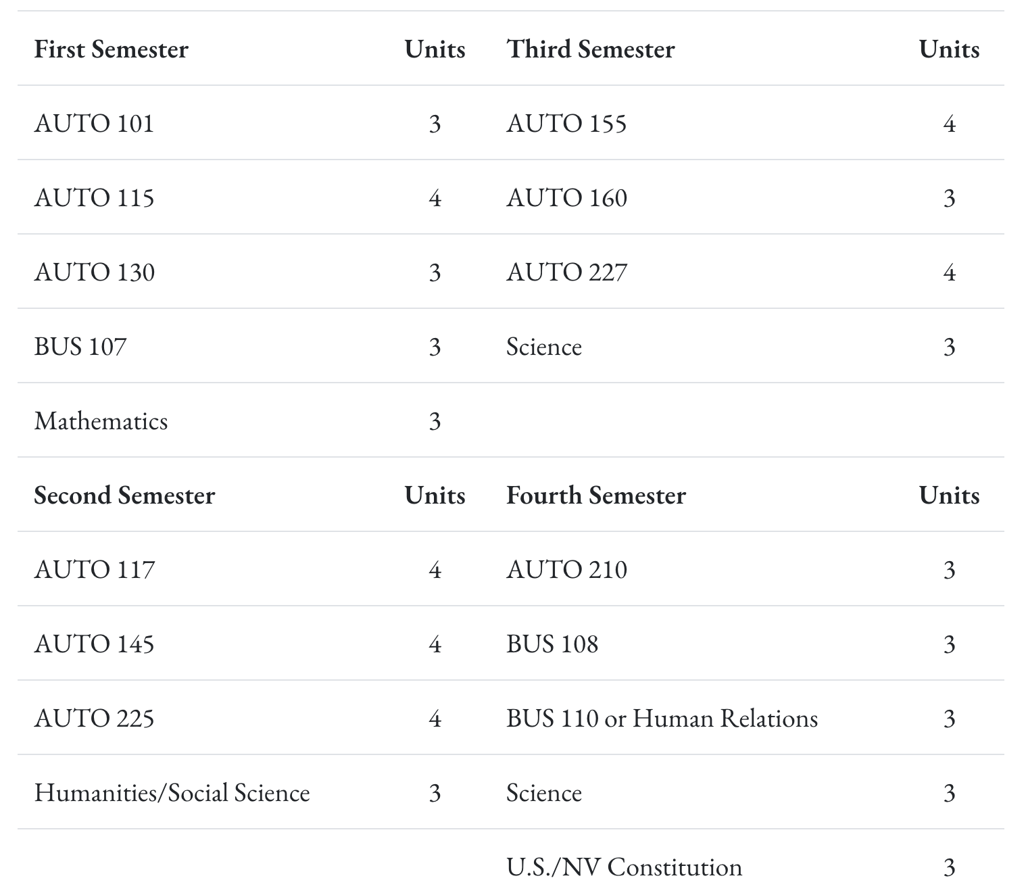

Certificate of Achievement in Automotive Mechanics Course Sequence

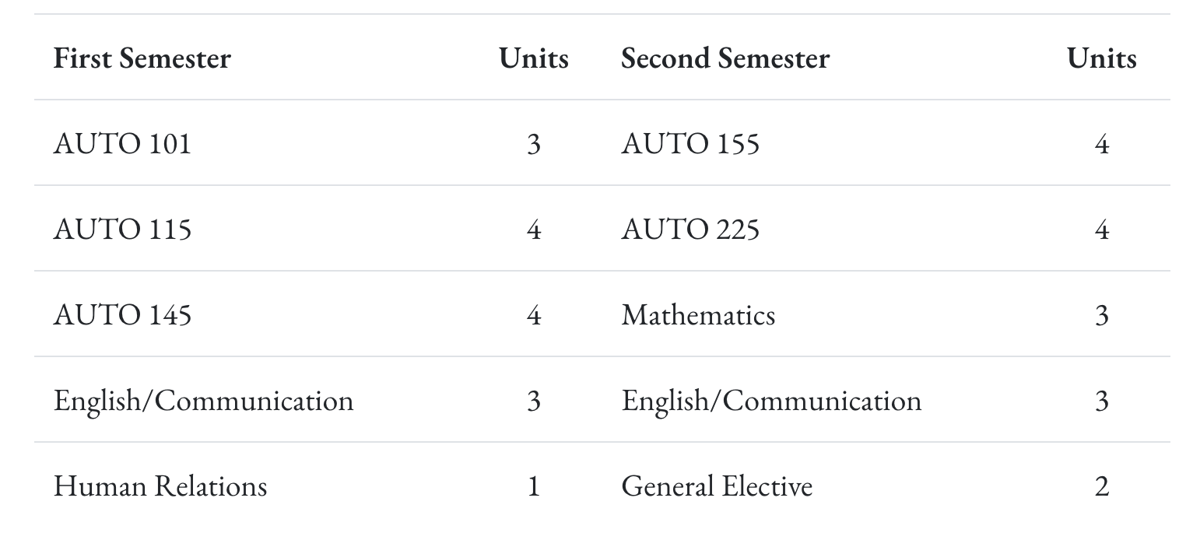

- Program Review History
  - A brief review was done in 2018 utilizing a previous program review template. At that time the program offered an AAS degree and professional certification through ASE, which WNC administered at the end of each semester. They primarily served high school students through the JumpStart automotive program and adult students who wanted to be able to gain employment after only one year of training. Concerns noted in the 2018 review include the following:
    - The need for additional full-time instructors.
    - The trend for students to have a decreasing desire to engage in physical hands-on activity.
    - They recommended shifting to an employment focused program rather than degree-based. “The industry of Automotive repair does not fit the paradigm of a degree seeking student.” This is interesting given the development of seven skills certificates and one certificate of achievement since that recommendation.

II. Alignment to Institutional Goals

WNC | Automotive Technology
Vision: WNC is an integral and innovative educational partner fostering equity and a life of learning in an exclusive environment for the evolving, diverse community we serve.  Values: WNC is student-centered, inquiry-driven, and data-informed as we nurture community connections and promote an environment of equity and inclusion.  Mission: WNC contributes to solutions for the 21st century by providing effective educational pathways for the students and communities of Nevada. | For those seeking a career in the automotive industry, WNC provides a choice between two high-demand, high-wage fields - automotive mechanics and collision repair. Both programs are accredited by the Automotive Service Excellence Education Foundation and provide access to industry-standard certifications needed for employment.  Mission: The mission of the Associate of Applied Science in Automotive Mechanics is to provide employment-related knowledge and skills necessary to succeed as a professional in a chosen field of study.
WNC Student Learning Outcomes:  - CONTENT KNOWLEDGE: Demonstrate understanding of essential information and concepts relevant to a discipline or area of study.  - COMMUNICATION: Effectively convey and/or interpret a central idea via visual, oral, or written media.  - QUANTITATIVE LITERACY: Correctly analyze, interpret, draw conclusions from, and communicate quantitative processes and information.  - INFORMATION LITERACY: Locate, evaluate, and appropriately use information from multiple resources in support of a claim or central idea.  - DIVERSITY AND SOCIETY: Identify and discuss changing human societies demonstrating an understanding of the subject and respect for various cultural, methodological, and/or theoretical perspectives.  - CRITICAL THINKING: Integrate knowledge and skills to develop logical conclusions and/or solutions that demonstrate a well-reasoned evaluation of a problem, question, perspective, or solution.  - CAREER PREPARATION: Apply specialized knowledge, approaches, and skills to successfully complete projects and/or demonstrate relevant professional and/or industry-standard competencies | AAS Student Learning Outcomes:  - Know the subject matter appropriate to the emphasis of the degree.  Have met the institutional student learning outcomes.  - Have met the institutional student learning outcomes.  - Have met the institutional student learning outcomes.  - Have met the institutional student learning outcomes.  - Have acquired skills and can perform tasks necessary for employment or career advancement.  - Have met the institutional student learning outcomes.  - Have met the institutional student learning outcomes.  AAS Technology Student Learning Outcomes:  Know the subject matter appropriate to the emphasis of the degree. (WNC SLO 1,3,6,7)  Communicate effectively and appropriately, in oral and written form. WNC SLO 2)  Locate, evaluate and properly utilize the tools and resources appropriate to a technology degree professional. (WNC SLO 1,6,7)  Acquire skills and perform tasks necessary for employment or career enhancement. (WNC SLO 1,7)  Developed an appreciation of the importance of social, ethical, legal and diversity issues. (WNC SLO 5,7)  Developed an appreciation of the need and importance of lifelong learning. (WNC SLO 1)

Analysis of alignment:

Curriculum Map

- Alignment to KPIs

WNC Institutional Objectives | Automotive Technology
WNC provides access to educational pathways and opportunities | - Enrollment Numbers (Non Dual): Fall - 98, Spring - 111  - Course Completion Rates: 95%  - Degree/Certificate Numbers 2025 - 12 skills certificate completors and 5 Certificate of Achievement completors
WNC students make an efficient transition from preparatory to college level coursework | WNC’s program aligns with the Nevada Department of Education (NDE) high school CTE program so that students are able to earn college credit for skills and competencies they master in high school and seamlessly continue toward a certificate or degree after graduation.  For students seeking to start the program after graduation, Nevada’s current graduation and GDE requirements adequately prepare students.
WNC provides equitable access for students regionally and demographically | Age Group Breakdown - Spring 25  - 18-19 years old = 7  - 20-24 years old = 16  - 25-34 years old = 6  - 35 plus years old = 9  First Generation College Students - Spring 25  - 12 students  Geographic Locations  - Students taking classes in Douglas County, Storey County, and Carson City
WNC provides access to dual credit pathways | WNC has partnered with three schools (Douglas HS, Carson HS, and Virginia City HS), which are receiving dual enrollment credit for a variety of classes. Each of these schools has a different model that WNC is using.  - Douglas HS - A WNC Instructor is teaching at Douglas High School. This instructor teaches 4 sections of Auto 101 and two sections of Auto 155 in the Fall and teaches 4 sections of Auto 115 and two sections of Auto 145 in the Spring. For students who finish the two-year pathway, they will receive 15 College Credits. Enrollment total for Fall was 102 students in Auto 101 and 46 students in Auto 155. Enrollment total for spring was 92 students in Auto 115 and 44 students in Auto 145.  - Virginia City HS - This is an affiliate taught class. 2024/25 was the first year these classes have been offered at VCHS. Students were enrolled in Auto 101 in the Fall and Auto 115 in the Spring. Enrollment totals were 42 students in the Fall and 37 students in the Spring  - Carson HS - This is a class taught by our full time Auto instructor on the WNC campus and students from Carson High School come to WNC to take the classes. These classes are 8 week accelerated courses, so students took Auto 101 and Auto 115 in the Fall, and then took Auto 145 and Auto 155 in the Spring. The Enrollment total for this cohort was 16 students.
WNC supports student learning, progress, and completion | Course Pass rates for Fall 24 was 81% across all auto classes.
WNC advances student achievement of learning outcomes at course, program, and institutional levels
WNC builds student engagement with education and the WNC community
WNC identifies and closes achievement gaps across student populations by supporting achievement across demographic groups in traditional and non-traditional fields
WNC sustains a learning environment that promotes equity and inclusion | Ethnicity breakdown for Spring Auto Classes (including dual enrollment):  - American Indian or Alaskan Native = 5  - Hispanic = 61  - Two or More Races = 22  - White = 129  Gender breakdown for Spring Auto Classes (including dual enrollment):  - Men = 202  - Women = 32  Course Accessibility  - 8 week courses  - 5 week courses  - Full semester courses
WNC responds to the needs of industry and provides effective pathways for students toward in-demand occupations | Twice a year advisory board meetings with a dozen industry representatives that help guide curriculum, and point students in the right direction for in-demand occupations.
WNC contributes to solutions to the critical issues facing 21st century Nevada | Partnerships with Carson City Toyota and Subaru of America.

III. Program Data

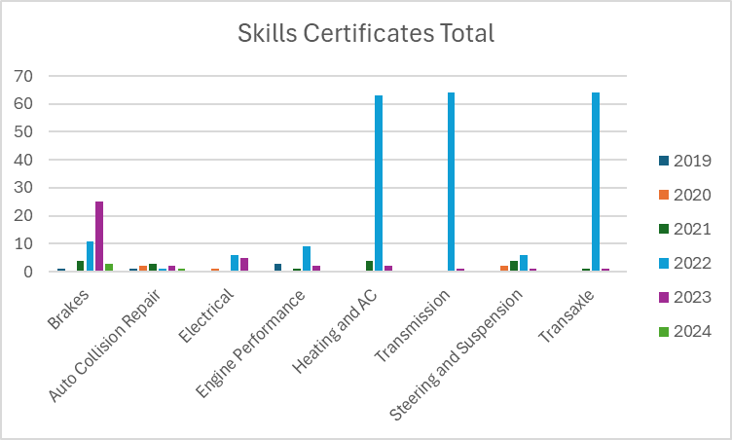

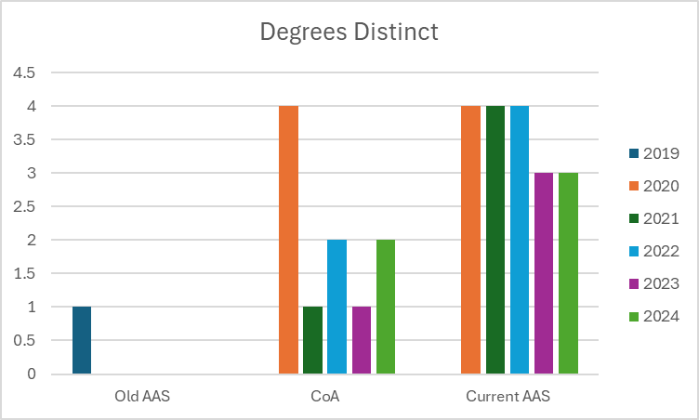

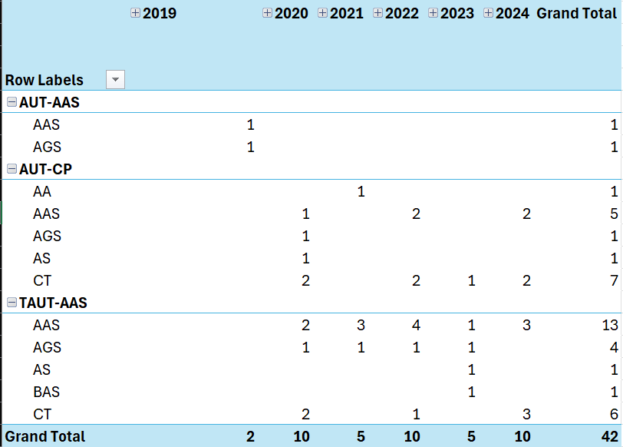
The 23 students who completed degrees in Automotive Mechanics between 2019 and 2024 earned 42 individual degrees in a variety of disciplines. Most of those who received multiple degrees earned a Certificate of Achievement and AAS, but some did earn degrees in other fields as well.
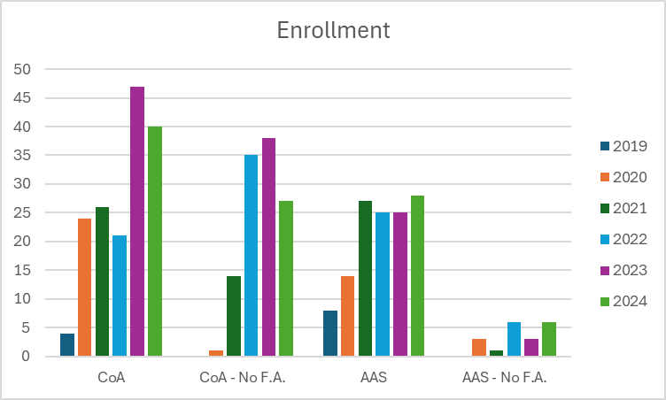

OSH 222 was added to all Skills Certificates (excluding collision repair), but was not added to the Certificate of Achievement or the AAS. This may explain the extreme reduction in skills certificates after 2022 without an apparent impact on degree completion.

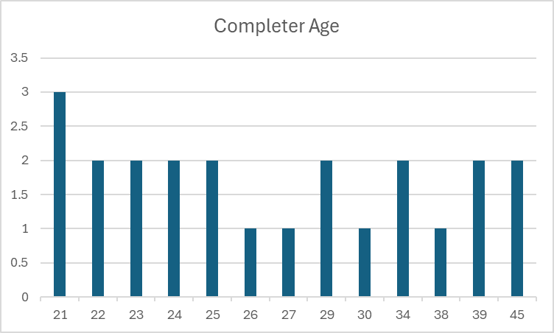

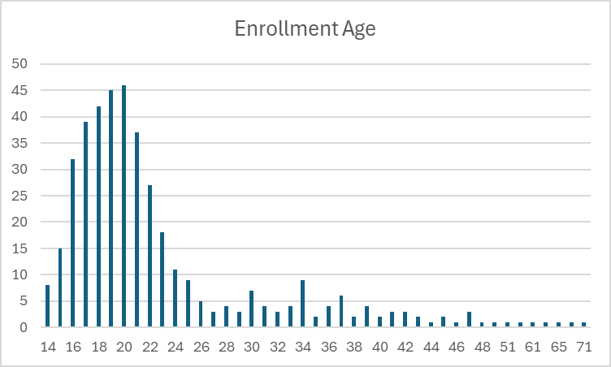
The vast majority of students who declare a degree in Automotive are of historically traditional college age (16-24), but degree completers are evenly distributed from 21-45.

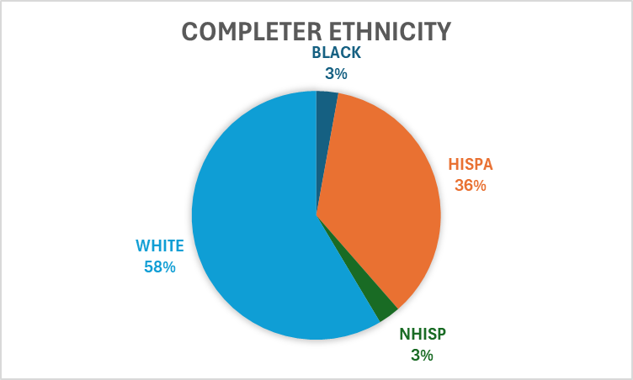

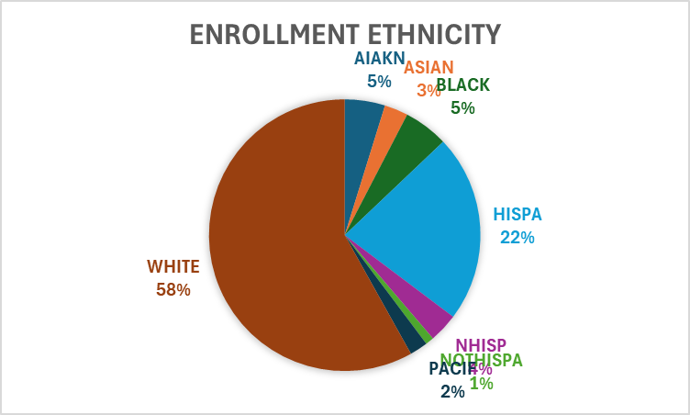
Ethnicity for Certificate of Achievement and AAS Award Enrollment - students frequently select different ethnicities over multiple semesters. In this case, each instance of selection was counted as a unique number, resulting in a percentage rather than a raw number.

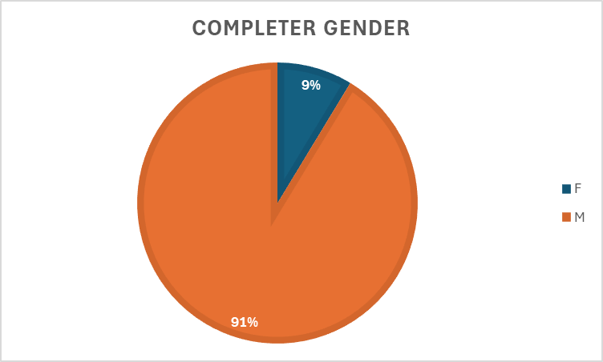

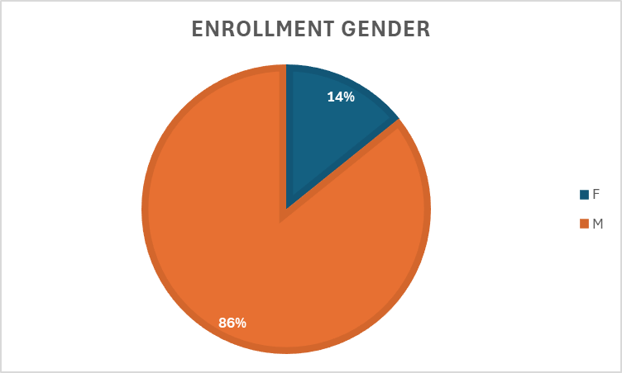
Only 2 of the 23 students who completed a Certificate of Achievement or AAS were women. The percentage of women who declare a degree in Automotive Mechanics is slightly higher, indicating that 1) we lost more female students in degree completion than male students, and 2) this is one of the programs with the highest gender inequality at WNC.

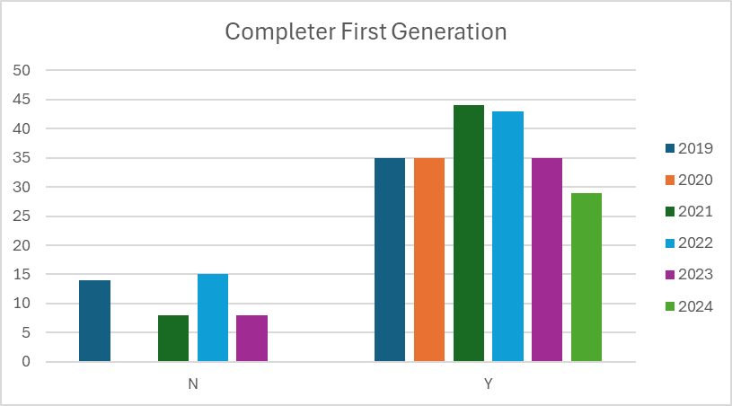

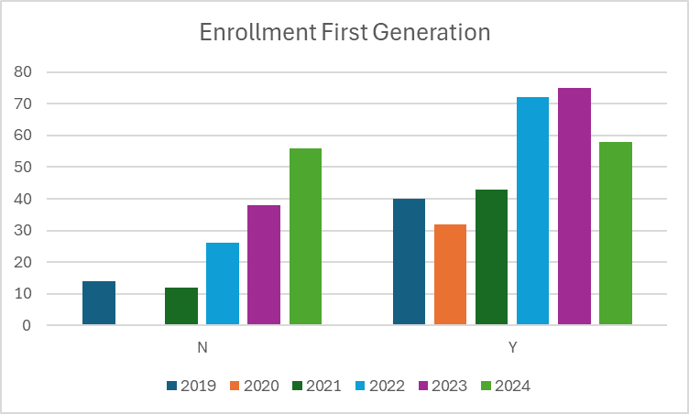

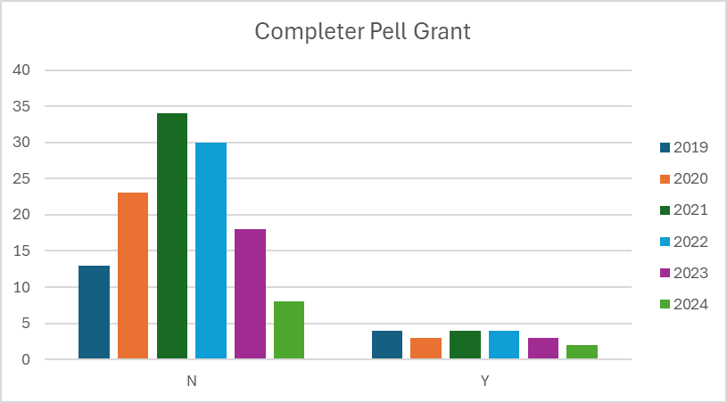

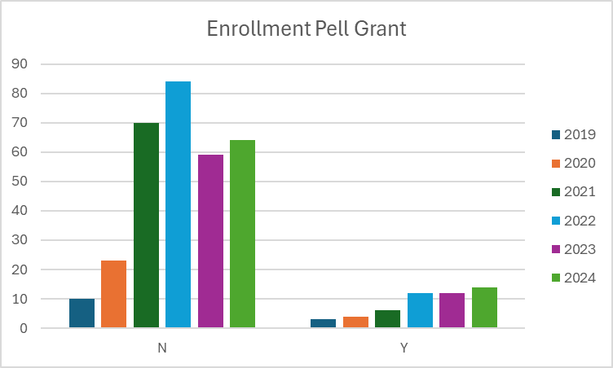

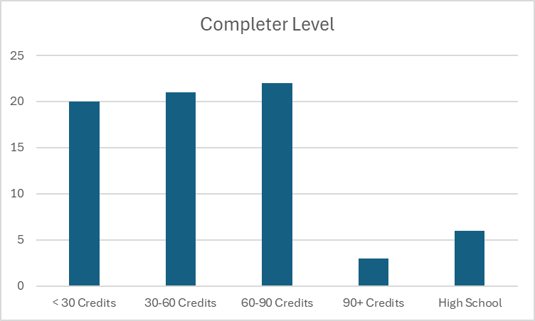
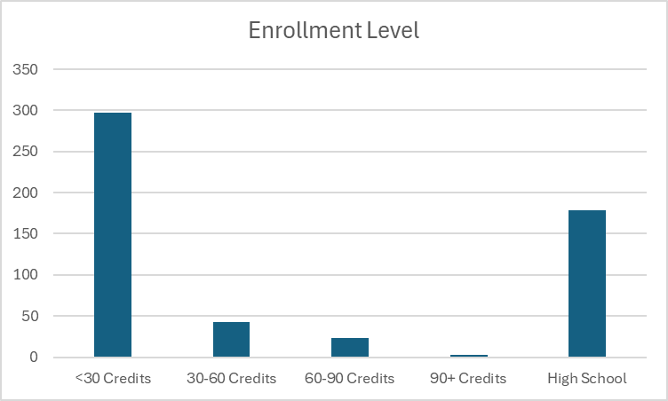
Enrollment and completer level is as expected given the nature of the program. Most students who declare a degree in Automotive Mechanics are new to the college experience, and those who complete a degree are distributed between 1, 2, and 3 years of college experience.

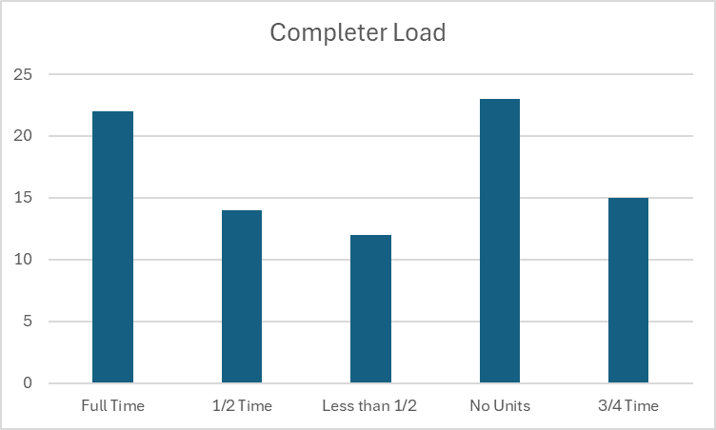
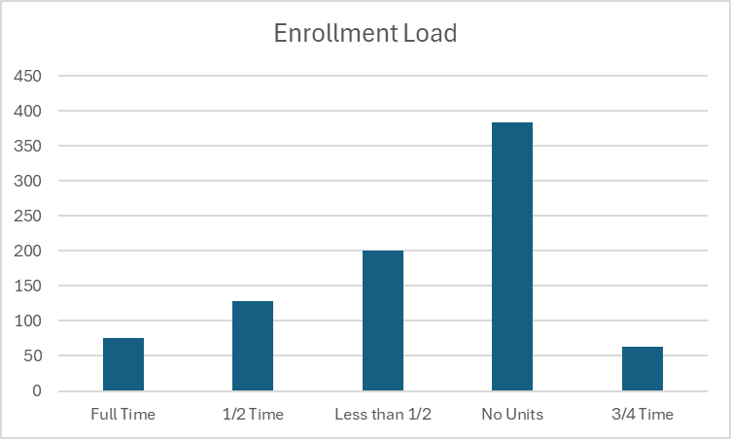
Students who declare a degree in Automotive Mechanics vary in how many classes they take per semester, often taking a semester with no enrollment. The majority of degree completers are full-time, though they do often take a semester with no enrollment.

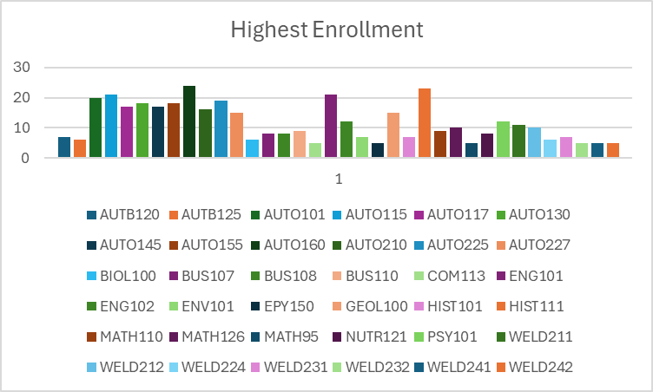
Degree completers, in addition to courses in Automotive Mechanics and General Education, frequently take courses in Welding as well, which makes sense given the need for welding skills in many automotive processes.
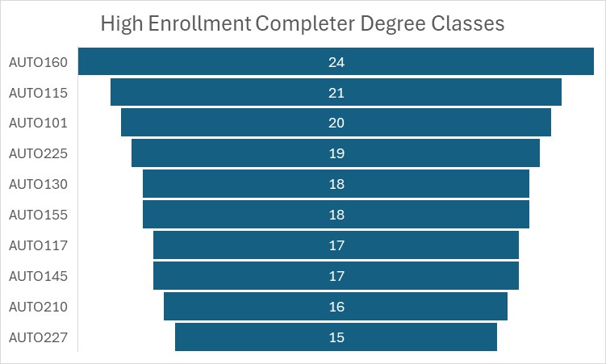

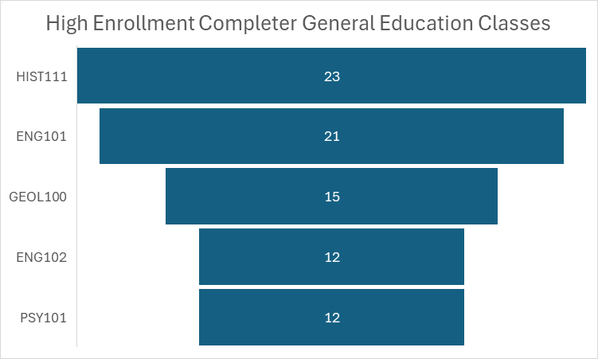

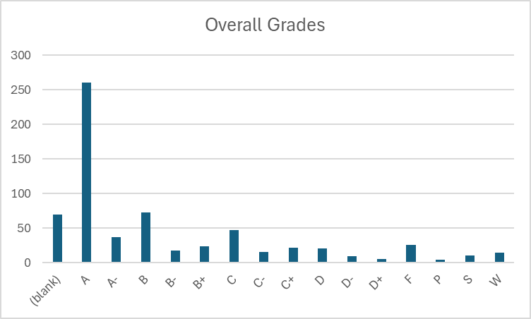
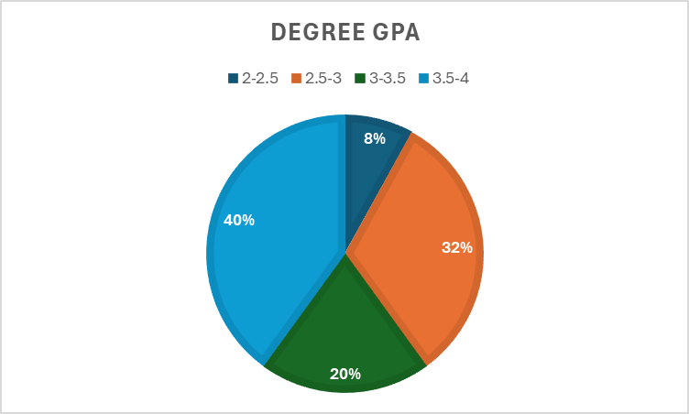

IV. Financials - provide a narrative response to each of the following:
- What are the institutional costs associated with this program?
- What is the cost to students to complete this program?
- If student fees are attached to this program, what is the justification for those fees?
- How do student fees support SLO achievement?
· Skills Certificate:
o Automotive Transmission/Transaxle
§ Tuition and Books - $2,052
o Automotive Heating and Air Conditioning
§ Tuition and Books - $1,655
o Automotive Brakes, Automotive Electrical/Electronic Systems, Automotive Steering and Suspension, Automotive Engine Performance
§ Tuition and Books - $1,780
· Certificate of Achievement:
o Tuition and Books - $4,475
· Associates:
o Tuition and Books - $8,660

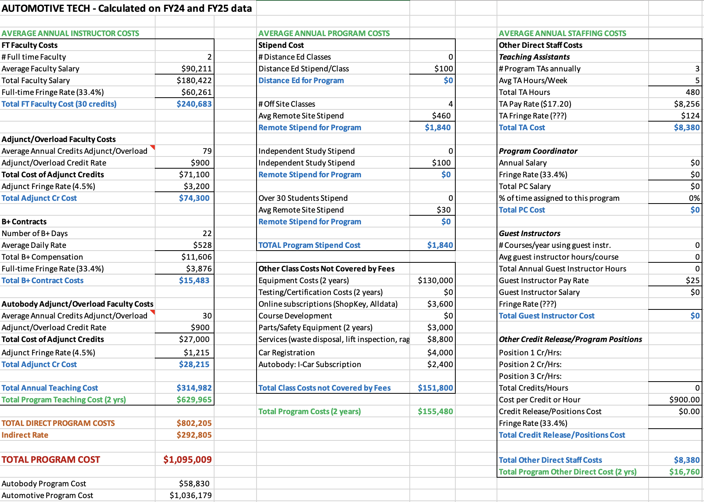

V. Additional Department Information

- Academic Advising
There is growing interest in how the fields of auto technology and auto body work can intersect and complement each other. I’ve heard some rumors suggesting that an auto body degree might be in the works, but if that doesn’t come to fruition, there may still be potential for incorporating a Certificate of Achievement (COA) or finding ways to integrate some auto body courses with the auto tech curriculum. Many students express interest in both areas, and offering opportunities to combine the two could provide a more well-rounded education and skill set for those pursuing careers in the automotive industry.
Dynamically dated classes have proven to be highly beneficial as they allow students to engage with auto-related material in a timely and relevant way. This approach ensures that students are learning the most up-to-date information and skills that are currently in demand. However, it's worth noting that while dynamically dated classes offer flexibility and relevance, they don’t always align with various funding options, particularly for veterans who rely on specific benefits. Despite this challenge, the overall takeaway is that dynamically dated courses are a positive development for students, providing them with valuable, current knowledge that is essential for success in the field.

- Advancement
Over the past year, the Automotive Mechanics program has been fortunate to receive approximately seven donated vehicles, many of which are new. These donations significantly enhance the program by providing students with the opportunity to work with the latest automotive technology, ensuring they gain hands-on experience with current industry standards. In addition to the vehicles, the program is supported by scholarships from several generous donors, including Dick Campaigni and the William N. Pennington Foundation. These scholarships help make the program more accessible and provide students with the financial support they need to pursue their education and training in automotive mechanics.

- Grants (Roads Workforce Liaison - Administrative Faculty Advancement, Grant Writer Advancement, Grant Administrator Vice President of Academic & Student Affairs, Career Services Specialist)

Six students received SANDI funding for Automotive Mechanics between 2019 and 2024. Two received ROADS funding and ten have received funding for the current academic year (these numbers will appear in the 2029 program review). No GJNN students received funding between 2019 and spring 2024.
GJNN runs out of funding in June of 2025. There could be a GJNN extension given the amount of money available in that program. They even have enough funding to cover out of state tuition. The SANDI grant expired on September 30, 2024.

- CFO

Course | Total Approved Fees | Expendable Supplies
AUTB 120 | 50 | 50
AUTB 125 | 50 | 50
AUTB 200 | 45 | 45
AUTB 205 | 45 | 45
AUTO 101 | 50 | 50
AUTO 115 | 50 | 50
AUTO 117 | 50 | 50
AUTO 130 | 50 | 50
AUTO 145 | 50 | 50
AUTO 155 | 50 | 50
AUTO 160 | 50 | 50
AUTO 190 | 45 | 45
AUTO 195 | 45 | 45
AUTO 198 | 25 | 25
AUTO 205 | 50 | 50
AUTO 210 | 50 | 50
AUTO 225 | 50 | 50
AUTO 227 | 50 | 50
AUTO 235 | 35 | 35

How course fee requests are approved:
Each year, the CFO sends out a request for any new course fees or changes to existing fees. Any new fees are then compiled and presented to the College Council for review. If a proposed fee exceeds $50, it must be approved by the Board of Regents (BOR). However, fees of $50 or less can be approved directly by the WNC College President.
Once a fee is approved or updated, the Student Finance Coordinator ensures that the new or revised fees are updated in PeopleSoft for the term when they become effective. This process ensures that students registering for these classes are charged the appropriate fee upon enrollment.

- Academic Director
With the growing popularity of hybrid and electric vehicles (EVs), an alternative fuels course has been added to the catalog, with plans to introduce another during this school year. These courses are scheduled to begin in Fall 2025.
In June 2023, a new director was hired after a transitional year when the division was led by an interim director. This leadership change required several adjustments within the division. Since the new director’s arrival, improvements in the department's overall effectiveness have been evident. The introduction of best practices in scheduling and communication has enhanced operational efficiency, and there has been a noticeable increase in awareness of the Workforce, Career, Technology, and Education division (WCTE) both on campus and in the surrounding communities. This increased visibility has contributed to a more cohesive and effective program.
The department is organized with a Director overseeing the entire division, which includes faculty in several areas such as Graphic Design, Business, Education, Criminal Justice, Aviation, EMS, Fire Science, Agriculture, Computer Information Technology, and Health/PE. The Director is supported by an Administrative Assistant IV, who handles a variety of administrative functions. To further improve operational efficiency, the division has recently expanded its team. An Outreach and Training Coordinator has been hired to manage all Skilled Trade Programs, including Welding, Automotive, Machine Tools, Construction, and Advanced Manufacturing. An additional Administrative Assistant III has been added to support various programs, including Skilled Trades, Fire Science, and EMS. Additionally, an Early Childhood Education (ECE) Program Coordinator was brought on board recently to manage the numerous ECE grants at the college. This organizational structure provides dedicated oversight and support across all programs, improving overall operational efficiency.
The department is committed to maintaining instructional effectiveness through several key initiatives. The recent hiring of a new Director and an Outreach and Training Coordinator provides focused leadership and specialized management for Skilled Trade Programs. This ensures that instructional practices align with industry standards and best educational practices. The addition of an Administrative Assistant III and an Early Childhood Education Program Coordinator enhances the support structure for various programs, enabling better coordination, resource allocation, and responsiveness to instructional needs. Furthermore, the department has implemented best practices for scheduling and communication, which optimize instructional time and improve interactions between faculty, students, and stakeholders. Each program, including Skilled Trades, Fire Science, EMS, and Early Childhood Education, benefits from dedicated coordinators who ensure that instructional materials, resources, and methodologies remain up-to-date and effective. The division also actively seeks feedback from students, faculty, and industry partners to identify areas for improvement, fostering continuous enhancement of instructional strategies.
The process for assigning teaching responsibilities within the department is highly collaborative. Full-time instructors provide the Director with an overview of course assignments for the upcoming semester. The Director reviews the plan, and if any issues arise—such as negative feedback from course evaluations or student complaints—the Director works with the instructors to ensure the best-qualified faculty member is assigned to each course. Faculty workloads are typically heavy, with most full-time WCTE faculty carrying an overload due to the large number of courses required to ensure students can graduate on time. To support new faculty, the department has developed a training course in collaboration with the Learning and Innovation department. This course provides new instructors with tools to enhance their teaching effectiveness and outlines the framework for course structure and delivery at the college. All instructors are fully credentialed, either through their educational background or relevant professional experience.
The program is actively focused on recruiting and retaining underrepresented faculty and staff through targeted outreach and recruitment initiatives. This includes engaging with professional networks and organizations that support diversity in education and industry, as well as participating in job fairs and events that attract a diverse pool of candidates. Creating an inclusive and supportive work environment is also a priority, as it helps retain underrepresented faculty and staff. While several significant hires have been made recently, the department faced a loss with the departure of Juan Ramirez, a full-time Welding Instructor, which impacted the College's standing within the community. However, the hiring of new adjunct instructors is expected to help rebuild trust and restore the program’s reputation.
Until recently, additional support staff was a significant concern. However, since May, the department has been able to hire an additional Administrative Assistant, an Outreach Coordinator, and an Early Childhood Education Program Coordinator. With these new hires, the department now has adequate support staff to meet its operational needs.
Many of the department's more costly programs, such as Perkins and WINN, are funded through grants. Lab fees are used to cover consumables, but rising material costs have created challenges. The department has had to dip into its general operating budget to secure the necessary supplies for maintaining industry-standard programs.
The department regularly assesses its use of funding and human resources through reviews and strategic planning. Financial resources are monitored to ensure alignment with the program’s goals and effective utilization. Expenditures are evaluated based on their impact on student outcomes, program growth, and operational efficiency. For human resources, the department reviews faculty and staff workloads and the effectiveness of course delivery and student support services. Feedback from students, faculty, and staff is used to identify areas for improvement, ensuring that resources are optimized to meet the program's needs.
Facilities remain one of the department's biggest concerns. Some buildings have mold issues, leading to classrooms being closed just before the semester begins. Other buildings experience uncontrollable leaks that pose a risk to expensive equipment and vehicles, further complicating operations.

- Learning and Innovation

In the Fall of 2023, Learning and Innovation piloted a 16-week Canvas-based “Faculty Development” course. This course provided information on expectations for WNC instructors as well as strategies and tools for teaching effectively.
Additionally, Learning and Innovation hosts the Zoom-based “Coffee and Classroom Conversations” series that focuses on a wide range of teaching topics. This series is driven by faculty interests and WCTE faculty have regularly attended these sessions.
The Learning and Innovation team has met with WCTE faculty for support in assignment development and teaching strategies, as well offering professional development opportunities for faculty in support of student learning initiatives including the introduction of best practices for working with students in CTE fields.
Learning and Innovation also provides technical support for Canvas including help desk support and instructional design.
The greatest adjustment has been the increased reliance on Zoom for the provision of training and support as well as the focus on Canvas support. Learning and Innovation has found that WCTE instructors can be reluctant to engage in professional development opportunities and may not be using Canvas to the full extent.

- ACMC

In February of 2023, the Automotive Mechanics program was updated to better align with current industry standards. This included the adoption of three new courses: AUTO 185: Introduction to Alternative Fueled Vehicles, AUTO 205: Manual Drive Train and Axles, and AUTO 291: Work Experience. In addition to these new courses, the skills certificates in the Automotive Mechanics program were updated to include OSH 222: General Industry Safety. In August of 2023, four automotive courses (AUTO 115: Auto Electricity & Electronics, AUTO 145: Automotive Brakes, AUTO 155: Automotive Steering and Suspension, AUTO 225: Automotive Engine Performance I and Fuel & Ignition) were all changed from variable to fixed credit. This change better reflects the amount of work being done in those courses and prevents possible issues in the number of credits for award completion.

- Financial Aid
Feedback from students tends to focus primarily on course delivery, conflicts with instructors, access to resources, and various learning challenges they may face. These concerns are important to address, as they directly impact the overall student experience and their ability to succeed in the program. By understanding and addressing these issues, we can improve both the quality of education and the support systems available to students.
For students pursuing the AAS-Tech degree, we observe that they are generally well supported throughout their studies. This is largely due to their close connection with their subject matter faculty, who provide guidance, mentorship, and specialized expertise. This connection seems to create a supportive environment that helps students stay engaged and succeed in their coursework.
There is discussion about whether there’s a way to track and demonstrate if students in WCTE degree programs are successfully stacking their credentials, such as earning Skills Certificates, Certificates of Achievement (COA), and ultimately completing the AAS degree. It may not have been formally reported, but it would be valuable to measure how students are progressing through these stacked credentials, as it could provide insights into the effectiveness of the program and highlight areas for improvement.
Students often declare a degree primarily to open up options for Financial Aid, even if they have no intention of completing the degree. While this practice is not entirely new, it’s something that should be noted. One area where the process falls short is in documenting whether the student has achieved their initial goal. There is a tendency to assume that if a student does not graduate with the degree, the assistance provided was a failure, even though they may have completed other objectives. This gap in tracking student outcomes could be addressed to better reflect the support students are receiving, regardless of whether they ultimately earn the degree.
Another ongoing challenge is the attraction of fraudsters to online programs, particularly those who are looking to take advantage of Financial Aid dollars. These individuals often target online programs to exploit the system, which remains a concern across many institutions.
Additionally, there are occasional issues with the approval process for certain programs, particularly when it comes to the AAS-Technology degrees, which are approved by agencies like the State Approving Agency for VA Benefits. When a new reviewer examines the catalog, there is often confusion about how to categorize the Technology emphasis or how to handle the different pathways, such as Automated Systems or CIT. While these issues can usually be resolved through conversation and clarification with the reviewer, it remains a recurring challenge that requires attention each time a new person evaluates the catalog.

- Faculty
In 2022, Alex Street started as an adjunct before moving into a full time, tenure-track, position in summer 2023. The main objective of this position is to prepare students for a career in the automotive industry from base level lube techs to automotive engineering.

Faculty have observed a drop-off of interest in pursuing careers in the automotive industry. Most people who take these classes are hobbyists, which may account for the low program enrollment despite a significant increase in course enrollment. There has been an increase in high school student enrollment, though it is unclear if these students will also be primarily interested in this field as hobbyists.

To help better serve students, the automotive labs need more and newer physical equipment. Ideally, the labs should be equipped with enough training devices for a full class of 16 students, but that is not the current capacity of our equipment. For example, for the AC class only there are only two AC machines, which represents a significant limitation when teaching a full class of students. The building itself is also in need of repair, for example there is a leak in the roof that may present a safety hazard for students.

As WNC currently only has one full-time faculty member in this area, and that instructor is carrying 21 credits per semester, a new full-time instructor would create a more equitable teaching load, and allow instructors to provide greater support and mentorship to students in the program. A dedicated TA could also help address this issue, as could additional support from the division administration for this specific program.

Faculty teaching in this area have noticed some additional challenges for students. Some faculty observed that the general education requirements of the AAS Tech degree may not be appropriate for students pursuing the field of auto mechanics. Depending on student needs, it may make sense to focus more on skills certs or to modify general education courses to meet the needs of this student population. Additionally, access to books continues to be an issue. The book is online, but students are having difficulty getting licenses or otherwise gaining access to it. Finally, there is a some concern that students are not getting adequate time during the semester to achieve course objectives. Increasing the weight of these classes and the associated increase in seat time would be helpful for this student population. Given the objectives of the courses, more time for guided practice with instructors specifically would be beneficial to students.

The collected data indicates that almost no one is taking OSH 222, which means very few people are being awarded skills certificates. Academic Advising and Access seems unsure of the CTE curriculum map and this may be impacting how students are planning their enrollment. Scholarships in this area are dependent on awards, which means that students will pursue a certificate if it comes with funding over a different degree that does not have funding attached. The ROADS program focuses almost exclusively on certification. While ASE certification can take 2 years for the complete program, there are different certification options available through the National Coalition of Certifications.

Student performance has been improving since Alex Street came on board, which is a testament to his supportive and effective approach to teaching this student population. There has also been an increase in community involvement and an improvement in the relationship with local dealerships. Alex has experience teaching OSH 222 at TMCC, and having him offer sections of that course in the Auto building could help bridge the gap we are seeing in skills certificate completion in this area.

VI. Faculty Profiles - provide a narrative response to each of the following:
- Brandon Rice
  - Certificate of Completion from Universal Technical Institute with Toyota Program
  - 7 years of industry experience
- Sunshine Haupt
  - Certificate of Completion from Universal Technical Institute
- Tim Bielman
  - Certificate in Automotive Service-Mechanical from Riverside Community College
  - Certificate in Automotive Service-Electrical from Riverside Community College
  - ASE Certifications in the following:
    - A3 – Manual Drive Train & Axles
    - A6 – Electrical/Electronic Systems
    - A7 – Heating & Air Conditioning
    - A8 – Engine Performance
    - L1 – Advanced Engine Performance Specialist
  - Nevada 2G Emissions License
- Michael Corry
  - Associate of Applied Science – Automotive Technology from WNC
  - ASE Certifications in the following:
    - A1 – Engine Repair
    - A6 – Electrical/Electronic Systems

Percentage of courses taught by instructor type: 62% full-time, 38% adjunct

VII. Comparisons - provide a narrative response to each of the following:
- TMCC
  - AAS: Automotive Certified Technician, Transportation Technologies
  - AAS: Diesel Technician, Transportation Technologies
  - Certificate of Achievement: Automotive ASE Technician
  - Certificate of Achievement: Automotive General Service Technician
  - Skills Certificates
    - Automotive Service Excellence, Basic
    - Automotive Service Excellence, General
    - Automotive Service Excellence, Master

- Universal Technical Institute (Sacramento)
  - Associate of Occupational Studies: Automotive Technology
  - ASE certifications
  - Diesel Mechanic
  - Diesel ASE certifications
- WYO Tech - wyoming technical institute. Direct competitor for UTI.

WNC offers a large range of skills certificates that scaffold towards a Certificate of Achievement and AAS degree. These programs are competitive with TMCC.

VIII. Recommendations and Commendations - provide a narrative response to each of the
following:
Commendations:
- This was the first time implementing the new program review process, which required assistance and participation from many individuals. Administrative departments and IT were essential in gathering necessary information and fielding questions.
- Automotive full-time faculty for their contributions to program history and insight into industry trends. Adjunct faculty for the program development participation.

Recommendations:
- Review the inclusion of OSH 222 in program awards.
  - Implement OSH 222 as part of Auto 101.
- Review General Education requirements for the Certificate of Achievement in order to eliminate the hidden credit requirement.
  - Require OSH 222 for the Certificate of Achievement and remove the 2 credit General Education requirement, resulting in an accurate 30 credit program.
- Develop award specific objectives and an accompanying assessment plan.
- Provide additional administrative support to WCTE.

12 General Education credits are required for the Certificate of Achievement, but if students follow the recommended selection of BUS 110 they will need to actually take 13 credits based on standard credits/class. The course outline for BUS 110 indicates 3 credits, which would also alter the number of required GE credits for this award.

