Program Review
Computer Information Technology
2024

Table of Contents:
- Program/Program Review History………………………2
- Alignment to Institutional Goals………………………...8
- Program Data……………………………………………14
- Financials………………………………………………..26
- Departmental Information………………………………27
- Faculty Profiles………………………………….………38
- Comparisons………………………………….…………39
- Recommendations and Commendations…….………….42

- Program/Program Review History
- Program Overview
  - Computer Information Technology has experienced a number of programmatic changes over the course of its history at WNC. This review will begin with data from 2013, as that is the year the AAS Technology degree was instituted and the previous program structure was deactivated. That year WNC removed emphases from degrees in order to comply with NSHE-required completion standards. As a result, CIT is now part of a 6 program degree including Automotive Mechanics, Construction, Machine Tool, Mechatronics Technology, and Welding.
  - The following is a list of currently offered awards in CIT:

Award | Description | Required Courses
Skills Certificate: Ethical Hacking | This program will prepare students to find vulnerabilities in information systems. Students completing the program will be prepared for the following industry certification exams: Comp TIA Network +, EC-Council Certified Network Defender and EC-Council Certified Ethical Hacker. Students will also be eligible to take the TestOut curriculum Pro series exams. | CIT 112: Network+  CIT 128: Introduction to Software Development  CIT 273: Network Defense  CIT 274: Ethical Hacking
Skills Certificate: IT Cisco Routing & Switching | In this program, students will develop the skills to plan, prepare, operate, monitor, and troubleshoot complex converged networks. Students will be prepared for the following industry certification exams: CompTIA A+, Comp TIA Network +, and Cisco CCNA Route and Switch. Students will also be eligible to take TestOut curriculum Pro series exams. | CIT 112: Network+  CIT 114: IT Essentials  CIT 128: Introduction to Software Development  CIT 220: Routing and Switching
Skills Certificate: Front End Developer | This program will provide the foundation for website development, preparing students for the following industry certifications exams: CompTIA A+, CompTIA Network+ and CIT Site Developer Associate. Students will also be eligible to take the TestOut Pro series exams. | CIT 112: Network+  CIT 114: IT Essentials  CIT 128: Introduction to Software Development  CIT 151: Beginning Web Development
Skills Certificate: IT Security - General Security | In this program, students will learn the baseline skills needed to perform core security functions needed for entry level positions. Students completing the program will be prepared for the following industry certification exams: Comp TIA Network +, CompTIA Linux+ and CompTIA Security+. Students will also be eligible to take the TestOut curriculum Pro series exams. | CIT 112: Network+  CIT 128: Introduction to Software Development  CIT 173: Introduction to Linux  CIT 217: Security+
Skills Certificate: Cybersecurity | WNC offers certification preparation for Certified Network Defender, Certified Ethical Hacker, and Computer Hacking Forensics Investigator. EC-Council certifications are recognized and respected worldwide. | CIT 217: Security+  CIT 273: Network Defense  CIT 274: Ethical Hacking  CIT 275: Hacking Forensics Investigation
Skills Certificate: Microsoft Certified Technology Specialist (MCTS) | The Microsoft Certified Technology Specialist (MCTS) certification program is designed to give students the skills needed to implement a Microsoft product or technology as part of an organization’s business solution. | CIT 211: Microsoft Operating System Management  CIT 212: Microsoft Networking II  CIT 213: Microsoft 365 Security Administration  CIT 214: Microsoft Azure Administration
Skills Certificate: IT Essentials | This program will provide a solid foundation for students to continue in any area of study based on personal or professional interest. Students will be prepared for the following industry certification exams: CompTIA A+, Comp TIA Network +. Students will also be eligible to take TestOut curriculum Pro series exams. | CIT 112: Network+  CIT 114: IT Essentials  CIT 128: Introduction to Software Development
Skills Certificate: IT Project Management | IT project management includes overseeing projects for software development, hardware installations, network upgrades, cloud computing and virtualization rollouts, business analytics and data management projects and implementing IT services. In this program, students will be prepared for the following industry certification exams: Microsoft MOS certification(s), CompTIA Project+, PMI CAPM. Students will also be eligible to take the TestOut curriculum Pro series exams. | CIT 128: Introduction to Software Development  CIT 263: Introduction to IT Project Management  IS 101: Introduction to Information Systems  COM 101: Oral Communications
Skills Certificate: Network Support | In this program, students will learn how to keep computer networks running efficiently. Students will be prepared for the following industry certification exams: CompTIA A+, Comp TIA Network +, and Wireshark Certified Network Analyst. Students will also be eligible to take TestOut curriculum Pro series exams. | CIT 112: Network+  CIT 114: IT Essentials  CIT 128: Introduction to Software Development  CIT 270: Network Tools
Skills Certificate: Secondary Education Endorsement - Programming | This program satisfies the programming requirement for licensed secondary educators in Nevada to add the Advanced Computer Science endorsement, allowing them to teach high school computer science courses. Coursework can be completed online. Students will be prepared for the following industry certifications exams: Python Institute's PCEP - Certified Entry-Level Python Programmer and PCAP - Certified Associate in Python Programming certifications. | CIT 128: Introduction to Software Development  CIT 148: Beginning Python Programming  CIT 248: Advanced Python Programming
Certificate of Achievement: Computer Information Technology | The Certificate of Achievement in Computer Information Technology allows a student to gain foundational knowledge and earn different industry recognized certifications that align with specific job opportunities in a variety of technology areas such as programming, front end or back end developer, networking, cybersecurity, IT program management and other emerging fields. Students may pursue different areas of personal or professional interests based on their choice of electives. | CIT 112: Network+  CIT 114: IT Essentials  CIT 128: Introduction to Software Development  CIT 217: Security+  7 credits from the following Computer Information Technology courses:  INF 100: Introduction to Informatics I - Basic Concepts  CS 135: Computer Science I  CS 202: Computer Science II  9 General Education Credits:  English/Communications  Mathematics  Human Relations
AAS Technology: Computer Information Technology | Students may earn a general degree in CIT by completing the program requirements and any combination of electives. Students who wish to specialize may choose an area of emphasis and complete the specific electives for each. The four emphasis areas are Front End Developer, Back End Developer, Cybersecurity and Programming. | CIT 112: Network+  CIT 114: IT Essentials  CIT 128: Introduction to Software Development  CIT 217: Security+  CIT 263: Introduction to IT Project Management  19 credits from the following*:  Any Computer Information Technology Course  Any Information Systems Course  INF 100: Introduction to Informatics I – Basic Concepts  CS 135: Computer Science I  CS 202: Computer Science II  24 credits of General Education:  English/Communications  Mathematics  Science  Human Relations  Humanities/Social Science  US & Nevada Constitution  General Elective  *Students should select electives based on their desired pathway: Front End Developer, Back End Developer, General Degree

Certificate of Achievement in Computer Information Technology Course Sequence
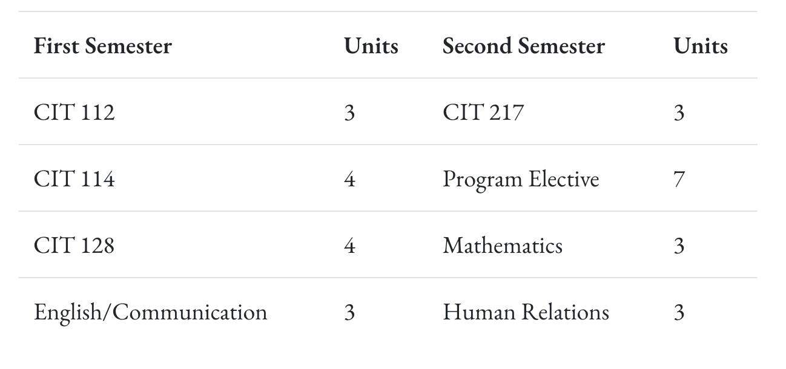

Associate of Applied Science in Computer Information Technology Course Sequence
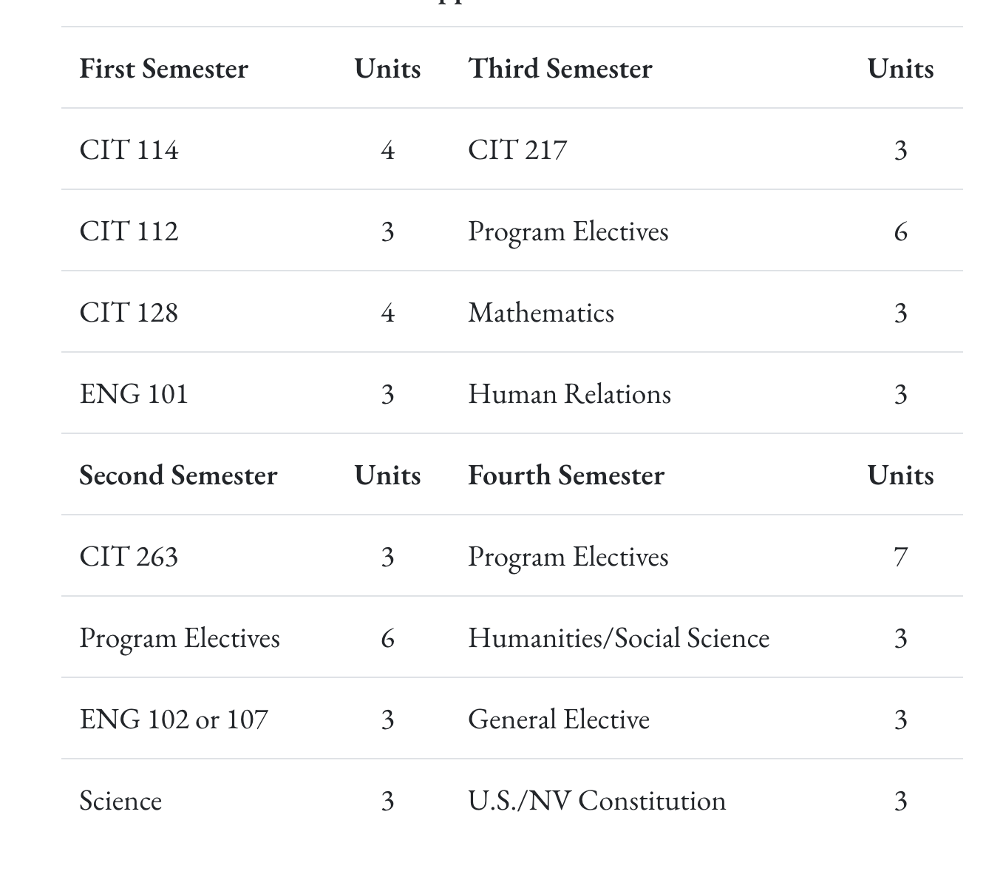

  - The Computer Information Technology program includes 10 skills certificates, a Certificate of Achievement, and an Associate of Applied Science in Technology. The AAS Tech offers four industry-aligned pathways. Alternatively students can select a general degree in CIT by completing the program requirements and any combination of electives. Please see section 5 for a comprehensive history of curricular changes in the program.
- Program Review History
  - A brief review was done in 2018 utilizing a previous program review template. At that time CIT offered 3 awards: AAS Technology, Certificate of Achievement: Networking Technician, and Certificate of Achievement: System Admin Technician. There have been significant curricular changes since the last program review, which are detailed in section 5 of this review. No recommendations are present in the 2018 program review.

II. Alignment to Institutional Goals
- Alignment to strategic plan and institutional goals
  - Table and narrative demonstrating how the program objectives align with WNC’s institutional goals.

WNC | Computer Information Technology
Vision: WNC is an integral and innovative educational partner fostering equity and a life of learning in an exclusive environment for the evolving, diverse community we serve.  Values: WNC is student centered, inquiry driven and data informed as we nurture community connections and promote an environment of equity and inclusion.  Mission: WNC contributes to solutions for the 21st century by providing effective educational pathways for the students and communities of Nevada. | Computer Information Technology (CIT) is the use and study of computers, networks, computer languages and databases within an organization to solve real problems to maintain functionality. In today’s digitally focused economy, CIT career opportunities are abundant and expanding. According to the US Bureau of Labor Statistics (BLS), web development jobs alone are projected to grow as much as 30% by 2031.  This course of study is designed to prepare students for a variety of specializations that are vital to today’s collaborative and connected business environments. Topics of focus will include programming, networking, server administration, information security, database design and development, systems analysis and designing, and web development. For career success, the most important skills students can develop are continuing to learn as technology advances and the ability to adapt quickly as industry changes.  Students can start their course of study with any of the Skills Certificates, stacking them on top of each other as they determine their area of interest. Students may also start with an Associate of Applied Science emphasis in mind and, working with an advisor or CIT instructor, plan backward to identify a starting point.  Mission: The mission of the Associate of Applied Science in Technology is to provide employment-related knowledge and skills necessary to succeed as a professional in a chosen field of study
WNC Student Learning Outcomes:  - CONTENT KNOWLEDGE: Demonstrate understanding of essential information and concepts relevant to a discipline or area of study.  - COMMUNICATION: Effectively convey and/or interpret a central idea via visual, oral, or written media.  - QUANTITATIVE LITERACY: Correctly analyze, interpret, draw conclusions from, and communicate quantitative processes and information.  - INFORMATION LITERACY: Locate, evaluate, and appropriately use information from multiple resources in support of a claim or central idea.  - DIVERSITY AND SOCIETY: Identify and discuss changing human societies demonstrating an understanding of the subject and respect for various cultural, methodological, and/or theoretical perspectives.  - CRITICAL THINKING: Integrate knowledge and skills to develop logical conclusions and/or solutions that demonstrate a well-reasoned evaluation of a problem, question, perspective, or solution.  - CAREER PREPARATION: Apply specialized knowledge, approaches, and skills to successfully complete projects and/or demonstrate relevant professional and/or industry-standard competencies | AAS Student Learning Outcomes:  - Know the subject matter appropriate to the emphasis of the degree.  Have met the institutional student learning outcomes.  - Have met the institutional student learning outcomes.  - Have met the institutional student learning outcomes.  - Have met the institutional student learning outcomes.  - Have acquired skills and can perform tasks necessary for employment or career advancement.  - Have met the institutional student learning outcomes.  - Have met the institutional student learning outcomes.  AAS Technology Student Learning Outcomes:  Know the subject matter appropriate to the emphasis of the degree. (WNC SLO 1,3,6,7)  Communicate effectively and appropriately, in oral and written form. WNC SLO 2)  Locate, evaluate and properly utilize the tools and resources appropriate to a technology degree professional. (WNC SLO 1,6,7)  Acquire skills and perform tasks necessary for employment or career enhancement. (WNC SLO 1,7)  Developed an appreciation of the importance of social, ethical, legal and diversity issues. (WNC SLO 5,7)  Developed an appreciation of the need and importance of lifelong learning. (WNC SLO 1)

Analysis of alignment:

CIT Program Curriculum Map

The general education courses for the Computer Information Technology (CIT) Program at Western Nevada College are structured to align closely with the institution’s Student Learning Outcomes (SLOs), ensuring that students develop a well-rounded education that integrates content knowledge, communication, critical thinking, quantitative literacy, information literacy, diversity, and career preparation.
Content Knowledge is fundamental to both WNC's institutional outcomes and the CIT Program. The CIT curriculum emphasizes mastery of subject matter relevant to technology and computing (CIT SLO 1), enabling students to understand and apply essential concepts in programming, cybersecurity, networking, and system analysis. This directly supports WNC’s goal of ensuring students demonstrate essential knowledge relevant to their discipline.
Communication is a critical skill in the technology industry, and the CIT Program incorporates effective oral and written communication (CIT SLO 2). Whether through technical documentation, coding standards, presentations, or collaborative projects, students develop the ability to convey and interpret ideas, aligning with WNC’s institutional goal of effective communication across various media.
Quantitative Literacy is an implicit component of the CIT Program, particularly in areas such as data analysis, algorithmic problem-solving, and computing processes. While not explicitly stated in the CIT SLOs, the emphasis on subject knowledge (CIT SLO 1) and technical problem-solving (CIT SLO 4) ensures students acquire the skills needed to analyze, interpret, and apply quantitative reasoning in computing contexts. These align with WNC’s goal of developing students’ abilities to correctly analyze and interpret quantitative information.
Information Literacy is a cornerstone of the CIT curriculum, as students are required to locate, evaluate, and properly use various technological tools and resources (CIT SLO 3). In an industry driven by constant technological advancements, the ability to research, assess, and apply new information is essential, directly aligning with WNC’s goal of fostering information literacy.
Diversity and Society is addressed in the CIT Program through its focus on social, ethical, legal, and diversity issues (CIT SLO 5). The program ensures students understand the ethical implications of technology, cybersecurity concerns, intellectual property rights, and the impact of technology on diverse communities. This supports WNC’s goal of fostering respect for various cultural, methodological, and theoretical perspectives.
Critical Thinking is deeply embedded in the CIT curriculum, particularly in its focus on problem-solving and technological troubleshooting (CIT SLO 6). Students integrate knowledge and skills to develop logical conclusions and innovative solutions to computing challenges, demonstrating WNC’s institutional emphasis on well-reasoned evaluations and problem-solving.
Career Preparation is a strong component of the CIT Program, as students acquire specialized skills and perform industry-relevant tasks necessary for employment (CIT SLO 4). Whether through programming, networking, system administration, or cybersecurity, students gain hands-on experience that prepares them for professional success, aligning directly with WNC’s goal of career preparation.
Program specific course outlines often indicate alignment with all 6 program learning outcomes or do not have outcomes listed. During the curricular review process, these outcomes should be revisited and clarified based on the new award-specific outcomes.
- Alignment to KPIs
  - Table showing the alignment of program data to institutional KPIs.

WNC Institutional Objectives | - Enrollment Numbers (Non Dual): Fall - 153, Spring - 140  - Course Completion Rates: 88%  - Degree/Certificate Numbers 2025 - 4 skills certificate completers and 3 Associate of Applied Science completers
WNC provides access to educational pathways and opportunities | WNC’s program aligns with the Nevada Department of Education (NDE) high school CTE program so that students are able to earn college credit for skills and competencies they master in high school and seamlessly continue toward a certificate or degree after graduation.  For students seeking to start the program after graduation, Nevada’s current graduation and GED requirements adequately prepare students.
WNC students make an efficient transition from preparatory to college-level coursework | Age Group Breakdown - Spring 25  - 18-19 years old = 9  - 20-24 years old = 16  - 25-34 years old = 31  - 35 plus years old = 22  First Generation College Students - Spring 25  - 31 students  Geographic Locations  - Students taking classes from all over the 6 county region, as most classes are offered in a self-paced or virtual setting.
WNC provides equitable access for students regionally and demographically | WNC offers courses on-line, in person and through dual enrollment to ensure equitable access across demographics and the geographical region
WNC provides access to dual credit pathways | Multiple schools, including Oasis Academy, Sierra Lutheran and Dayton HS participate in dual enrollment opportunities for high school students. CIT 128 is offered at Sierra Lutheran and Oasis, usually with a concurrent model. A new pathway with Dayton started this past year, where students will take CIT 114 and CIT 112 their first year in the program at Dayton HS. This is also an affiliate taught class with support from our full time CIT Instructor.
WNC supports student learning, progress, and completion | Course Pass rates for Fall ‘24 was 59% across all CIT classes.
WNC advances student achievement of learning outcomes at course, program, and institutional levels
WNC builds student engagement with education and the WNC community
WNC identifies and closes achievement gaps across student populations by supporting achievement across demographic groups in traditional and non-traditional fields | Ethnicity breakdown for Spring CIT Classes (including dual enrollment):  - Hispanic = 25  - Two or More Races = 7  - White = 52  Gender breakdown for Spring CIT Classes (including dual enrollment):  - Men = 65  - Women = 27  Course Accessibility  - Open Entry Courses  - Hybrid Courses  - Self Paced, Full-Semester  - Online, synchronous/asynchronous  - In person
WNC sustains a learning environment that promotes equity and inclusion | Twice a year advisory board meetings that include a dozen industry representatives that help guide curriculum, and point students in the right direction for in-demand occupations.
WNC responds to the needs of industry and provides effective pathways for students toward in-demand occupations | The full time instructor sits on multiple advisory boards for the state, including a task force for AI.
WNC contributes to solutions to the critical issues facing 21st-century Nevada | - Enrollment Numbers (Non Dual): Fall - 153, Spring - 140  - Course Completion Rates: 88%  - Degree/Certificate Numbers 2025 - 4 skills certificate completers and 3 Associate of Applied Science completers

III. Program Data (All data is from Fall 2019 through Summer 2024)
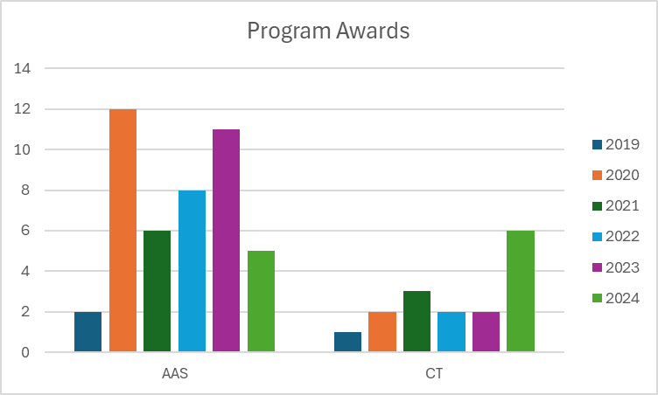
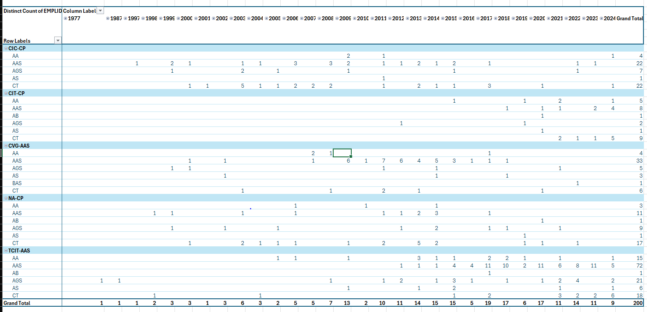
This chart indicates the number and type of awards earned by students who have declared a particular CIT program. For example, students enrolled in CIC-CP earned AA, AAS, AGS, AS, and CT degrees from 1997 to 2024. While students may begin a program in CIT, they often earn an award in a different program. Alternatively, students earn secondary awards in CIT after completing awards in other programs. CIT students are participants of the wider WNC community, often over decades.
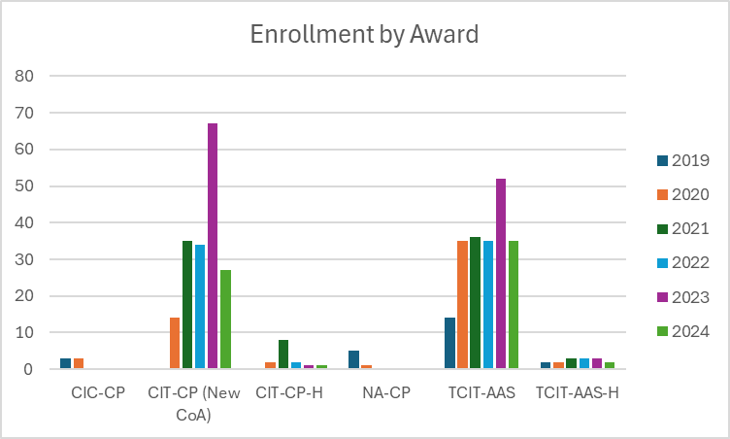
CIT-CP and TCIT-AAS/TCIT-AAS-H are the currently offered certificate of achievement and associate degree options for the CIT program, making the larger enrollment numbers logically consistent. The remaining awards were deactivated when CIT was incorporated into the AAS Technology degree in 2013.

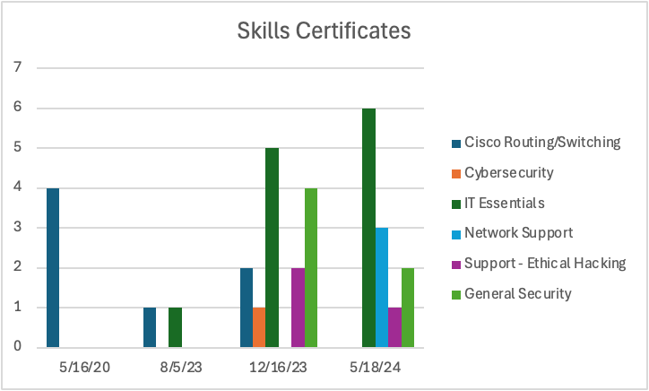
Front End Developer, IT Project Management and the Secondary Education Endorsement were first available in Fall 2023 and had no completions by the end of Summer 2024. Microsoft Certified Technology Specialist, an existing skills certificate, had no completions between Fall 2019 and Summer 2024.

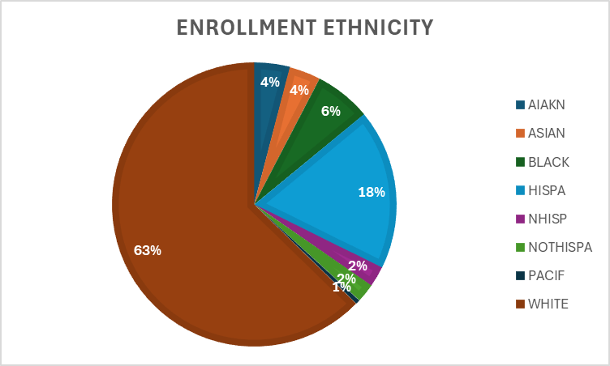
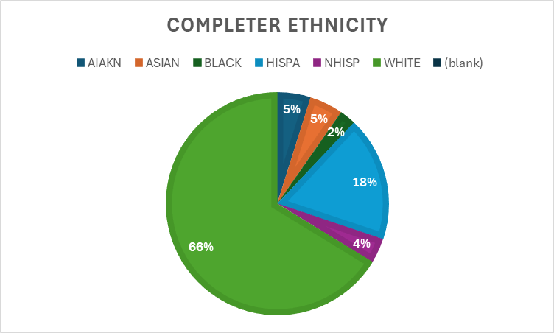
Ethnicity for Certificate of Achievement and AAS Award Enrollment - students frequently select different ethnicities over multiple semesters. In this case, each instance of selection was counted as a unique number, resulting in a percentage rather than raw number.
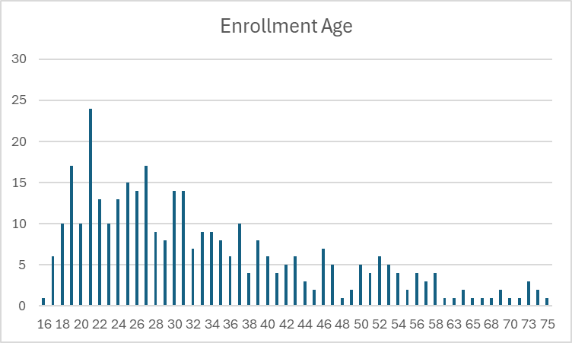

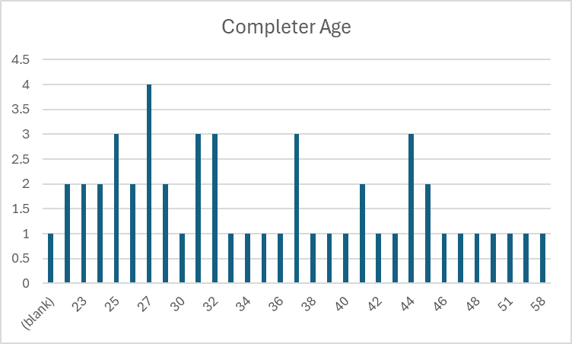

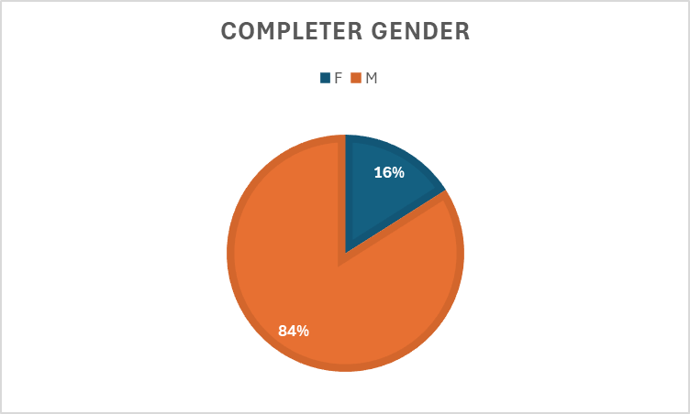
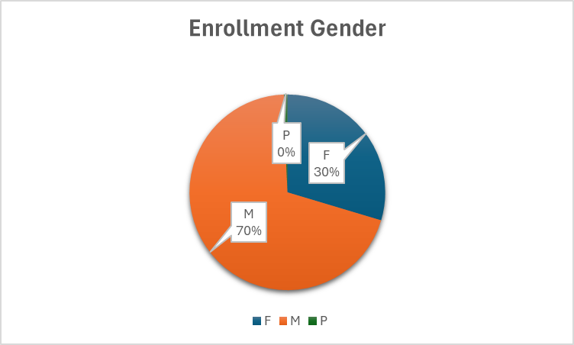
Female students who declare a program in CIT do not complete at the same rate as their male counterparts. Nationally women complete degrees at a higher rate than men, which indicates an industry specific gender issue.

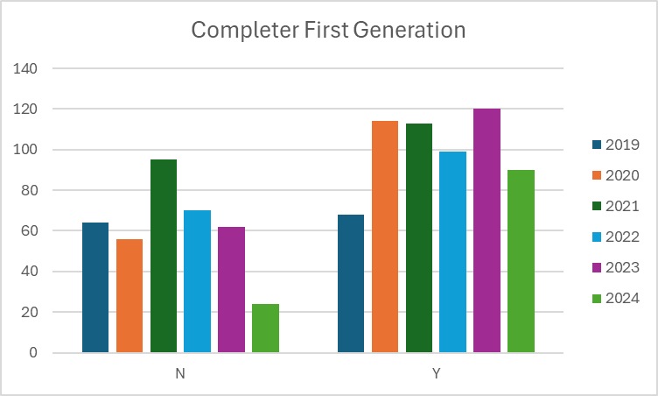

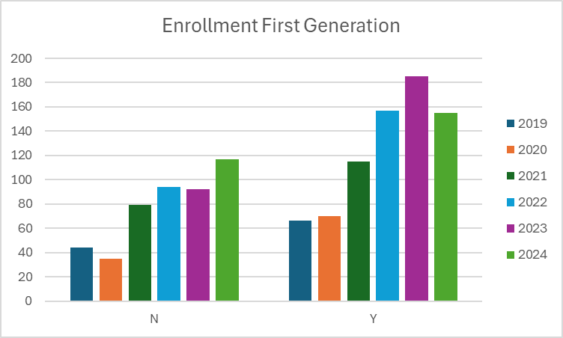

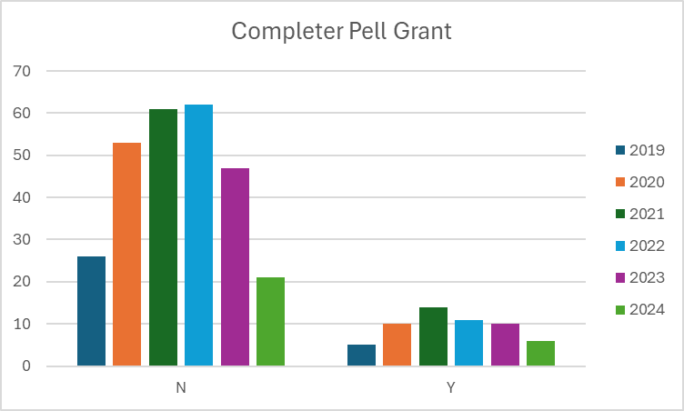

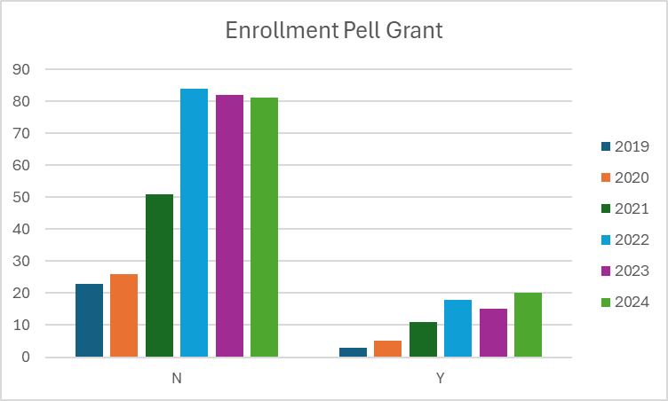

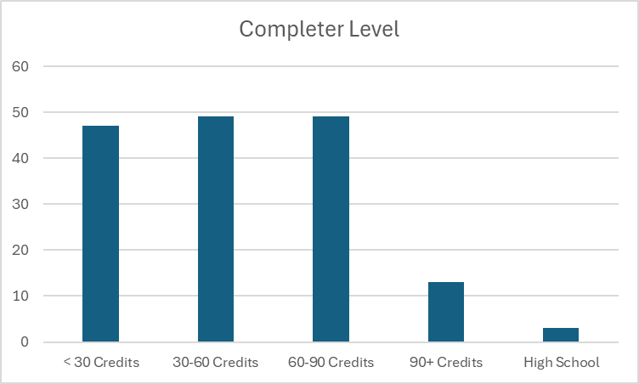

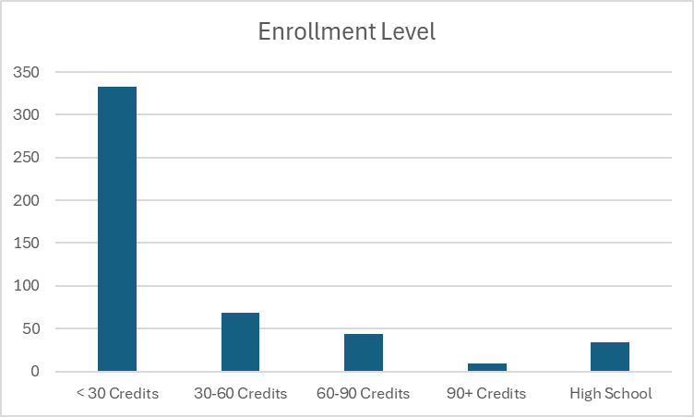
Number of credits when a student declares or completes an award. As expected, students have earned more credits by the time they complete and the vast majority of students declaring are Freshman (have earned under 30 credits).

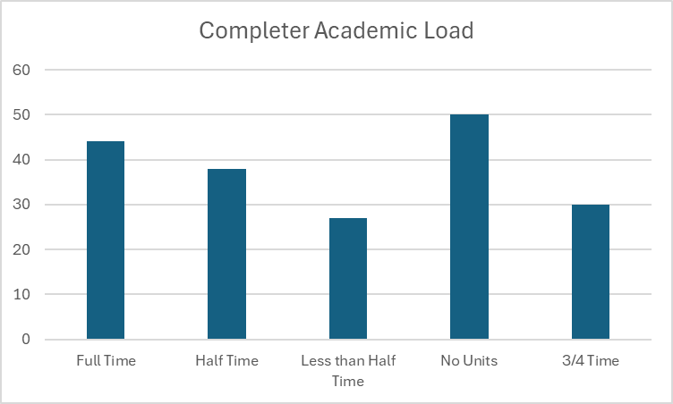

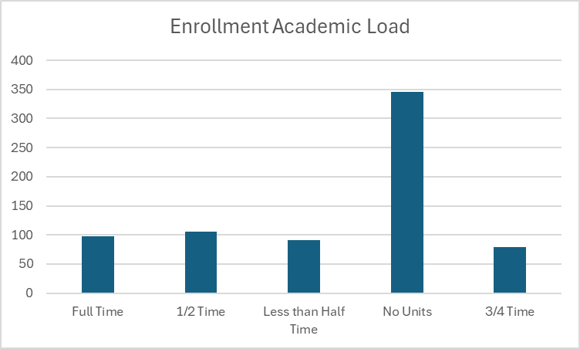
Enrollment is per semester. Student enrollment often fluctuates semester to semester and often students take no classes during a given semester.
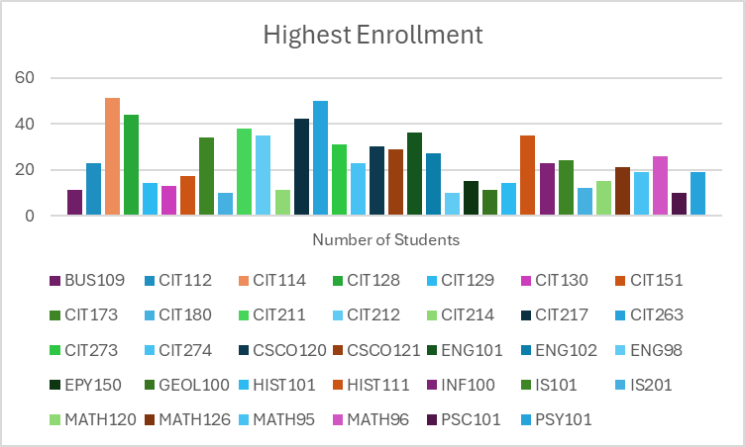

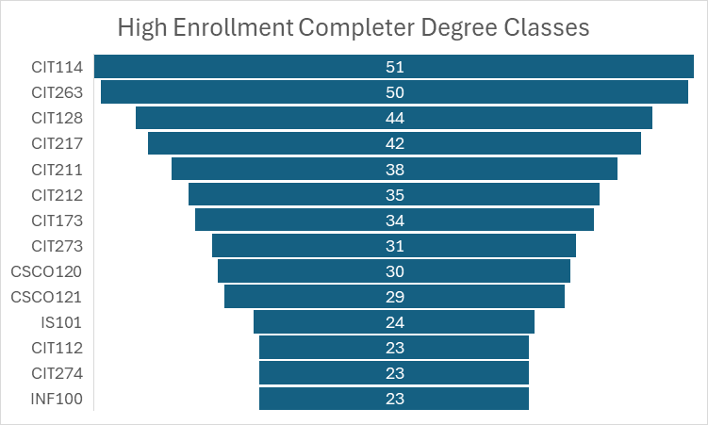

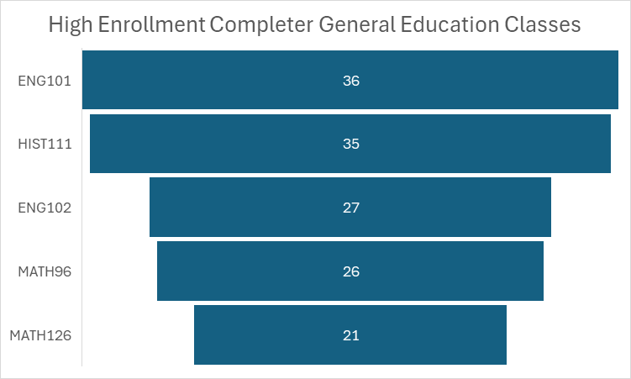

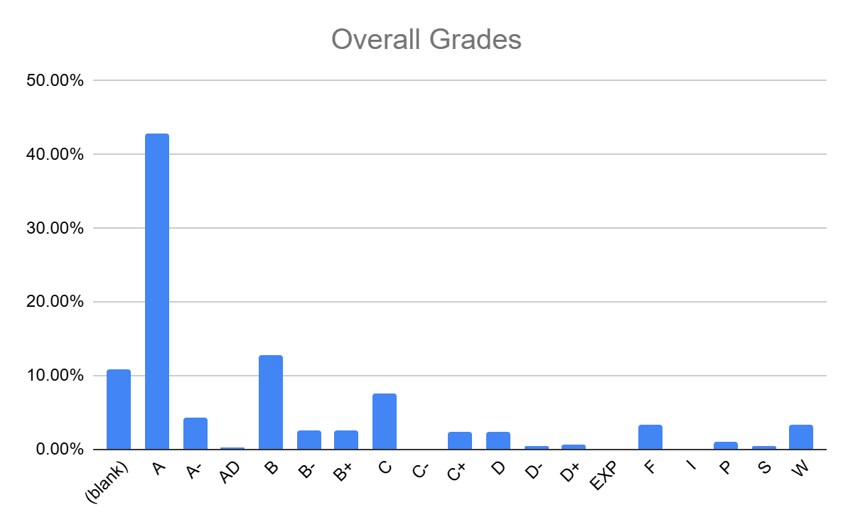

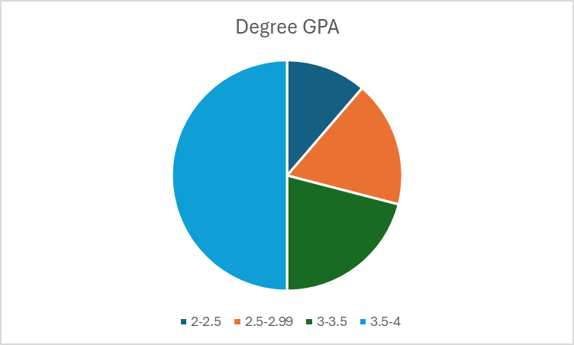

IV. Financials

Average cost for a student to complete the following awards:
· Skills Certificate:
o IT Cisco Routing and Switching; Network Support
§ Tuition and Books - $2,430
o Front End Developer
§ Tuition and Books - $2,297
o IT Security-Ethical Hacking; IT Security-General Security; IT Project Management
§ Tuition and Books - $2,165
o Cybersecurity; Microsoft Certified Technology Specialist
§ Tuition and Books - $2,032
o IT Essentials
§ Tuition and Books - $1,795
o Secondary Education Endorsement-Programming
§ Tuition and Books - $1,663
· Certificate of Achievement:
o Tuition and Books - $4,768
· Associates:
o Tuition and Books - $9,035

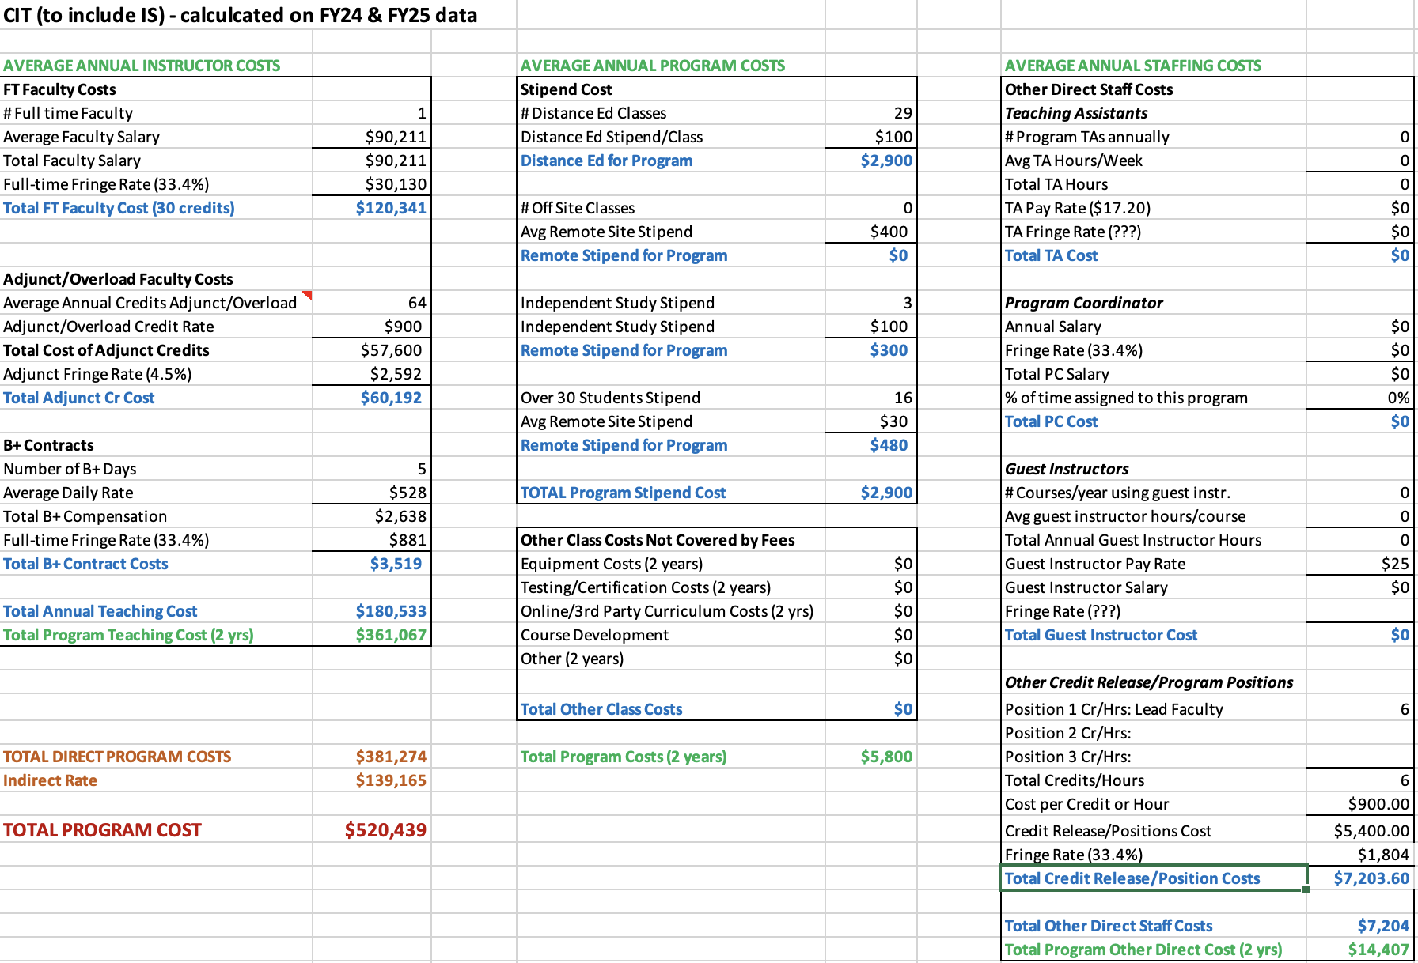

V. Additional Department Information

Overall Summary of Section V:
Several departments mentioned concerns regarding the limited scheduling options for one of the courses required for degree completion, however, the enrollment report over the past 5 years suggests that the availability of this course did not present a significant obstacle to students pursuing these degrees. The enrollment report revealed that there are issues with the limited availability of some core courses in the program, however, the planned addition of a tenured faculty member in this area should alleviate this problem. For example, it was suggested that the limited availability of seats in both CIT 112 and 128 has caused some students to select alternative programs or fail to complete the program in which they are enrolled; however it is only in the most recent semester that the online section of CIT 112 was full and did not have availability for additional enrollment, this recent enrollment issue suggests that students would benefit from different teaching modality options. CIT 128 is only offered through lecture capture/asynchronous. Both of these courses are required for eight out of the ten offered skills certificates, but scheduling should not be the primary concern for low completion rates. If students prefer an in-person option for these courses, perhaps a different course of study would be prudent.
Additional concerns from individual departments:
- It would be beneficial to have articulated credit agreements with full-time faculty for translating common industry certifications into college credits in order to speed up the enrollment process.
- Many students receive grant funding for Computer Information programs, both for credit and through Continuing education. WNC is currently competing internally for students.
- There is a lack of transparency in the cost of programs.
- Rising costs for consumables are creating budgeting concerns in addition to concerns regarding facilities (mold, leaks).
- Technology programs are no longer at the forefront of state and federal initiatives.
- The skills certificates were implemented in order to allow students to complete a program in a single semester, but many of those certificates have prerequisites that mandate a multiple-semester program.
- Fraudulent enrollment continues to be a problem for online programs.
- Students often declare a degree so they can qualify for federal funding, despite having no intention of completing that degree. When they do not complete we assume it is the failure of WNC, but this may not be the case. We have no way to track students’ processes of degree selection or changes.
- Outside approving agencies for financial aid such as the State Approving Agency for VA Benefits are often confused about the Technology emphasis of the AAS or various pathways and emphases. This is cleared up with additional communication, but presents itself regularly as a problem.

- Scheduling
Enrollment Report
- Academic Advising
It may be beneficial to establish clear, articulated credit agreements with the full-time faculty, ensuring that when students arrive with common industry certifications, there is a defined process for translating those certifications into college credits. With the increasing number of certification options available in the CIT field, students often seek credit for their existing credentials; however, if full-time faculty need to review each certification individually before awarding credit, this could slow down the process, potentially causing students to lose interest and turn to online schools that offer a quicker turnaround.
CIT 128, which is a required course in the program, is consistently offered on Tuesdays at 4 p.m. It may be worth exploring flexibility in the modality or timing of this course, as many other CIT courses are available online. The in-person nature of CIT 128 could present a scheduling barrier for students, especially those with other commitments.
While students consistently show strong interest in the cybersecurity path, the availability of relevant classes can sometimes be a challenge. Offering more flexible course options or expanding the availability of cybersecurity courses could help meet student demand and support their success in this area.
The program guide outlines pathways, a feature that provides students with helpful information on how to specialize their AAS in CIT degree; however, some students may mistakenly believe that these pathways will appear on their diploma or resume, which is not the case. Although there is a description above the pathway in the guide to clarify this, additional communication may be needed to ensure students fully understand the distinction. Currently, this is addressed during advising, but further clarity may be beneficial.
Lastly, there are occasional challenges with the availability of electives within the CIT program. These limitations may restrict students' ability to tailor their coursework to their specific interests or career goals, which could impact their overall satisfaction with the program.
- Advancement
There are many technical student scholarships through William N. Pennington Foundation as well as other donors.
- Grants
The Certificate of Achievement in Computer Information Technology and the following skills certificates are qualified programs through the Good Jobs Northern Nevada program: Cisco Routing & Switching, Cybersecurity, IT Essentials, IT Project Management, IT Security: Ethical Hacking, IT Security: General Security, Microsoft Certified Technology Specialist, and Network Support. 4 students have received this funding for the Cybersecurity program.
GJNN runs out of funding in June of 2025 and CIT skills certificates require at least two semesters, making this funding option no longer viable for CIT students. There could be a GJNN extension given the amount of money available in that program. They even have enough funding to cover out of state tuition. The SANDI grant expired on September 30, 2024.
The vast majority of students who enroll in Continuing Ed CIT programs are grant funded. The higher expense of non-credit programs makes the out of pocket student less likely.

- CFO (CS, Cisco, IS, CIT)

Course | Total Approved Fee | Expendable Supplies | Computer Lab Fee
CIT 110 | $30 |  | $30
CIT 112B | $30 |  | $30
CIT 114 | $30 |  | $30
CIT 128 | $30 | $10 | $20
CIT 130 | $30 |  | $30
CIT 132 | $30 |  | $30
CIT 151 | $30 |  | $30
CIT 152 | $30 |  | $30
CIT 161 | $30 |  | $30
CIT 180 | $30 |  | $30
CIT 201B | $10 |  | $10
CIT 202B | $10 |  | $10
CIT 203B | $10 |  | $10
CIT 204B | $10 |  | $10
CIT 211 | $40 |  | $40
CIT 212 | $40 |  | $40
CIT 213R | $40 |  | $40
CIT 214R | $40 |  | $40
CIT 215R | $40 |  | $40
CIT 151 | $30 |  | $30
CIT 260 | $30 |  | $30
CIT 273 | $30 |  | $30
CIT 274 | $30 |  | $30
CIT 275 | $30 |  | $30
CS 202 | $30 |  | $30
CS 135 | $30 |  | $30
CSCO 120 | $30 |  | $30
CSCO 121 | $30 |  | $30
CSCO 220 | $30 |  | $30
CSCO 221 | $30 |  | $30
IS 101 | $30 |  | $30
IS 201 | $30 |  | $30

How course fee requests are approved:
Each year, the CFO sends out a request for any new course fees or changes to existing fees. Any new fees are then compiled and presented to the College Council for review. If a proposed fee exceeds $50, it must be approved by the Board of Regents (BOR). However, fees of $50 or less can be approved directly by the WNC College President.
Once a fee is approved or updated, the Student Finance Coordinator ensures that the new or revised fees are updated in PeopleSoft for the term when they become effective. This process ensures that students registering for these classes are charged the appropriate fee upon enrollment.

- Academic Director
The field of Computer Information Technology (CIT) is continuously evolving, with artificial intelligence (AI) increasingly integrated into processes. In June 2023, a new director was hired after a transitional year when the division was led by an interim director. This leadership change required several adjustments within the division. Since the new director’s arrival, improvements in the department's overall effectiveness have been evident. The introduction of best practices in scheduling and communication has enhanced operational efficiency, and there has been a noticeable increase in awareness of the Western College of Technology and Education (WCTE) division both on campus and in the surrounding communities. This increased visibility has contributed to a more cohesive and effective program.
The department is organized with a Director overseeing the entire division, which includes faculty in several areas such as Graphic Design, Business, Education, Criminal Justice, Aviation, EMS, Fire Science, Agriculture, Computer Information Technology, and Health/PE. The Director is supported by an Administrative Assistant IV, who handles a variety of administrative functions. To further improve operational efficiency, the division has recently expanded its team. An Outreach and Training Coordinator has been hired to manage all Skilled Trade Programs, including Welding, Automotive, Machine Tools, Construction, and Advanced Manufacturing; the funding for this position was through a grant that concludes in June 2025, though it will likely be on-going based on additional grant funding. An additional Administrative Assistant III has been added to support various programs, including Skilled Trades, Fire Science, and EMS; this role is grant-funded through June 2025 and will likely be on-going for skilled trades based on additional grant funding, though it will not continue to support EMS and Fire Science. Additionally, an Early Childhood Education (ECE) Program Coordinator was brought on board recently to manage the numerous ECE grants at the college; this role is grant funded through June 2026 and it is unclear if there will be continued funding after that point. This organizational structure provides dedicated oversight and support across all programs, improving overall operational efficiency.
The department is committed to maintaining instructional effectiveness through several key initiatives. The recent hiring of a new Director and an Outreach and Training Coordinator provides focused leadership and specialized management for the WCTE Division and the Skilled Trade Programs. This ensures that instructional practices align with industry standards and best educational practices. The addition of an Administrative Assistant III and an Early Childhood Education Program Coordinator enhances the support structure for various programs, enabling better coordination, resource allocation, and responsiveness to instructional needs. Furthermore, the department has implemented best practices for scheduling and communication, which optimize instructional time and improve interactions between faculty, students, and stakeholders. Each program, including Skilled Trades, Fire Science, EMS, and Early Childhood Education, benefits from dedicated coordinators who ensure that instructional materials, resources, and methodologies remain up-to-date and effective. The division also actively seeks feedback from students, faculty, and industry partners to identify areas for improvement, fostering continuous enhancement of instructional strategies.
The process for assigning teaching responsibilities within the department is highly collaborative. Full-time instructors provide the Director with an overview of course assignments for the upcoming semester. The Director reviews the plan, and if any issues arise—such as negative feedback from course evaluations or student complaints—the Director works with the instructors to ensure the best-qualified faculty member is assigned to each course. Faculty workloads are typically heavy, with most full-time WCTE faculty carrying a significant overload due to the large number of courses required to ensure students can graduate on time and the challenge of finding skilled adjuncts. To support new faculty, the department has developed a training course in collaboration with the Learning and Innovation department. This course provides new instructors with tools to enhance their teaching effectiveness and outlines the framework for course structure and delivery at the college. All instructors are fully credentialed, either through their educational background or relevant professional experience.
The program is actively focused on recruiting and retaining underrepresented faculty and staff through targeted outreach and recruitment initiatives. This includes engaging with professional networks and organizations that support diversity in education and industry, as well as participating in job fairs and events that attract a diverse pool of candidates. Creating an inclusive and supportive work environment is also a priority, as it helps retain underrepresented faculty and staff. While several significant hires have been made recently, the department has lost three faculty members in WCTE since 2022 including Emily Howarth in Automation and Industrial Technology, Jason Spohr in Automotive, and Juan Ramirez, a full-time Welding Instructor, which impacted the College's standing within the community. However, the hiring of new adjunct instructors is expected to help rebuild trust and restore the program’s reputation.
There is a recognized need for a second full-time instructor in CIT to help manage the growing demand for courses and support students effectively.
Until recently, additional support staff was a significant concern. However, since May, the department has been able to hire an additional Administrative Assistant, an Outreach Coordinator, and an Early Childhood Education Program Coordinator. With these new hires, the department now has adequate support staff to meet its operational needs. All of these positions are currently grant-funded, and it is unclear at this time if there will be funding available to make them sustainable in the long term.
Many of the department's more costly programs, such as Perkins and WINN, are funded through grants. Additionally, Skilled Trades programs are often funded through the Governor’s Office of Economic Development (Workforce Innovation for the New Nevada) grants, providing critical resources including equipment, access to certifications, and staff. Lab fees are used to cover consumables, but rising material costs have created challenges. The department has had to dip into its general operating budget to secure the necessary supplies for maintaining industry-standard programs.
The department regularly assesses its use of funding and human resources through reviews and strategic planning. Financial resources are monitored to ensure alignment with the program’s goals and effective utilization. Expenditures are evaluated based on their impact on student outcomes, program growth, and operational efficiency. For human resources, the department reviews faculty and staff workloads and the effectiveness of course delivery and student support services. Feedback from students, faculty, and staff is used to identify areas for improvement, ensuring that resources are optimized to meet the program's needs.
Facilities remain one of the department's biggest concerns. Some buildings have mold issues, leading to classrooms being closed just before the semester begins. Other buildings experience uncontrollable leaks that pose a risk to expensive equipment and vehicles, further complicating operations.

- Learning and Innovation

In the Fall of 2023, Learning and Innovation piloted a 16-week Canvas-based “Faculty Development” course. This course provided information on expectations for WNC instructors as well as strategies and tools for teaching effectively.
Additionally, Learning and Innovation hosts the Zoom-based “Coffee and Classroom Conversations” series that focuses on a wide range of teaching topics. This series is driven by faculty interests and WCTE faculty have regularly attended these sessions.
The Learning and Innovation team has met with WCTE faculty for support in assignment development and teaching strategies, as well offering professional development opportunities for faculty in support of student learning initiatives including the introduction of best practices for working with students in CTE fields.
Learning and Innovation also provides technical support for Canvas including help desk support and instructional design.
The greatest adjustment has been the increased reliance on Zoom for the provision of training and support as well as the focus on Canvas support. Learning and Innovation has found that WCTE instructors can be reluctant to engage in professional development opportunities and may not be using Canvas to the full extent.

- ACMC
The most recent changes were made in 2022. We added several skills certificates and 4 pathways for the AAS (front end, back end, cybersecurity, and programming). The purpose of the skills certificates was to create programs that could be completed in a single semester; however, certain classes such as CIT 270 have a prerequisite of CIT 112, which mandates a multiple-semester completion.
Tech programs are no longer at the forefront of state or federal employment training initiatives; the focus is now shifting towards teacher education.
It is unclear if the skills certificates or degrees are leading to careers in this field. The idea of the skills certificates in part was to skill up people already working in these fields for professional advancement; however, there is not currently data available to establish if the intended outcome is being achieved. Also, last fall a student fee increase was approved.
In November 2019, the Certificates of Achievement in Computer Information Technology and Cyber Security Technician were adopted to provide a step in the scaffold between the skills certificates and associate of applied science in CIT; at the same time, the Certificates of Achievement in Network Support Technician and System Administration Technician were deactivated as they were no longer aligned with the CIT program.
In May 2020, a series of CIT courses were adopted (CIT 112, CIT 152, CIT 220, CIT 251, CIT 270, CIT 280, and CIT 281) as the first step in a larger restructuring of the CIT program; these courses provide two potential pathways for students, one on the software side and on the other side hardware.
In May of 2021, CIT 134 was added to the WNC course offerings, focusing on the C# Programming language. In October of 2022, CIT 148 and CIT 248 were added to the WNC course catalog with the intent of offering these courses to K-12 teachers who are looking to obtain an endorsement of the Nevada Department of Education in advanced computer science to teach related high school classes.
In November of 2022, the CIT program underwent significant revision. Skills Certificates for Front End Developer, IT Cisco Routing and Switching, IT Essential Skills, IT Network Support, IT Security: Ethical Hacking, General Security, and IT Project Management were added to the program. These skills certificates were created to provide multiple entry points for students based on their interest or employment, providing a step for students on their way to an AAS Tech degree. At this time, emphases were created under the AAS to delineate different pathways for students pursuing this area of study. Additionally, at this time a new skills certificate for Secondary Education Endorsement Programming was also adopted in response to an identified need of the K-12 system and the new state requirements for teaching computer science students.
In February of 2023, an additional course was adopted, CIT 230, to address needs identified in the state and provide greater training for students in Java. Also in February 2023, the Certificate of Achievement in CIT was updated to allow students more options in how to complete the requirements of the certificate. Finally, at that time, the Certificate of Achievement in Cybersecurity was deactivated as the required coursework was too narrowly defined to allow students to easily complete it.

- Financial Aid
Feedback from students tends to focus primarily on course delivery, conflicts with instructors, access to resources, and various learning challenges they may face. These concerns are important to address, as they directly impact the overall student experience and their ability to succeed in the program. By understanding and addressing these issues, we can improve both the quality of education and the support systems available to students.
For students pursuing the AAS-Tech degree, we observe that they are generally well supported throughout their studies. This is largely due to their close connection with their subject matter faculty, who provide guidance, mentorship, and specialized expertise. This connection seems to create a supportive environment that helps students stay engaged and succeed in their coursework.
There is discussion about whether there’s a way to track and demonstrate if students in WCTE degree programs are successfully stacking their credentials, such as earning Skills Certificates, Certificates of Achievement (COA), and ultimately completing the AAS degree. It may not have been formally reported, but it would be valuable to measure how students are progressing through these stacked credentials, as it could provide insights into the effectiveness of the program and highlight areas for improvement.
Students often declare a degree primarily to open up options for Financial Aid, even if they have no intention of completing the degree. While this practice is not entirely new, it’s something that should be noted. One area where the process falls short is in documenting whether the student has achieved their initial goal. There is a tendency to assume that if a student does not graduate with the degree, the assistance provided was a failure, even though they may have completed other objectives. This gap in tracking student outcomes could be addressed to better reflect the support students are receiving, regardless of whether they ultimately earn the degree.
Another ongoing challenge is the attraction of fraudulent enrollment in online programs, particularly by those who are looking to take advantage of Financial Aid dollars. These individuals often target online programs to exploit the system, which remains a concern across many institutions.
Additionally, there are occasional issues with the approval process for certain programs, particularly when it comes to the AAS-Technology degrees, which are approved by agencies like the State Approving Agency for VA Benefits. When a new reviewer examines the catalog, there is often confusion about how to categorize the Technology emphasis or how to handle the different pathways, such as Automated Systems or CIT. While these issues can usually be resolved through conversation and clarification with the reviewer, it remains a recurring challenge that requires attention each time a new person evaluates the catalog.
- Continuing Education - Here is a list of students enrolled in applicable Continuing Education programs:

CompTIA Certification Training: A+, Network+, Security+ | 3 students enrolled, and were funded through WIOA when the for-credit CompTIA program was not on the ETPL.
Data Analyst | 76 students enrolled, 10 were self-pay and the rest were grant-funded
Python Developer | 32 students enrolled, 3 were self-paid, 3 were employer-paid and the rest were grant-funded

- Faculty

There have been a lot of changes in this program to keep up with a continually changing industry. The change in Division director in WCTE has been positive for this program though we are still adjusting to the difference in leadership styles and goals. CIT continues to struggle with the incongruity between the speed at which the industry changes and the perceived slow-down of the processes necessary to make changes institutionally. Under the previous division director, significant portions of the program were duplicated in continuing ed; subsequent to this action, the full-time faculty member in this area was asked to assist in the articulation of credit for prior learning agreements for the certificates earned in Continuing Education so that student completing those certificates could receive credit for that learning as part of their degree program. While students may see the immediate benefits of certification while seeking employment, the full degree is more likely to ensure job security once employment has been found. It is a strength of this program that the core 5 classes feed into skills certificates and that those then scaffold up to the certificate of achievement and AAS degrees; however, staffing shortages mean we are still struggling to offer every course in the core every semester.

The field is generally moving towards more automation. The recent advances in Artificial Intelligence is already influencing the industry, though the full ramifications of this technology on this field are still unclear. Additionally, things computer science professionals used to do manually are now being written into the hardware directly, allowing hardware to take the place of some of the training previously included in the program. This change in the field means instruction is now focused more on coding and scripting.

The hiring of a new full-time faculty member will have a significant positive impact on the program by opening up scheduling options and supporting the development of curriculum that can be used by full-time and adjunct faculty. This program would benefit from having greater freedom to innovate; such as moving away from set semester start and end dates, opening up restrictions (like age) on student enrollment, and the ability to tailor course curriculum to student needs. Currently, there are functions in Canvas that are not being utilized that would ease assessment of Institutional Student Learning Outcomes. It would be beneficial to have increased marketing opportunities, particularly in the face of the many educational options available for these kinds of programs.

There were significant issues with the way Textbook Brokers handled the access codes for course materials. As we look for a new bookstore partnership, we need to consider how they handle digital materials and student access codes.

The enrollment of this program is largely dependent on industry trends meaning there is a lot of variation from year to year and it is very hard to predict. Anecdotally, enrollment seems to be trending generally downward as more online certification options become available. The current trends suggest that further educational experience beyond certification is being sought by employers, which is good news for us. The certifications we offer are relevant to the industry and the students seeking employment, based on feedback from adjunct faculty who also work in the industry. Some students coming into the program have no experience with this subject and have difficulty completing a skills certification without the background knowledge more typically found in people pursuing education in this field.

The limitations of how we offer classes are hurting our ability to compete with other certification programs. Many similar programs are entirely self-paced and competency-based meaning students can accelerate their program if they so choose. Once they have finished a course at WNC students have to wait until the start of a semester to enroll in the next class. If a class does not have enough enrollment to run, students end up getting pushed into an independent study class, which is difficult on both faculty and students.

VI. Faculty Profiles
- Full Time
  - Dave Riske, Master’s of Science in Information Technology
- Adjunct
  - Zach Cupp
    - Associate of Applied Science – Computer Networking Technology from WNC
    - CCNA (Certified Cisco Network Administrator)
  - Topher Reynolds
    - Bachelor's Degree in Information Systems from UNR
    - Associate Degree in Computer Networking from TMCC
  - Mona Willden
    - CCNA (Certified Cisco Network Administrator)
    - CCAI (Certified Cisco Authorized Instructor)
    - MCP (Microsoft Certified Professional)
    - CNA (Certified Novell Administrator)
    - CEH (Certified Ethical Hacker)
    - 23 years of industry experience
  - Emil Stoica
    - Master of Science – Data Analytics from WGU
    - Bachelor of Science – Data Analytics from WGU
    - Associate of Applied Science – Computer Information Technology from WNC
    - Certifications include:
      - TestOut PC Pro, Network Pro & Security Pro Certified
      - CompTia A+ Core 1 (1001) & Core 2 (1002), Network + Certified
      - Oracle 12c Administrator 1Z0-062 & SQL 1Z0-071 Certified
      - SAS Base Programmer 9.4 A00-231 Certified
      - CIW Data Analyst Certified
  - Geoff Rivera
    - Master of Science in Cybersecurity from Southern New Hampshire University
    - Bachelors of Science in Information Security from University of Phoenix
    - Associate of Science in IT Networking from University of Phoenix
    - Certifications include:
      - Certified JAMF Tech (200), JAMF
      - Certified JAMF Administrator (300), JAMF
      - Certified Web Application Penetration Tester (GWAPT), GIAC
      - Certified Internal Security Assessor, PCI
- 43% full time, 57% adjunct

VII. Comparisons
Comparison Institutions:
- WNC Continuing Education - a significant number of WNC students end up taking
- CSN (number of graduates in 2024)
  - Computer Science, AA (42)
  - Computer Science, CA
  - Computing and Information Technology: Cyber Security - Compliance, AAS (4)
  - Computer and Information Technology: Cyber Security - Digital Forensics: AAS (15)
  - Computing and Information Technology: Cyber Security - Network Security: AAS (50)
  - Computing and Information Technology: Networking - Network Administration: AAS
  - Computing and Information Technology: Networking - Cloud Systems Administration: AAS (4)
  - Computing and Information Technology: Software - Database: AAS (3)
  - Computing and Information Technology: Software - Programming: AAS (52)
  - Computing and Information Technology: Software - Web Development: AAS (17)
  - Computing and Information Technology: Cyber Security - Digital Forensics: CA
  - Computing and Information Technology: Information Management - Network Infrastructure Analyst: CA
  - Computing and Information Technology: Information Management - Software Analyst: CA
  - Computing and Information Technology: Information Management - Virtual Computing Analyst: CA (2)
  - Computing and Information Technology: Networking - Cloud Systems Administration, CA
  - Skills Certificates:
    - Cisco Certified Network Associate
    - Cisco Certified Network Professional
    - CompTIA A+ and Network+
    - CompTIA Project+
    - CompTIA Security+
    - Red Hat Linux Administrator
    - Microsoft Cloud Specialist
- While not listed on the website for Computer and Information Technology, these programs listed graduates in 2024:
  - Computing and Information Technology - Networking - Client/Server (1)
  - Computing and Information Technology - Networking - Router/Switch (4)
  - Computing and Information Technology - Networking - System Administration (8)
- Cost: $123.75/lower division credit (2024-2025 academic year. $115.50/credit for 2023-2024 academic year)

- TMCC
  - Computer Programming, Computer Information Technology, AAS
  - Cybersecurity, Computer Information Technology, AAS
  - Networking, Computer Information Technology, AAS
  - Web Development, Computer Information Technology, AAS
  - Computer Technologies, Certificate of Achievement
  - Skills Certificates
    - Cisco Certified Network Associate (CCNA) Routing and Switching
    - Cisco Certified Network Associate (CCNA) Security
    - CompTIA Certification Preparation
    - IT Basics
    - IT Specialty - Back End Developer
    - IT Specialty - Front End Developer
    - IT Specialty - Full Stack Developer
  - Certifications
    - A+ Certification
    - Cisco Certification
    - Cybersecurity Certification
    - Linux Certification
    - Microsoft Office Specialist (MOS) Certification
    - Network+ Certification
  - FastTrack - Tech Careers FastTrack Program - IT Support Specialist
    - This is a non-credit program that provides a faster path to completion for students who are not interested in traditional, for-credit educational pathways.

- Nevada Technology Academy
  - Certificate of Completion
    - CISCO Networking
    - Cybersecurity
    - Computer Technology
    - IoT
    - Coding Academy
  - Tuition
    - Tuition: $106.75/credit
    - Technology fee $100/semester
    - Lab fee $9/credit
    - Application fee $40/once upon acceptance
    - Enrollment deposit $100/one time fee

- Coursera ($59/month for Coursera plus). Many certificate options available from individual companies (Microsoft Back-End Developer, IT Support, Cisco Networking).

- Udacity - 200 free training courses. Alternatively there are many certification options available that provide mentor support and cumulative industry specific projects ($125/month).

The market is saturated with training opportunities, both formal and informal, for Computer Information Technology seeking students. With WNC’s limited resources, unfortunately we do not have a competitive edge amongst our peers. Our scheduling is limited, our faculty is limited, and students can easily gain these skills elsewhere. Additionally, we are competing against ourselves with the separation between for-credit programs and Continuing Education offerings.

VIII. Recommendations and Commendations

Commendations:
- This was the first time implementing the new program review process, which required assistance and participation from many individuals. Administrative departments and IT were essential in gathering necessary information and fielding questions.
- CIT full-time faculty for their contributions to program history and insight into industry trends. Adjunct faculty for the program development participation.

Limitations:
- Data - the 6 AAS Technology program reviews were delayed by more than a year due to problems collecting complete and accurate data. Solution: either the office of Institutional Research and Effectiveness will need to resolve the identified data consistency issues or the program review specialist will need access to the current data warehouse.
- Infrastructure - we were unable to assess division and institution level data due to computer processing limitations. Solution: we need a computer that has a large data processing capacity.
- Faculty participation - we were unable to garner adequate participation for faculty forums. We will continue to gather faculty feedback via part 5.11 of the program review template, but will transfer faculty approval of recommended curricular decisions to the Curriculum Committee.

Program-specific recommendations:
- The ROI on this program is problematic. We need to revisit the priorities of the program and determine if the emphasis should be on award completion or course enrollment.
  - Develop a dual-credit Canvas shell.
- Reevaluate skills certificate award curriculum based on current industry standards, WNC resource limitations, and student needs.
- Work with Scheduling to offer all five core courses every semester, with varying dates/times.
  - Change course scheduling designation to asynchronous online for all CIT courses.
- Work with Admissions and Records and the VPASA to develop 1) credit for prior learning options for students, and 2) more flexible enrollment options to allow for accelerated pacing without limitations of the semester schedule.
  - Consider a fastrack option for flexible enrollment.
- Review course outcomes to more accurately align with 1) institutional SLOs, and 2) the new award-specific objectives.
  - Develop award specific objectives and an accompanying assessment plan.
- Evaluate internal competition with Continuing Education.
- Provide additional administrative support to WCTE.

Program-review process recommendations:
- Systematic assessment of SLOs is the only way to determine if students are meeting the indicated outcomes, as industry exams are not required for course completion. Faculty should work with the Accreditation and Curriculum Management Coordinator to develop a comprehensive assessment plan. Assessment needs to be used instead of industry exam pass rates because those are not required so students are not obligated to provide that information to the college.
- We do not currently have a method for capturing faculty professional development experiences, course- level curricular changes based on assessment, and assessment activities outside of the assessment Jotform. Solution: modify the annual faculty self evaluation to prescribe certain mandatory activities (assessment, professional development, curricular changes and why).
- Scheduling analysis - the enrollment report provides a great deal of information, but we do not currently have a method for analyzing that information. Implementing the Coursedog scheduling report, or alternative analytical tool, would provide data on where students stop completing programs.
- Work with faculty and the division director to develop suggested course sequences for skills certificates.
- Work with faculty and the division director to develop award-specific outcomes for WCTE programs.
- We need to develop better tracking mechanisms for student services, including Academic Advising and Learning and Innovation in order to determine how often individual students are utilizing these services.
- We need to implement entrance, exit, and degree change surveys for students in order to determine reasons for selecting particular programs. Work with Admissions and Records and Institutional Research to include these surveys in the degree declaration, degree change, and graduation application forms.
- Change ethnicity surveys to select all that apply.

This is consistent with concerns expressed by the Career and College Readiness office.
7 credits are required for the CoA, but all the courses offered are 3 credits.
The WCTE Division retrieved this information from the IR Dashboard. This illustrates the inaccuracies in our current public reporting system. At the time of this report (February 2025) no awards had been conferred to students, yet the dashboard lists 4 skills certificate completers and 3 AAS completers. This is an example of the need for the following recommendation: Data - the 6 AAS Technology program reviews were delayed by more than a year due to problems collecting complete and accurate data. Solution: either the office of Institutional Research and Effectiveness will need to resolve the identified data consistency issues or the program review specialist will need access to the current data warehouse.

