Program Review
Machine Tool Technology
2024

Table of Contents:
- Program/Program Review History……………………………………………………..2
- Alignment to Institutional Goals……………………………………………………….7
- Program Data…………………………………………………………………..……...12
- Financials……………………………………………………………………..……….23
- Departmental Information……………………………………………………….……24
- Faculty Profiles…………………………………………………………………….….31
- Comparisons…………………………………………………………………...……...32
- Recommendations and Commendations……………………………………...………33

- Program/Program Review History
- Program Overview
  - This review will functionally begin with data from 2013 as that is the year the AAS Technology degree was instituted and previous programs were deactivated. That year WNC removed emphases from degrees in order to comply with NSHE completion requirements. As a result, Machine Tool Technology is now part of a 6 program degree including Automotive Mechanics, Computer Information Technology, Construction, Mechatronics Technology, and Welding.
  - The following is a list of currently offered awards in Machine Tool Technology:

Award | Description | Required Courses
Skills Certificate: Machine Tool Technology | The National Institute for Metalworking Skills (NIMS) offers various levels of certification in machining. | Level 1: Chucking, Surface Grinding and Milling  MTT 105: Machine Shop I  MTT 110: Machine Shop II  MTT 250: Machine Shop III  Level 3: CNC Operating, Turning and Measurement  MTT 230: Computer Numerical Control I  MTT 232 Computer Numerical Control II  MTT 260 Machine Shop IV
Certificate of Achievement: Machine Tool Technology | Students will prepare for entry into machining occupations. Learn setup and use of industrial equipment and tools utilized by machinists to manufacture parts for all types of machines. Operation of CNC (computer numerical control) lathes and mills and other hand tools preparing students for National Institute for Metalworking Skills (NIMS) exams Levels 1 and 3. | DFT 110: Blueprint Reading for Industry  or CONS 120: Blueprint Reading and Specification  MTT 105: Machine Shop I  MTT 106: Machine Shop Practice I  MTT 110: Machine Shop II  MTT 111: Machine Shop Practice II  MTT 230: Computer Numerical Control I  General Education Requirements: 10 credits  English/Communications (6)  Recommended BUS 108  Human Relations (1)  Mathematics (3)  MATH 110 Recommended
Associate of Applied Science Technology: Machine Tool Technology | The mission of the Associate of Applied Science in Technology is to provide employment-related knowledge and skills necessary as a professional in a chosen field of study. | DFT 110: Blueprint Reading for Industry  MTT 105: Machine Shop I  MTT 106: Machine Shop Practice I  MTT 110: Machine Shop II MTT 111: Machine Shop Practice II  MTT 230: Computer Numerical Control I  MTT 232: Computer Numerical Control II  MTT 250: Machine Shop III MTT 251: Machine Shop Practice III  MTT 260: Machine Shop IV  Choose 7 credits from the following:  AIT 101: Fundamentals of Applied Industrial Technology (4)  MTT 261: Machine Projects (1-6)  MTT 262: Machine Shop Practice IV (2)  MTT 292: Computer-Aided Manufacturing I (4)  MTT 292: Computer-Aided Manufacturing II (4)  MTT 295: Work Experience (1-6)  Any MTT Course (1-6)  General Education Requirements: 24 credits  English/Communications (6)  Recommended BUS 107  Human Relations (3)  Recommended BUS 110  Humanities/Social Science (3)  Mathematics (3)  Recommended MATH 110  Science (3)  US/Nevada Constitution (3)  General Elective (3)

Certificate of Achievement in Machine Tool Technology Course Sequence

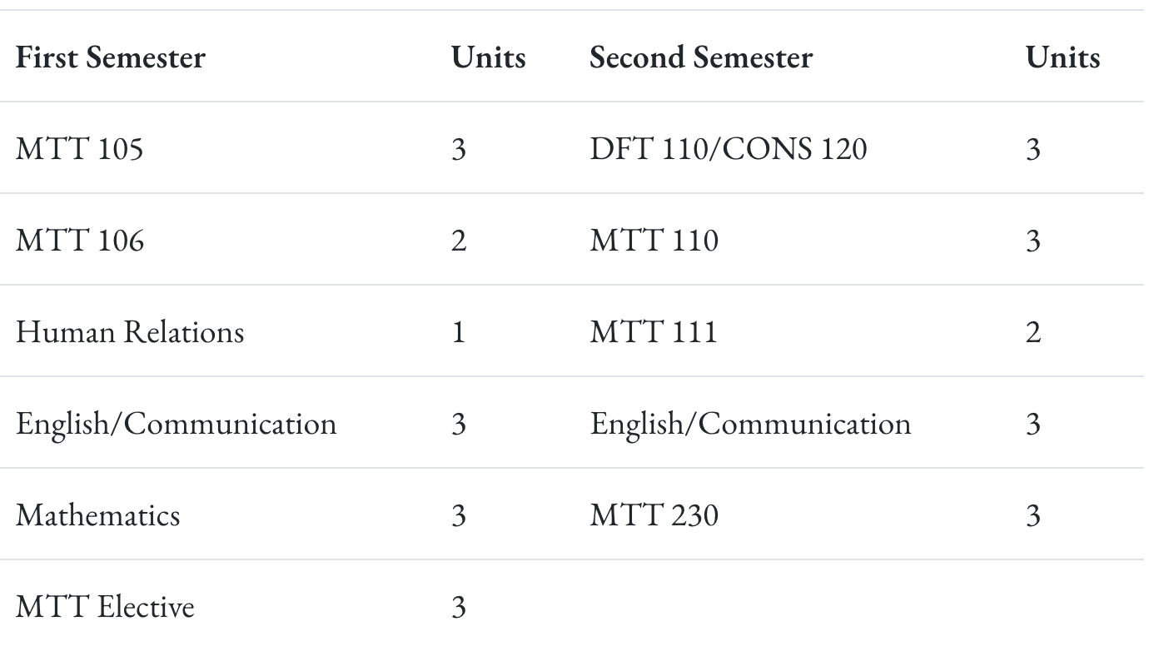

Associate of Applied Science in Machine Tool Technology Course Sequence

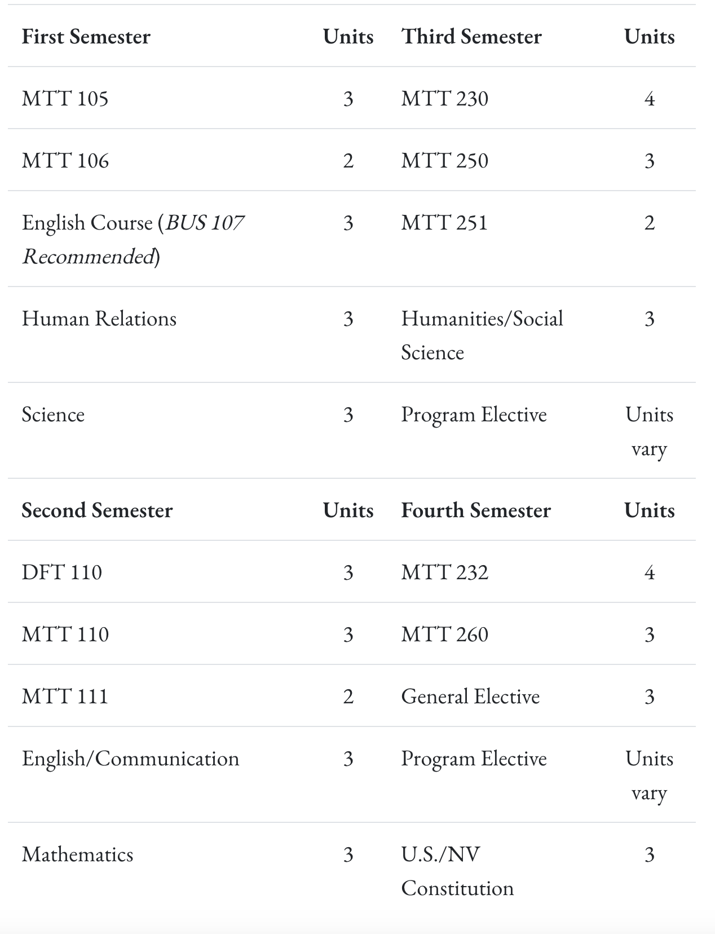

- Program Review History
  - A brief review was done in 2018 utilizing a previous program review template. At that time, Machine Tool Technology offered an Associate of Applied Science and predominantly served older students with manufacturing backgrounds to maintain or increase their knowledge base. They also partnered with Job Connect and JOIN to aid local employers in hiring suitable employees. At that time, they made enrollment in the degree program a requirement in order to enroll in classes. This was done to increase FTE.

II. Alignment to Institutional Goals

WNC | Machine Tool
Vision: WNC is an integral and innovative educational partner fostering equity and a life of learning in an exclusive environment for the evolving, diverse community we serve.  Values: WNC is student centered, inquiry driven and data informed as we nurture community connections and promote an environment of equity and inclusion.  Mission: WNC contributes to solutions for the 21st century by providing effective educational pathways for the students and communities of Nevada. | Machinists shape metal and other materials into precision parts and objects through the set up and operation of complex equipment such as milling and drilling machines, grinders and lathes. This program allows students to gain technical skill proficiency in manual machining, as well as automated Computer Numerical Control (CNC) machines. Aligned with the National Institution for Metalworking Skills certification, this program will prepare students with the skills needed for entry level employment or to improve skills for career advancement.  Students will prepare for entry into machining occupations. Learn setup and use of industrial equipment and tools utilized by machinists to manufacture parts for all types of machines. Operation of CNC (computer numerical control) lathes and mills and other hand tools preparing students for National Institute for Metalworking Skills (NIMS) exams Levels 1 and 3.  The mission of the Associate of Applied Science in Technology is to provide employment-related knowledge and skills necessary as a professional in a chosen field of study.
WNC Student Learning Outcomes:  - CONTENT KNOWLEDGE: Demonstrate understanding of essential information and concepts relevant to a discipline or area of study.  - COMMUNICATION: Effectively convey and/or interpret a central idea via visual, oral, or written media.  - QUANTITATIVE LITERACY: Correctly analyze, interpret, draw conclusions from, and communicate quantitative processes and information.  - INFORMATION LITERACY: Locate, evaluate, and appropriately use information from multiple resources in support of a claim or central idea.  - DIVERSITY AND SOCIETY: Identify and discuss changing human societies demonstrating an understanding of the subject and respect for various cultural, methodological, and/or theoretical perspectives.  - CRITICAL THINKING: Integrate knowledge and skills to develop logical conclusions and/or solutions that demonstrate a well-reasoned evaluation of a problem, question, perspective, or solution.  - CAREER PREPARATION: Apply specialized knowledge, approaches, and skills to successfully complete projects and/or demonstrate relevant professional and/or industry-standard competencies | AAS Student Learning Outcomes:  - Know the subject matter appropriate to the emphasis of the degree.  Have met the institutional student learning outcomes.  - Have met the institutional student learning outcomes.  - Have met the institutional student learning outcomes.  - Have met the institutional student learning outcomes.  - Have acquired skills and can perform tasks necessary for employment or career advancement.  - Have met the institutional student learning outcomes.  - Have met the institutional student learning outcomes.  AAS Technology Student Learning Outcomes:  Know the subject matter appropriate to the emphasis of the degree. (WNC SLO 1,3,6,7)  Communicate effectively and appropriately, in oral and written form. WNC SLO 2)  Locate, evaluate and properly utilize the tools and resources appropriate to a technology degree professional. (WNC SLO 1,6,7)  Acquire skills and perform tasks necessary for employment or career enhancement. (WNC SLO 1,7)  Developed an appreciation of the importance of social, ethical, legal and diversity issues. (WNC SLO 5,7)  Developed an appreciation of the need and importance of lifelong learning. (WNC SLO 1)
Content Knowledge
The program’s emphasis on technical competence in machining processes directly addresses WNC’s institutional goal of content knowledge. Students gain a comprehensive understanding of materials, manufacturing processes, machine operation, and safety protocols (Program SLO 1). This technical foundation ensures students demonstrate mastery of essential concepts specific to the machining discipline.
Communication
Clear communication is crucial in the machining field, where misinterpretation can lead to costly errors or safety risks. The program develops students’ ability to communicate effectively in both oral and written forms (Program SLO 2), whether through reading and interpreting blueprints, documenting machining processes, or collaborating on shop floor tasks. This supports WNC’s outcome that students effectively convey and interpret central ideas in professional contexts.
Quantitative Literacy
The application of math and measurements is inherent in machining, from calculating dimensions and tolerances to operating CNC machines. Although not separately listed as a standalone outcome, quantitative literacy is embedded in Program SLOs 1 and 3, as students analyze technical specifications and make precise adjustments to equipment and tooling. These tasks align with WNC’s goal of ensuring students can correctly interpret and communicate quantitative data and processes.
Information Literacy
Students are required to evaluate and utilize a wide range of technical resources, including machine manuals, CAD/CAM software, and CNC programming tools (Program SLO 3). Instructors guide students in sourcing relevant industry documentation and interpreting specifications to support manufacturing decisions, which directly fulfills WNC’s emphasis on information literacy—using appropriate resources to support claims and actions.
Diversity and Society
The Machine Tool Technology Program integrates an understanding of ethical, legal, and diversity-related issues in the workplace (Program SLO 5). Topics such as workplace safety regulations, professional ethics, and inclusive collaboration in diverse teams are discussed, aligning with WNC’s institutional outcome to foster awareness and respect for societal and cultural dynamics.
Critical Thinking
Machinists must troubleshoot machine errors, optimize workflows, and interpret technical drawings with precision. Students learn to develop logical solutions to real-world machining challenges (Program SLOs 1 and 3), integrating knowledge and hands-on skills. These experiences directly support WNC’s critical thinking outcome by promoting well-reasoned evaluation and decision-making in a technical context.
Career Preparation
The Machine Tool Technology Program is firmly grounded in career preparation, offering hands-on experience with industry-standard equipment and tools, including CNC lathes and mills (Program SLOs 1 and 4). Students develop a strong portfolio of competencies aligned with NIMS certification standards, preparing them for immediate employment or advancement in machining careers. This meets WNC’s institutional objective of equipping students with specialized, industry-relevant skills.

WNC Institutional Objectives | Machine Tool
WNC provides access to educational pathways and opportunities | - Courses are offered in 5-week and full-semester options  - Enrollment has increased in the last year  - Recent change in skills certificate allows students to stack manual machining and CNC machining to obtain a COA and/or Associates.
WNC students make an efficient transition from preparatory to college level coursework | For students seeking to start the program after graduation, Nevada’s current graduation and GDE requirements adequately prepare students.
WNC provides equitable access for students regionally and demographically | MTT classes are offered on both the Carson campus as well as the Fallon campus.
WNC provides access to dual credit pathways | At this time there are no dual credit pathways for Machine Tools
WNC supports student learning, progress, and completion | If students take an entry-level class, they are prone to continue taking classes.
WNC advances student achievement of learning outcomes at course, program, and institutional levels | 70% of students demonstrate proficiency in core competencies such as manual machining, CNC operation, blueprint reading, and safety protocols.
WNC builds student engagement with education and the WNC community | Partnerships for upskilling employees with 2 local companies
WNC identifies and closes achievement gaps across student populations by supporting achievement across demographic groups in traditional and non-traditional fields
WNC sustains a learning environment that promotes equity and inclusion
WNC responds to the needs of industry and provides effective pathways for students toward in-demand occupations | Full time instructor stays up to date with the newest trends in the industry, and incorporates those into his classes. When industry wants to upskill their employees WNC makes it work.
WNC contributes to solutions to the critical issues facing 21st century Nevada | Multiple students have found job placements after their training at WNC.

Curriculum Map
III. Program Data

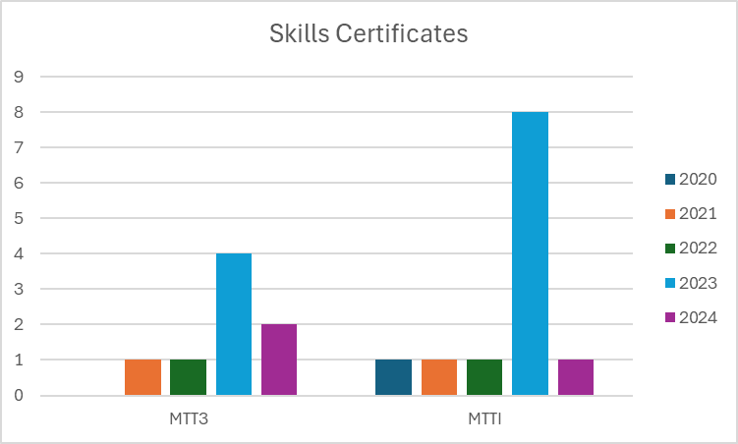

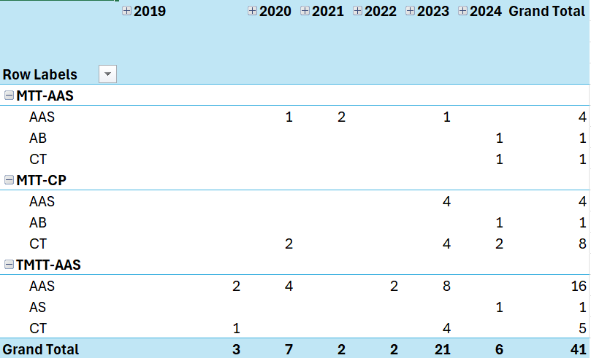

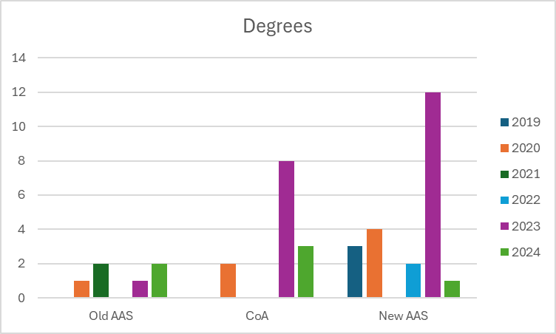

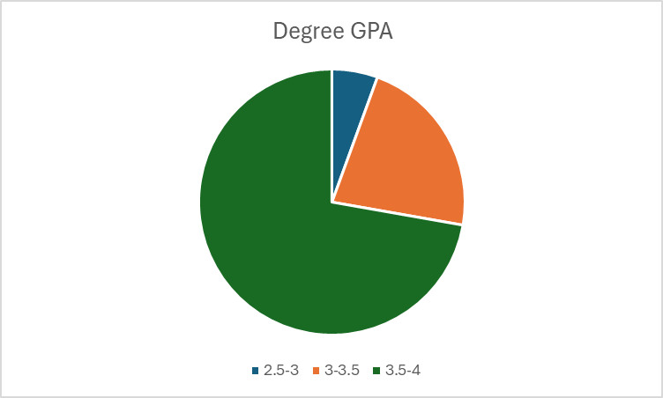

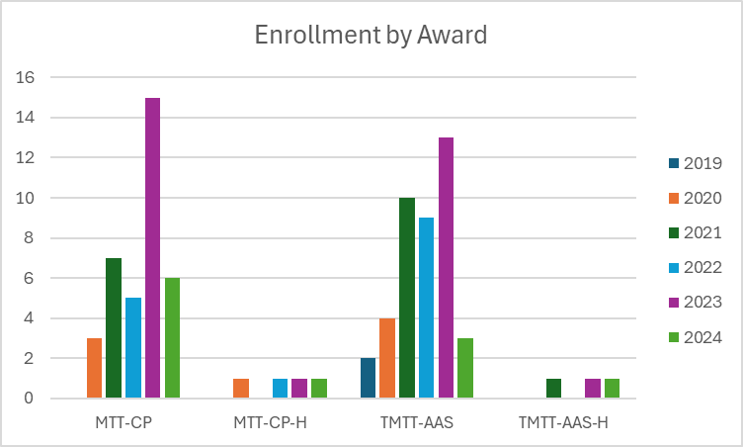

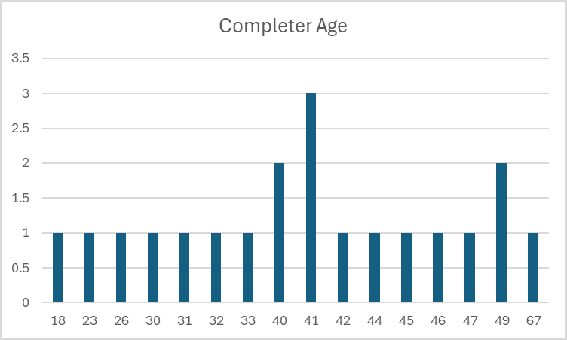

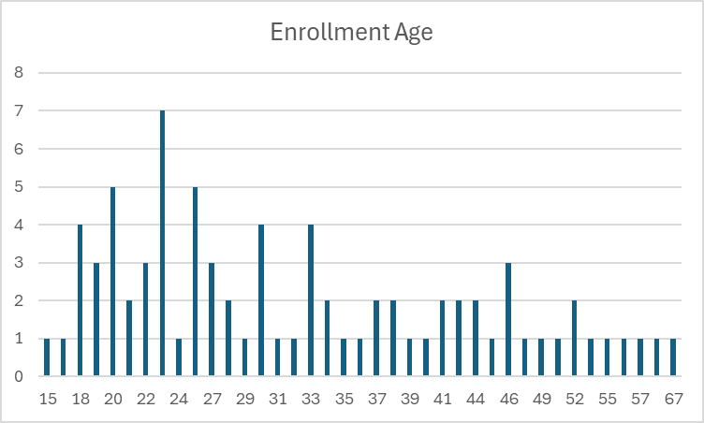

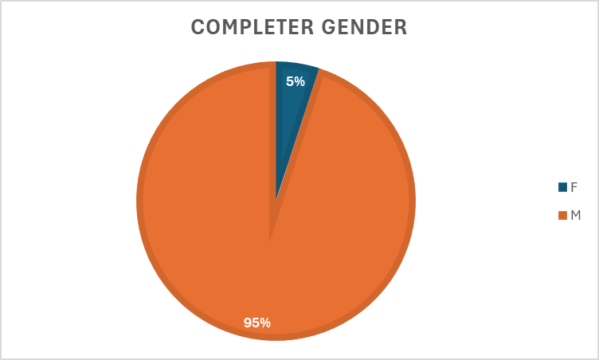

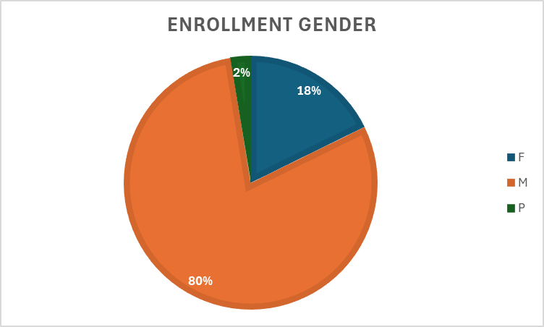

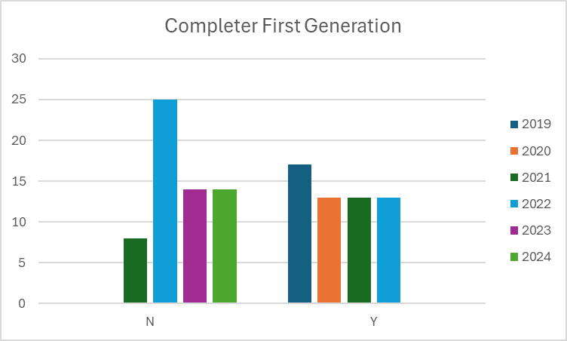

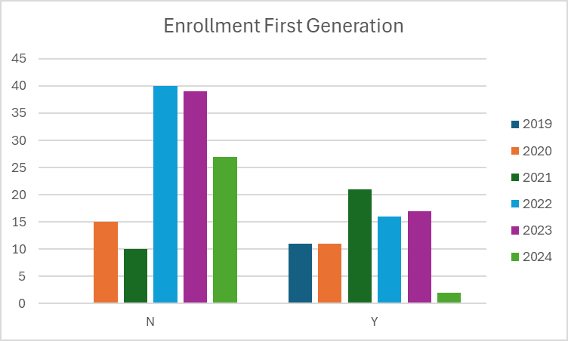

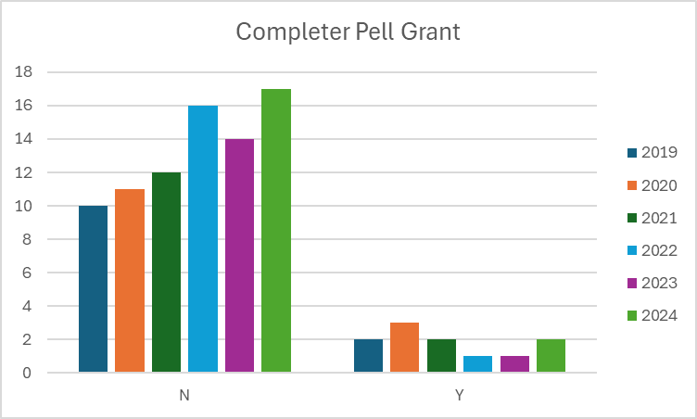

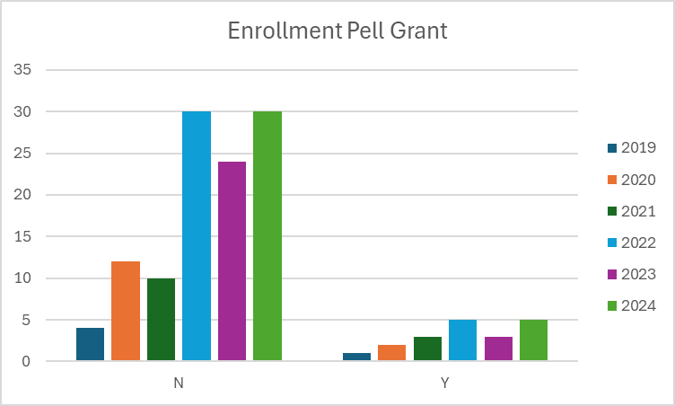

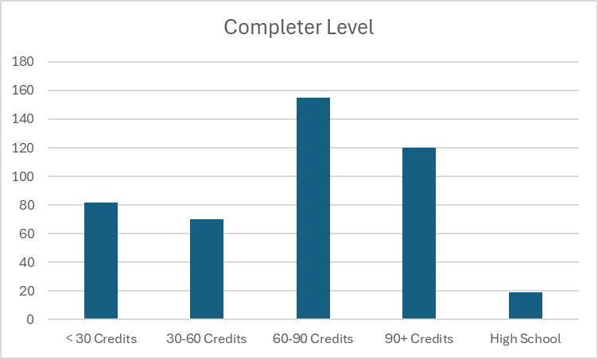

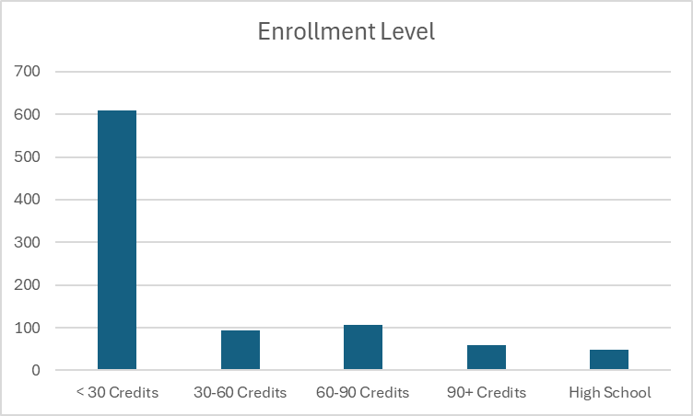

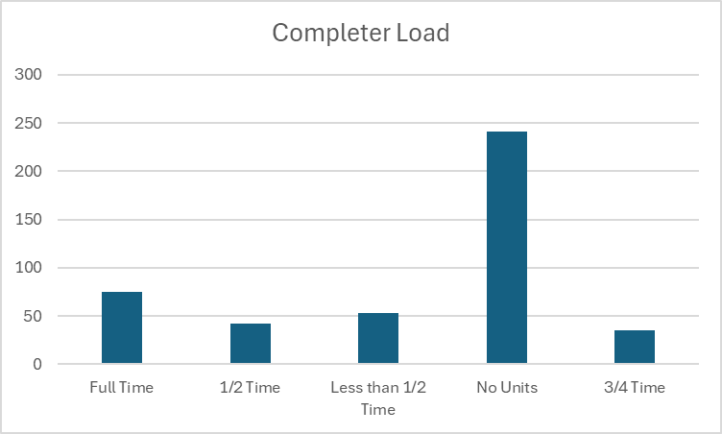

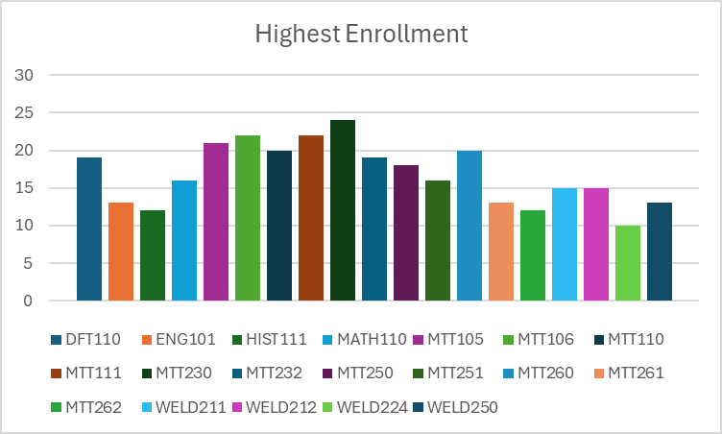

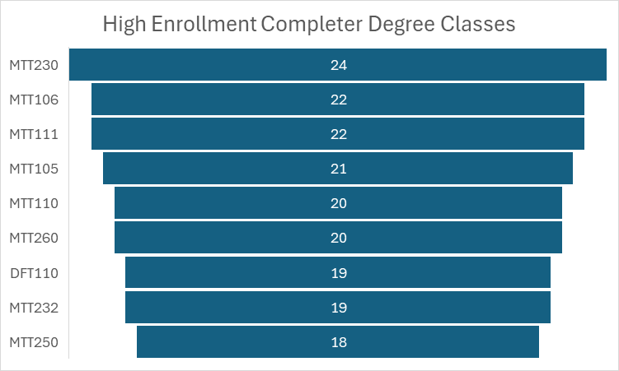

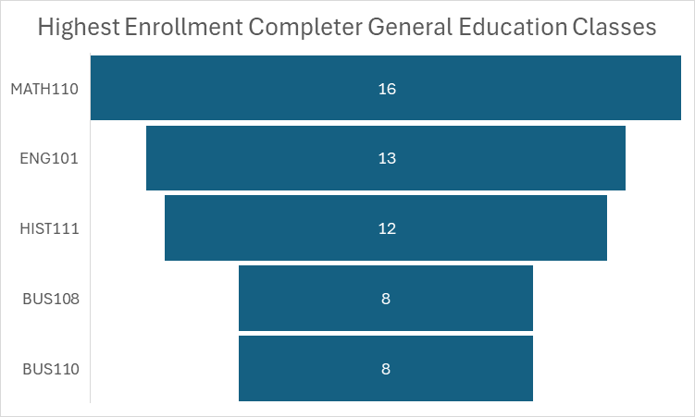

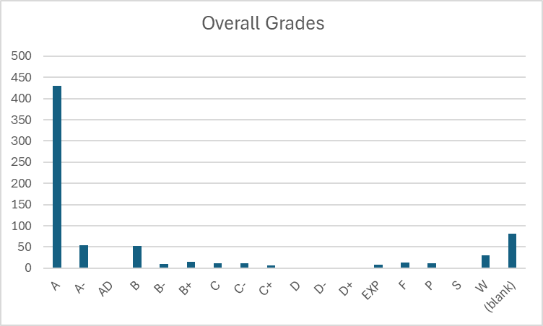

IV. Financials

- Skills Certificate:
  - Level 1: Chucking, Surface Grinding and Milling
    - Tuition and Books – $1,315
  - Level 3: CNC Operating, Turning and Measurement
    - Tuition and Books - $1,580

- Certificate of Achievement:
  - Tuition and Books – $4,293
- Associates:
  - Tuition and Books – $8,210

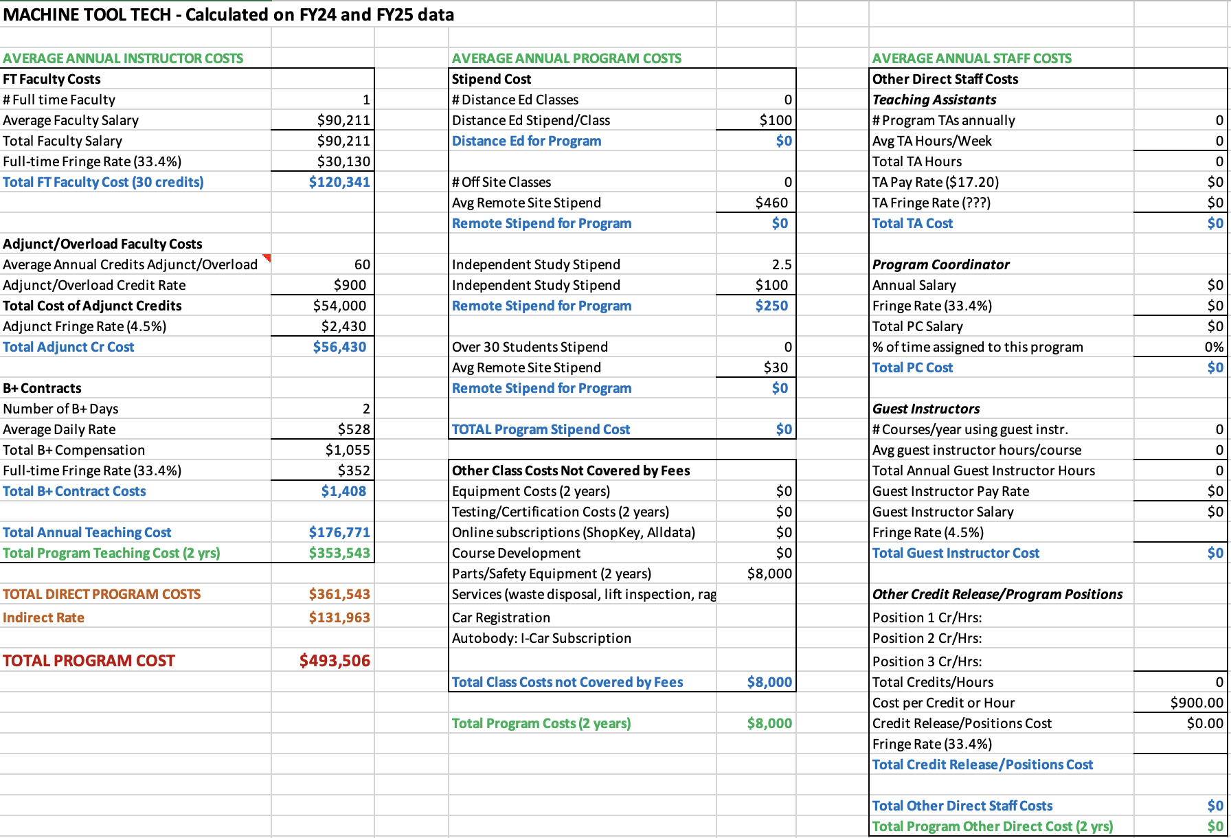

V. Additional Department Information

- Academic Advising
There are concerns about low enrollment in the MTT program, which may result in class cancellations. This can be discouraging and demotivating for students, making it more difficult to complete the program. Additionally, the availability of many classes is inconsistent.

- Advancement
Scholarships for the program are provided through the William N. Pennington Foundation, along with several other supporting donors.

- CFO

Course | Total Approved Fee | Expendable Supplies
MTT 105 | $45 | $45
MTT 106 | $40 | $40
MTT 110 | $45 | $45
MTT 111 | $40 | $40
MTT 230 | $45 | $45
MTT 232 | $45 | $45
MTT 250 | $45 | $45
MTT 251 | $40 | $40
MTT 260 | $45 | $45
MTT 261 | $45 | $45
MTT 262 | $40 | $40
MTT 291 | $40 | $40
MTT 292 | $15 | $15
MTT 293 | $15 | $15

How course fee requests are approved:
Each year, the CFO sends out a request for any new course fees or changes to existing fees. Any new fees are then compiled and presented to the College Council for review. If a proposed fee exceeds $50, it must be approved by the Board of Regents (BOR). However, fees of $50 or less can be approved directly by the WNC College President.
Once a fee is approved or updated, the Student Finance Coordinator ensures that the new or revised fees are updated in PeopleSoft for the term when they become effective. This process ensures that students registering for these classes are charged the appropriate fee upon enrollment.
- Academic Director
In June 2023, a new director was hired after a transitional year when the division was led by an interim director. This leadership change required several adjustments within the division. Since the new director’s arrival, improvements in the department's overall effectiveness have been evident. The introduction of best practices in scheduling and communication has enhanced operational efficiency, and there has been a noticeable increase in awareness of the Western College of Technology and Education (WCTE) both on campus and in the surrounding communities. This increased visibility has contributed to a more cohesive and effective program.
The department is organized with a Director overseeing the entire division, which includes faculty in several areas such as Graphic Design, Business, Education, Criminal Justice, Aviation, EMS, Fire Science, Agriculture, Computer Information Technology, and Health/PE. The Director is supported by an Administrative Assistant IV, who handles a variety of administrative functions. To further improve operational efficiency, the division has recently expanded its team. An Outreach and Training Coordinator has been hired to manage all Skilled Trade Programs, including Welding, Automotive, Machine Tools, Construction, and Advanced Manufacturing. An additional Administrative Assistant III has been added to support various programs, including Skilled Trades, Fire Science, and EMS. Additionally, an Early Childhood Education (ECE) Program Coordinator was brought on board recently to manage the numerous ECE grants at the college. This organizational structure provides dedicated oversight and support across all programs, improving overall operational efficiency.
The department is committed to maintaining instructional effectiveness through several key initiatives. The recent hiring of a new Director and an Outreach and Training Coordinator provides focused leadership and specialized management for Skilled Trade Programs. This ensures that instructional practices align with industry standards and best educational practices. The addition of an Administrative Assistant III and an Early Childhood Education Program Coordinator enhances the support structure for various programs, enabling better coordination, resource allocation, and responsiveness to instructional needs. Furthermore, the department has implemented best practices for scheduling and communication, which optimize instructional time and improve interactions between faculty, students, and stakeholders. Each program, including Skilled Trades, Fire Science, EMS, and Early Childhood Education, benefits from dedicated coordinators who ensure that instructional materials, resources, and methodologies remain up-to-date and effective. The division also actively seeks feedback from students, faculty, and industry partners to identify areas for improvement, fostering continuous enhancement of instructional strategies.
The process for assigning teaching responsibilities within the department is highly collaborative. Full-time instructors provide the Director with an overview of course assignments for the upcoming semester. The Director reviews the plan, and if any issues arise—such as negative feedback from course evaluations or student complaints—the Director works with the instructors to ensure the best-qualified faculty member is assigned to each course. Faculty workloads are typically heavy, with most full-time WCTE faculty carrying an overload due to the large number of courses required to ensure students can graduate on time. To support new faculty, the department has developed a training course in collaboration with the Learning and Innovation department. This course provides new instructors with tools to enhance their teaching effectiveness and outlines the framework for course structure and delivery at the college. All instructors are fully credentialed, either through their educational background or relevant professional experience.
The program is actively focused on recruiting and retaining underrepresented faculty and staff through targeted outreach and recruitment initiatives. This includes engaging with professional networks and organizations that support diversity in education and industry, as well as participating in job fairs and events that attract a diverse pool of candidates. Creating an inclusive and supportive work environment is also a priority, as it helps retain underrepresented faculty and staff. While several significant hires have been made recently, the department faced a loss with the departure of Juan Ramirez, a full-time Welding Instructor, which impacted the College's standing within the community. However, the hiring of new adjunct instructors is expected to help rebuild trust and restore the program’s reputation.
There is a recognized need for a second full-time instructor in CIT to help manage the growing demand for courses and support students effectively.
Until recently, additional support staff was a significant concern. However, since May, the department has been able to hire an additional Administrative Assistant, an Outreach Coordinator, and an Early Childhood Education Program Coordinator. With these new hires, the department now has adequate support staff to meet its operational needs.
Many of the department's more costly programs, such as Perkins and WINN, are funded through grants. Lab fees are used to cover consumables, but rising material costs have created challenges. The department has had to dip into its general operating budget to secure the necessary supplies for maintaining industry-standard programs.
The department regularly assesses its use of funding and human resources through reviews and strategic planning. Financial resources are monitored to ensure alignment with the program’s goals and effective utilization. Expenditures are evaluated based on their impact on student outcomes, program growth, and operational efficiency. For human resources, the department reviews faculty and staff workloads and the effectiveness of course delivery and student support services. Feedback from students, faculty, and staff is used to identify areas for improvement, ensuring that resources are optimized to meet the program's needs.
Facilities remain one of the department's biggest concerns. Some buildings have mold issues, leading to classrooms being closed just before the semester begins. Other buildings experience uncontrollable leaks that pose a risk to expensive equipment and vehicles, further complicating operations.
- Learning and Innovation

In the Fall of 2023, Learning and Innovation piloted a 16-week Canvas-based “Faculty Development” course. This course provided information on expectations for WNC instructors as well as strategies and tools for teaching effectively.
Additionally, Learning and Innovation hosts the Zoom-based “Coffee and Classroom Conversations” series that focuses on a wide range of teaching topics. This series is driven by faculty interests and WCTE faculty have regularly attended these sessions.
The Learning and Innovation team has met with WCTE faculty for support in assignment development and teaching strategies, as well offering professional development opportunities for faculty in support of student learning initiatives including the introduction of best practices for working with students in CTE fields.
Learning and Innovation also provides technical support for Canvas including help desk support and instructional design.
The greatest adjustment has been the increased reliance on Zoom for the provision of training and support as well as the focus on Canvas support. Learning and Innovation has found that WCTE instructors can be reluctant to engage in professional development opportunities and may not be using Canvas to the full extent.

- ACMC

DATE | CHANGE/ACTION | DETAILS
October 2019 | Adoption of New MT Courses | WNC added three new Machine Tool (MT) courses—MT 130, MT 132, and MT 134—in partnership with Southwest Gas to meet local workforce needs in energy and pipeline industries.
February 2025 | Renamed Skills Certificates | - “MT Level 1 Skills Certificate” renamed “Manual Machining Skills Certificate”  - “MT Level 3 Skills Certificate” renamed “CNC Machining Skills Certificate” to match industry terminology.
February 2025 | Updated Manual Machining Certificate | The newly named Manual Machining Skills Certificate was revised for better alignment with the Machine Tool Technology Certificate of Achievement and the AAS Technical degrees.

- Financial Aid
Feedback from students tends to focus primarily on course delivery, conflicts with instructors, access to resources, and various learning challenges they may face. These concerns are important to address, as they directly impact the overall student experience and their ability to succeed in the program. By understanding and addressing these issues, we can improve both the quality of education and the support systems available to students.
For students pursuing the AAS-Tech degree, we observe that they are generally well supported throughout their studies. This is largely due to their close connection with their subject matter faculty, who provide guidance, mentorship, and specialized expertise. This connection seems to create a supportive environment that helps students stay engaged and succeed in their coursework.
There is discussion about whether there’s a way to track and demonstrate if students in WCTE degree programs are successfully stacking their credentials, such as earning Skills Certificates, Certificates of Achievement (COA), and ultimately completing the AAS degree. It may not have been formally reported, but it would be valuable to measure how students are progressing through these stacked credentials, as it could provide insights into the effectiveness of the program and highlight areas for improvement.
Students often declare a degree primarily to open up options for Financial Aid, even if they have no intention of completing the degree. While this practice is not entirely new, it’s something that should be noted. One area where the process falls short is in documenting whether the student has achieved their initial goal. There is a tendency to assume that if a student does not graduate with the degree, the assistance provided was a failure, even though they may have completed other objectives. This gap in tracking student outcomes could be addressed to better reflect the support students are receiving, regardless of whether they ultimately earn the degree.
Another ongoing challenge is the attraction of fraudsters to online programs, particularly those who are looking to take advantage of Financial Aid dollars. These individuals often target online programs to exploit the system, which remains a concern across many institutions.
Additionally, there are occasional issues with the approval process for certain programs, particularly when it comes to the AAS-Technology degrees, which are approved by agencies like the State Approving Agency for VA Benefits. When a new reviewer examines the catalog, there is often confusion about how to categorize the Technology emphasis or how to handle the different pathways, such as Automated Systems or CIT. While these issues can usually be resolved through conversation and clarification with the reviewer, it remains a recurring challenge that requires attention each time a new person evaluates the catalog.

- Faculty
Full-time faculty member Ron Beller brings more than four decades of hands-on experience in manufacturing to the classroom, blending practical “building things” know-how with essential shop theory. His students learn safety rules and etiquette alongside measuring, drafting, and the self-reliance they’ll need on the job. He insists they ask for help when it counts—and he’s seen a welcome shift as local employers, facing acute labor shortages, finally raise wages and hire high-school graduates for entry-level CNC work. These young technicians may spend a semester simply loading parts, pressing buttons, and checking tolerances, but Ron sees that as a solid launchpad: they enter the workforce debt-free and can return later to build on their skills without loans hanging over their heads.
Despite TMCC’s theory-heavy program, Ron pushes for a curriculum that mirrors a real shop floor. He’d like counselors to better understand the “down-here” reality, ensuring students in MTT 105 also take DFT 110: Blueprint Reading for Industry, since few high schools still teach drafting. He dreams of a CNC 3 course that unites mills, lathes, and laser cutting—much like the manual-skills project class, where students design, build, and troubleshoot tangible components.
Ron has also become the de facto facilities manager for his lab: patching broken air hoses, jury-rigging plumbing, and even installing the shop’s first eye-wash station after noticing it sat unused. He’s documented successes—student projects, post-graduation placements, and glowing testimonials—but feels the program remains the “red-headed stepchild,” starved for publicity and administrative support. As he contemplates retirement in a few years, he hopes his teaching assistant will step up, carrying forward a legacy of practical instruction, shop pride, and an unrelenting drive to bridge the gap between classroom and career.

VI. Faculty Profiles - provide a narrative response to each of the following:

- Ron Beller
  - AAS equivalent training at American River College
- John Mullins
  - National Institute for Metal Working Skills (NIMS) Certifications:
  - CNC Milling Operator
  - CNC Turning Operator
  - Job planning, Benchwork &amp; Layout
  - Measurement, Materials and Safety
  - OSHA 10

Percentage of courses taught by instructor type: 85% full-time, 15% adjunct

VII. Comparisons - provide a narrative response to each of the following:
- TMCC
  - AAS - Machine, Manufacturing Technologies
  - Certificate of Achievement - Computer Numeric Controlled (CNC) Machining
  - Skills Certificates
    - Machining Level 1, CNC Milling
    - Machining Level 1, CNC Turning
- Torchmate - online or a 3-day in-person training program. $1,050
- NCLab - through CSN $5,070

TMCC and WNC offer comparable programs, though TMCC breaks its Level 1 Skills Certificate into two, adding Introduction to Machine Shop to the first series. Torchmate would be a good choice for a student looking for basic skills without a transcript, and the NCLab program provides a more robust program, also without the option of a transcript.

VIII. Recommendations and Commendations - provide a narrative response to each of the
following:
Commendations
- This was the first time implementing the new program review process, which required assistance and participation from many individuals. Administrative departments and IT were essential in gathering necessary information and fielding questions.
- Machine Tool full-time faculty for their contributions to program history and insight into industry trends. Adjunct faculty for the program development participation.
Recommendations
- Add a CNC 3 (MTT 296: Computer Numerical Control Practice II) projects class to run stacked with MTT 232.
- DFT 110 should be a prerequisite or run concurrently with MTT 105.
  - This should be reviewed during the next program review to assess enrollment impacts. The recommended course sequence also needs to be updated.
- Develop award-specific objectives and an accompanying assessment plan.
- Provide additional administrative support to WCTE.

