SOURCE: WNC January 2021 Planning Retreat

Writing and using S.M.A.R.T. GOALS

S – Specific - When setting a goal, be specific about what you want to accomplish. Think about this as the mission statement for your goal. This isn’t a detailed list of how you’re going to meet a goal, but it should include an answer to the popular ‘w’ questions:
- Who – Consider who needs to be involved to achieve the goal (this is especially important when you’re working on a group project).
- What – Think about exactly what you are trying to accomplish and don’t be afraid to get very detailed.
- When – You’ll get more specific about this question under the “time-bound” section of defining SMART goals, but you should at least set a time frame.
- Where – This question may not always apply, especially if you’re setting personal goals, but if there’s a location or relevant event, identify it here.
- Which – Determine any related obstacles or requirements. This question can be beneficial in deciding if your goal is realistic. For example, if the goal is to open a baking business, but you’ve never baked anything before, that might be an issue. As a result, you may refine the specifics of the goal to be “Learn how to bake in order to open a baking business."
- Why – What is the reason for the goal? When it comes to using this method for employees, the answer will likely be along the lines of company advancement or career development.
M – Measurable - What metrics are you going to use to determine if you meet the goal? This makes a goal more tangible because it provides a way to measure progress. If it’s a project that’s going to take a few months to complete, then set some milestones by considering specific tasks to accomplish.
A – Achievable - This focuses on how important a goal is to you and what you can do to make it attainable and may require developing new skills and changing attitudes. The goal is meant to inspire motivation, not discouragement. Think about how to accomplish the goal and if you have the tools/skills needed. If you don’t currently possess those tools/skills, consider what it would take to attain them.
R – Relevant - Relevance refers to focusing on something that makes sense with the broader business goals. For example, if the goal is to launch a new product, it should be something that’s in alignment with the overall business objectives. Your team may be able to launch a new consumer product, but if your company is a B2B that is not expanding into the consumer market, then the goal wouldn’t be relevant. When writing SMART goals they have to be written in such a way that they lead to meaningful work that positively impacts the organization. This is where the relevance to what you set as a goal is created. It is not that difficult to write goals that meet all of the other requirements for a SMART goal. Embedding the aspirational aspect (the relevance of the work you are embarking on) is where the most important part of the goal comes from. Set goals that are realistic in your pursuit of them but above all goals that are meaningful is what we strive for in our work.

T – Time-Bound - Anyone can set goals, but if it lacks realistic timing, chances are you’re not going to succeed. Providing a target date for deliverables is imperative. Ask specific questions about the goal deadline and what can be accomplished within that time period. If the goal will take three months to complete, it’s useful to define what should be achieved half-way through the process. Providing time constraints also creates a sense of urgency.

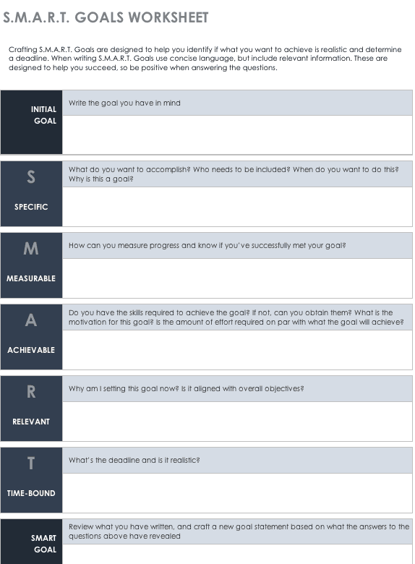 | The Easiest Way to Write SMART Goals  When it comes to writing SMART goals, be prepared to ask yourself and other team members a lot of questions. The answers will help fine-tune your strategy, ensuring the goals are something that’s actually attainable. While you should be as realistic as possible, it’s important to approach writing SMART goals with a positive attitude. After all, this is something that you want to achieve.  This doesn’t have to be a daunting experience; in fact, it should be quite illuminating. Later in the article, we demonstrate how to write SMART goals for two typical business scenarios: completing a project and improving personal performance. Below, we’ve included an easy-to-use SMART goals template in Word, along with a template to help you plan and manage your goals in Smartsheet.

Examples of SMART Goals
Here are two examples of initial goals we'll use to walk through this process:
- I want to complete a project
- I want to improve my performance
This is a typical approach to creating goals, but both of these are very vague. With the current wording, the goals probably aren’t going to be attainable. The statements lack specifics, timelines, motivation, and a reality check.
Now, let’s use the SMART goals formula to clarify both and create new and improved goals.
Goal 1: I want to complete a project
- Specific: Many people are accessing our current site from their mobile devices. Since it’s not a responsive site, it provides a poor experience for customers. I want to launch a mobile app for my company website by the end of Q2, which requires involvement from software development, design, and marketing.
- Measurable: Creating a mobile app for our company site will require a lot of resources. To make it worthwhile, I’d like to have 50,000 installs of the site within six months of launch. I’d also like to show a 5% conversion rate from customers using the mobile site.
- Achievable: The departments that will be involved have signed-off on creating a mobile app. I’ll need to manage the project and set milestones to keep everyone motivated and on target.
- Relevant: Improving the customer experience on mobile devices is a core initiative for my company this year.
- Time-Bound: In order to achieve 50,000 mobile app installs and a 5% conversion rate by the end of the fiscal year, the app will need to be launched by Q2 with a robust marketing campaign that should continue through the end of the year.
Goal 2: I want to improve my performance
- Specific: I received low marks on my ability to use PowerPoint at my last performance review. Improving my skills requires that I learn how to use PowerPoint efficiently and practice using it by creating various presentations. I’d like to be more proficient using PowerPoint in time for my next review in six months.
- Measurable: By the time of my next review, I should be able to create presentations that incorporate graphs, images, and other media in a couple of hours. I should also be able to efficiently use and create templates in PowerPoint that my coworkers can also use.
- Achievable: Improving my PowerPoint skills is instrumental in moving forward in my career and receiving a better performance review. I can set time aside every week to watch PowerPoint tutorials and even enroll in an online class that can teach me new skills. I can also ask coworkers and my manager for PowerPoint tips.
- Relevant: Working with PowerPoint is currently 25% of my job. As I move up in the company, I’ll need to spend 50% of my time creating PowerPoint presentations. I enjoy my career and want to continue to grow within this company.
- Time-Bound: In six months, I should be proficient in PowerPoint ensuring it only occupies 25% of my workload instead of the nearly 40% of the time it occupies now.
Once you go through and write your goals according to each SMART characteristic, you can then combine and consolidate all the work you’ve done into one SMART goal.
SMART goal: I want to complete a project
- Description: Improving the customer experience on mobile devices is a core initiative for my company this year, so we are going to create a mobile app. By the end of the fiscal year, there should be 50,000 installs of the mobile app we develop, and it should produce a 5% conversion rate. We’ll build the mobile app in-house and launch it by the end of Q2 with an app-related marketing campaign that will continue to the end of the year.
- Milestone: Mobile app launches end of Q2.
- Deadline: End of the fiscal year.
SMART goal: I want to improve my performance
- Description: To grow in my career, I need to improve my PowerPoint skills. By taking online classes and reviewing tutorials, I’ll improve my PowerPoint skills so that it only requires 25% of my work time.
- Milestone: Complete an online PowerPoint course in three months.
- Deadline: Next employee review in six months.

