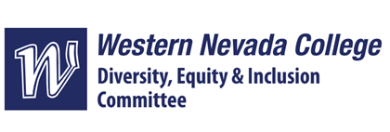

DEI Committee 10/18/2024

Meeting Minutes

Members present in person: Nichole Paul, Diego Flores, Haileigh Fitzgerald

Members present via Zoom: Peter Christman, Mary Gillespie

Members not present: Lisa Gallo Swan, Eric York, Katy Edmunds

Guests present: Amanda Stibick (oversight)

| Agenda Item | Discussion |
| --- | --- |
| Call to Order | 12:02 PM |
| Roll Call |  |
| Approval of Minutes for meeting 3/26/2024 | Motion by Haileigh, seconded by Mary |
| Working groups for SMART Goals:   1. Committee led | Conversations still ongoing for setting up the LGBTIA+ 101 talks.  “Don’t Cancel That Class” has a DEI option now.  Free films that we can request to be posted about DEI topics  10/29, noon, Wildcat commons, meeting with the DEI from UNR, lunch and learn  Another speaker opportunity from Melody (Aaron) and Susan  Reviewing new DEI policies as they come through and providing suggestions. (Not a SMART goal, but may be one in the future.)  DEI workshop during the facility meetings before the semester or professional development  Reach out to TMCC about doing another session involving helping student and faculty veterans  Renaming DEI to include belonging and accessibility?  Working groups vs. all working on things at once. Decided on the latter. |
| Working groups for SMART Goals   1. Student led | Meeting on 10/28 to talk to ASWN about their ideas for events  -Multicultural fair, after spring break  -Latino leadership academy has been discontinued due to equity concerns |
| Upcoming meeting date | 11/15 at noon |
| Open Discussion | None |
| Public Comment | None |
| Next Meeting | The next meeting will take place on November 15 at 12:00 PM. |
| Meeting adjourned | 12:28 PM |